**Guidance on making a short video for social media**

**Unforgettable Gardens Book Promo**

**What we want**

* 1 x video no more than 30 seconds long for sharing across all our social media (Instagram, Facebook, TikTok & X).
* A passionate and engaging explanation of what makes your park/garden so ‘Unforgettable’ – this can highlight a fun fact, an important conservation message or its historical significance. It should be delivered in a light, informal and inspiring tone.
* This can be recorded in your own garden, local park (or anywhere you can find a ‘green’ plant-y background!). If it is possible to record at the site you are speaking about, that would be fantastic, but you **must ensure** you have all the proper permissions in place to do so. Please copy Frankie in to any correspondence with site owners confirming this so we have a record.
* Ensure that you don’t use any jargon, acronyms or long words that aren’t immediately understandable to those who aren’t garden historians, unless you can provide a definition in that same video. For example, we avoid using the phrase ‘historic designed landscape’ on social media where possible.
* Add a quick plug for the book! Something along the lines of: ‘This and many more fabulous gardens are featured in Unforgettable Gardens, our book coming soon’. Keep it vague I can add more detail in the caption and potentially reuse these clips at a later date.
* Good examples of short engaging videos in exactly the tone we want are Paul Rabbitt’s reels promoting his public parks series. The first of these where he refers to Blur’s song did well as it linked his topic to pop culture!   
    
  1.<https://www.instagram.com/reel/C50qXP0qqmz/?utm_source=ig_web_copy_link&igsh=MzRlODBiNWFlZA==>

2.<https://www.instagram.com/reel/C6YYWZRKLSr/?utm_source=ig_web_copy_link&igsh=MzRlODBiNWFlZA==>

3.<https://www.instagram.com/reel/C7L2wHQK4N_/?utm_source=ig_web_copy_link&igsh=MzRlODBiNWFlZA==>

**Technical stuff**

**Setting up your camera on a smartphone/tablet**

*Let me know if you don’t know how to do any of the below and I can help:*

* Set the video to record at a minimum of 1080p at 30fps (frames per second). If you can record in higher quality, please do.
* When in your camera app, if you want to focus on something, just tap that item. A square box should appear with the little sun next to it. This focuses your camera on the object within the square. It’s essential you are in focus!
* If your room is too light/dark, you need to adjust the exposure. On an iPhone, you do this by moving the little sun up and down.

**Recording your video**

1. Record in portrait, not landscape.

 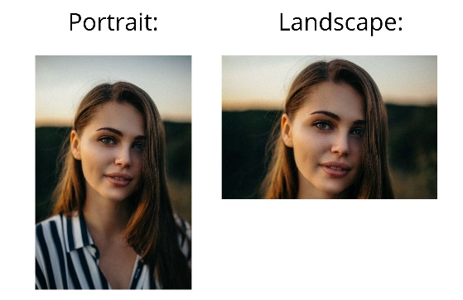

1. Record at least 2 takes so we can select the best version or edit where necessary.
2. Wait a few seconds after you press record to begin speaking, and similarly wait 4-5 seconds after you’ve finished speaking before you end recording. This helps with editing and your starting/ending pauses will not make it into the final cut!
3. Try to frame your video so there isn’t much happening in the bottom third of your shot – we need this space to add subtitles and a caption.
4. If recording outside, be aware of background noise and that you may need a microphone for best results. A lot of smartphones come with headphones that have microphones so use those if you can.
5. You can film whilst walking/moving outside, this may be more interesting and work better than standing still, so decide what works best for you.
6. Send your video to me via wetransfer if it doesn’t attach to an email. Alternatively, you can send it via WhatsApp – just make sure you tap ‘HD’ when you do this so I get the highest quality version.

