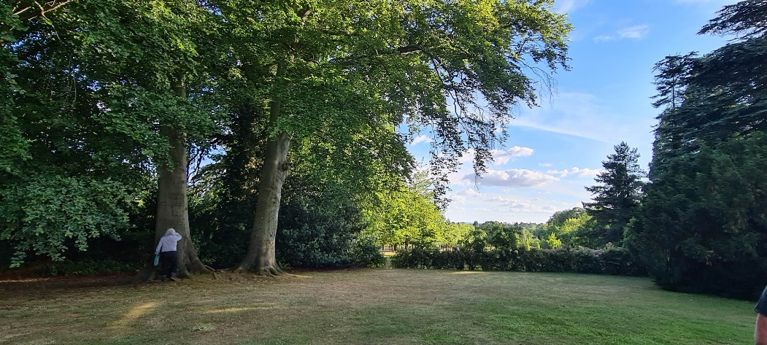

Nottinghamshire’s Garden Story

Research Training 2023-24
with Gardens Trust Volunteer Support Officers Tamsin McMillan, Sally Bate and Frankie Taylor

Please save the dates of any sessions you’d like to attend – we’ll let you know when bookings are open, at https://thegardenstrust.org/events/. All are free to attend.

Don’t worry if you can’t make all the dates:
Webinars will be recorded, so you will be able to watch them at a time to suit you.
Extra meetings can be added, as required, to support you as you research your landscape.

14th Nov. 2023 | An Introduction to Garden History  Tuesday 14th November, 6-7.30pm (online)  We’ll take you on a whistlestop tour through British garden history, from the earliest Roman gardens, to medieval deer parks, Georgian landscape parks, Victorian public parks and modern landscapes, and everything in-between!
21st Nov. | Understanding the Threats facing Historic Parks and Gardens  Tuesday 21st November, 6-7.30pm (online)  A summary of the many ways in which the historic designed landscapes we care about can be threatened by development, neglect and inappropriate management, and how volunteer research projects like NGS can help to prevent this.
5th Dec. | Beginning Historic Landscapes Research: Introduction to resources  Tuesday 5th December, 6-7.30pm (online)  A summary of the range of materials you can access to start understanding the history and development of your site. To include online maps and documents, archive materials and secondary sources. Full notes will be provided afterwards, to support you as you start your research.
13th Dec. | Visiting Nottinghamshire Archives  Wednesday 13th December, 10-12am, County House, Castle Meadow Road, Nottingham, NG2 1AG  A two hour visit to the county archives will provide an introduction to using the archives to research your site and will include a behind the scenes tour. Archivists will present some of the maps, images and written sources relating to Nottinghamshire’s historic designed landscapes.  Places are limited, so volunteers contributing to Nottinghamshire’s Garden Story will be given priority. Please email tamsinmcmillan@thegardenstrust.org to book this session.
10th Jan. | Preparing for your site visit  Wednesday 10th January, 6-7.30pm (online)  An introduction to reading the landscape; what you’ll need to bring; and how to prepare.
16th Jan. | Recording: Walking an example site  Tuesday 16th January, 11am-2pm (location tbc)  We will walk around an historic landscape, recording the current layout and anything we can see from earlier periods, including paths, planting, trees and garden buildings. You’ll learn what to look out for and how to fill in a site visit form.
30th Jan. | Collecting memories and an introduction to sharing your research  Tuesday 30th January, 6-7.30pm (online)  Frankie Taylor, the Gardens Trust’s Audience Development and Engagement Officer, will explain why it’s so important to learn about landscapes from people who know and use them, and how to collect memories, including oral histories. We’ll also start to look at the ways in which we can share this project’s research with others, including via social media and leaflets.
27th Feb. | How to share your research online  Tuesday 27th February, 6-7.30pm (online)  How, and why, to upload your finished research to online databases (including Historic Environment Records, Parks & Gardens UK and Local Lists) so that it can be used by others to understand and protect landscapes.
Mid-March | Sharing the project’s outcomes and lessons learnt  Date and time tbc (online)
Mid-April | End of Project Celebration for the Volunteers  Date, time and venue tbc
For more information, email tamsinmcmillan@thegardenstrust.org

