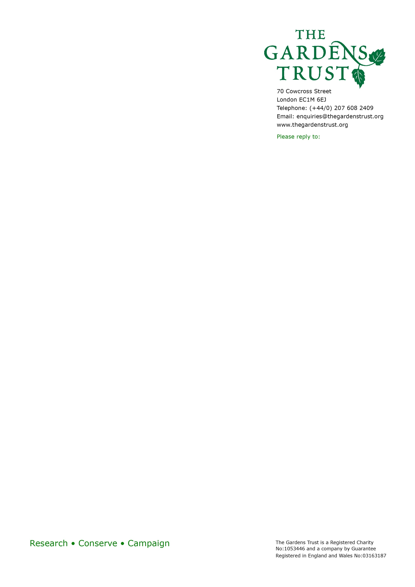
The Gardens Trust Community Grant
A grant scheme made possible with thanks to the generosity of the Gentian Trust

Application Form
Applicant:
Name of Group:
What is your group working to achieve? (200 words maximum)
Address and postcode of group:
Website Address:
When was your group set up?
Legal Status of your group (eg registered charity, group of volunteers, CIC)
Registered Charity Number if applicable
If you have applied successfully before, please state the date and amount of the award.
Income:
£
Names of trustees:
Expenditure:
£
Unrestricted or Free Reserves:
£
Latest Audited/Examined Statement of Financial Activities Year Ending:
Are your accounts available to view on the Charity Commission website? Yes No
Project summary
Please outline what your project will do and why. (300 words maximum)
Project start date:
Project end date:

The historic designed landscape
Which historic designed landscape does your project relate to? Please describe it, including its current condition. Please describe the arrangement under which it is open to the public. (300 words maximum)
Background
If this application is to cover a smaller part of a bigger project, please outline the bigger project. (200 words maximum)
Project plan
Please describe how you will carry out your project. What will the tasks be? What is the timetable?
(500 words maximum)
Project purpose
Please explain why you want to do it and what the benefit will be. Please estimate how many people will benefit, and who they will be. (300 words maximum)
Project team
Please describe who will deliver your project. Will there be volunteers, or staff? How many? What will they be doing? (300 words maximum)

Project costs
Total cost of project (including vat):
Sum requested from the Gardens Trust Community Grant, including vat. (Total grant fund £3500):
Funding already secured: please state source and whether confirmed or pending.
How much is being provided from your own resources?
Please list principal items of expenditure from within this grant.
Is the grant required in one payment or in stages? If in stages, please indicate likely dates and amounts.
Evaluation and reporting
How will you measure the success of the project? (200 words maximum)
Please attach evidence that the project has the support of the landowner where appropriate (eg a letter). List them here.
You may attach extra information, but not more than 3 sides of A4. List this here.
Grant payment
Please provide bank details if a grant is to be paid by BACS:
Bank Name:
Account Name:
Sort code:
Account Number:
If the grant is to be paid by cheque, please state the name of the payee:
How did you hear about the Gardens Trust?
I confirm that I am authorised to submit this application on behalf of this organisation.
Signature:
Print Name:
Contact details of person completing this form.
Name:
Position/ Job Title:
Email Address:
Telephone Number:

THE DEADLINE FOR APPLICATIONS IS 15TH OCTOBER. PLEASE EMAIL THE APPLICATION FORM AND SUPPLEMENTARY DOCUMENTS TO CATHERINE.FORD@THEGARDENSTRUST.ORG
WE WILL NOTIFY APPLICANTS BY MID-NOVEMBER.
* The Gardens Trust is committed to protecting the personal data of individuals and complies with applicable data protection legislation. A copy of our privacy notice may be downloaded from our website. By ticking the box you provide your consent for us to process your personal data for the purposes of responding to the relevant application, so that it can be considered. You also agree to comply with the applicable data protection legislation, including providing all notices and obtaining consents required, if you provide the personal data of others to us for the purposes of this application.
The Gardens Trust Community Grant
Guidance for applicants

This grant is made possible with thanks to the generosity of Peter and Rosy Gent of the Gentian Trust.

There is a total grant fund of £3500. We are expecting applications for up to this amount.

The applicant must be a volunteer group. It does not have to be a registered charity, but does need to be able to demonstrate that it is an active group with a clear plan.

The project can be based anywhere in the United Kingdom.

The project can be any activity relating to historic designed landscapes.

We will particularly be encouraging applications that reflect GT priorities around conservation, sharing knowledge, and encouraging inclusive participation and enjoyment of historic designed landscapes.

We will be looking for something that will act as seed-funding/pump priming for a sustainable activity. For example, an application to fund a restoration plan, Friends group set-up costs, research project, or volunteer training scheme will be better received than a one-off summer fair.

Preference will be given to helping smaller charities, where a grant can have more significant impact.

The applying group does not need to be a registered charity, but it does need to make a convincing case that it is competent to manage the grant and project.

This grant can cover both capital and revenue projects.
We do not fund projects which have already been completed. Our preference is to fund projects that have not yet begun, but in some circumstances we may consider contributions to those already underway.

Preference to projects that will be substantially completed within 18 months of the application.

Having previously been awarded or refused a grant has no bearing on your ability to apply again.

Project costs
You will need to state the income and expenditure figures from your organisation’s latest audited accounts.

If you are a small group and not required to produce audited accounts, please state the income and expenditure totals of your annual budget.

If you are applying for a specific project or activity, you should outline all the costs involved in delivering the project, including staff costs and a reasonable percentage of overheads, if relevant.

There is a total grant fund of £3500. We are expecting applications for up to this amount.

Timeline
The deadline for application is 15th October each year. Please send applications to Catherine.ford@thegardenstrust.org.
Your application will be acknowledged by email within two weeks of receipt. If your proposal is not eligible, you will be told by email.
Applicants will be notified by mid-November of the outcome.

Reporting
If awarded a grant, you will be required to report on the use made of it within six months of the end of the period. If the project will take more than a year, you will be asked to report annually. We do not require long reports: a page of A4 will usually be ample.
We will also want to cover your project in our publications, website and social media. You will be required to help with material for this.

For any questions not answered by these guidelines, please email Catherine.ford@thegardenstrust.org

