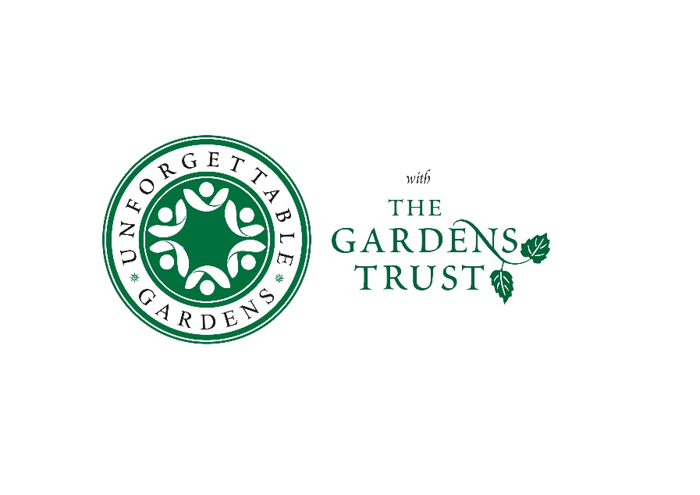

**CHESHIRE GARDENS TRUST PRESS RELEASE**

**Cheshire Gardens Trust plans people’s pop-up museum at Queen's Park, Crewe**

As part of this year’s Heritage Open Days festival, Cheshire Gardens Trust will be inviting members of the public to visit their free pop-up museum at Queens Park, Crewe on Saturday 16th September 2023, 10.30am-4.30pm. Open for one day only, Cheshire Gardens Trust will be asking local people to share their stories and memories of Queens Park, and other public parks in and around Crewe. This event is part of the Trust’s work to share the beauty, significance and importance of our local parks, gardens and other designed landscapes in Cheshire.

Members and volunteers from Cheshire Gardens Trust will be on hand to share the work they do to research and protect historic parks and gardens in addition to staff and volunteers from the Gardens Trust, Cheshire Archives and the Friends of Queens Park. Visitors of all ages are welcome and will also be able to talk to archivists and garden historians as well as take part in garden games, create a Tudor ‘tussie mussie’ posy, to celebrate herbalist and author John Gerard, born in nearby Nantwich, and even try their hand at a ‘Garden History Lucky Dip’ activity.

Sally Bate, Volunteer Support Officer for the Gardens Trust, said: "We are looking forward to meeting members of the community around Queens Park and sharing in their memories of these incredibly important local green spaces. We often take parks for granted but they can be very vulnerable places that rely on volunteers from all walks of life to help protect them for future generations – we hope the day will inspire people to look at their local parks from a different angle”.

During the event, volunteers from Cheshire Gardens Trust will be recording people’s memories of their favourite Cheshire parks and sharing these in a digital people’s museum that will evolve through the day, demonstrating the important role parks play in all of our lives. Do come and take part, and bring along your park-related memories for the volunteers to record or photograph. Just look for the Heritage Open Day signs near the park café.

It is hoped that many of the items and memories will be able to add to existing records about public parks or via Historic England’s ‘Missing Pieces Project’ <https://historicengland.org.uk/listing/missing-pieces/>, helping us all to understand more about what makes our parks so special to local communities.

Increasingly, parks and gardens throughout the UK face a variety of threats to their survival, ranging from funding cuts to building developments, lack of wider community support and neglect. In 2022, the Gardens Trust dealt with over 1700 planning applications that affected Registered Parks and Gardens in England. As this number continues to increase year on year, it is becoming harder to campaign to protect our historic green spaces. It is hoped that by working in partnership with the public and local organisations we can not only highlight the increasing threats that parks face but work together to help support and protect them for everyone’s benefit, now and in the future.

**Notes for editors**

**About Cheshire Gardens Trust**

Cheshire Gardens Trust is a charitable volunteer organisation dedicated to understanding and promoting appreciation of parks and gardens and their history in Cheshire. We are part of the national network of local County Gardens Trusts affiliated to [the Gardens Trust](http://thegardenstrust.org/), the umbrella organisation concerned with the preservation and enhancement of the country’s outstanding gardens and landscapes. We also aim to encourage the making of new parks and gardens, to safeguard the ones that we have and to encourage local communities to appreciate and care for the parks and gardens in their area. Cheshire Gardens Trust is a membership organisation that offers visits, talks and events on landscape-related subjects.

**About the Gardens Trust**

The Gardens Trust is the UK national charity dedicated to protecting and conserving our heritage of designed landscapes. We campaign on their behalf, undertake research and conservation work and encourage public appreciation and enjoyment of these special places. The Gardens Trust is also a statutory consultee in the English planning system, responding to thousands of planning proposals affecting registered parks, gardens and landscapes every year. Through our national network of County and Country Garden Trusts, we have access to people and local expertise throughout the country. The Gardens Trust is also a membership organisation which relies on members and donors to support our work. Find out more on our website http://thegardenstrust.org or follow us on social media @thegardenstrust

**About Heritage Open Days**

 Heritage Open Days is coordinated nationally by the [National Trust](https://www.nationaltrust.org.uk/) with support from players of [People’s Postcode Lottery](https://www.postcodelottery.co.uk/good-causes). Heritage Open Days is organised by an enormous network of people who share a passion for places, history and culture. Locally, thousands of organisations and volunteers programme, fund and manage a fantastic array of site openings and events, jointly attracting millions of visitors. They make Heritage Open Days England’s biggest voluntary cultural event.

**Images**

By permission of Cheshire Archives and Barbara Moth, Cheshire Gardens Trust



