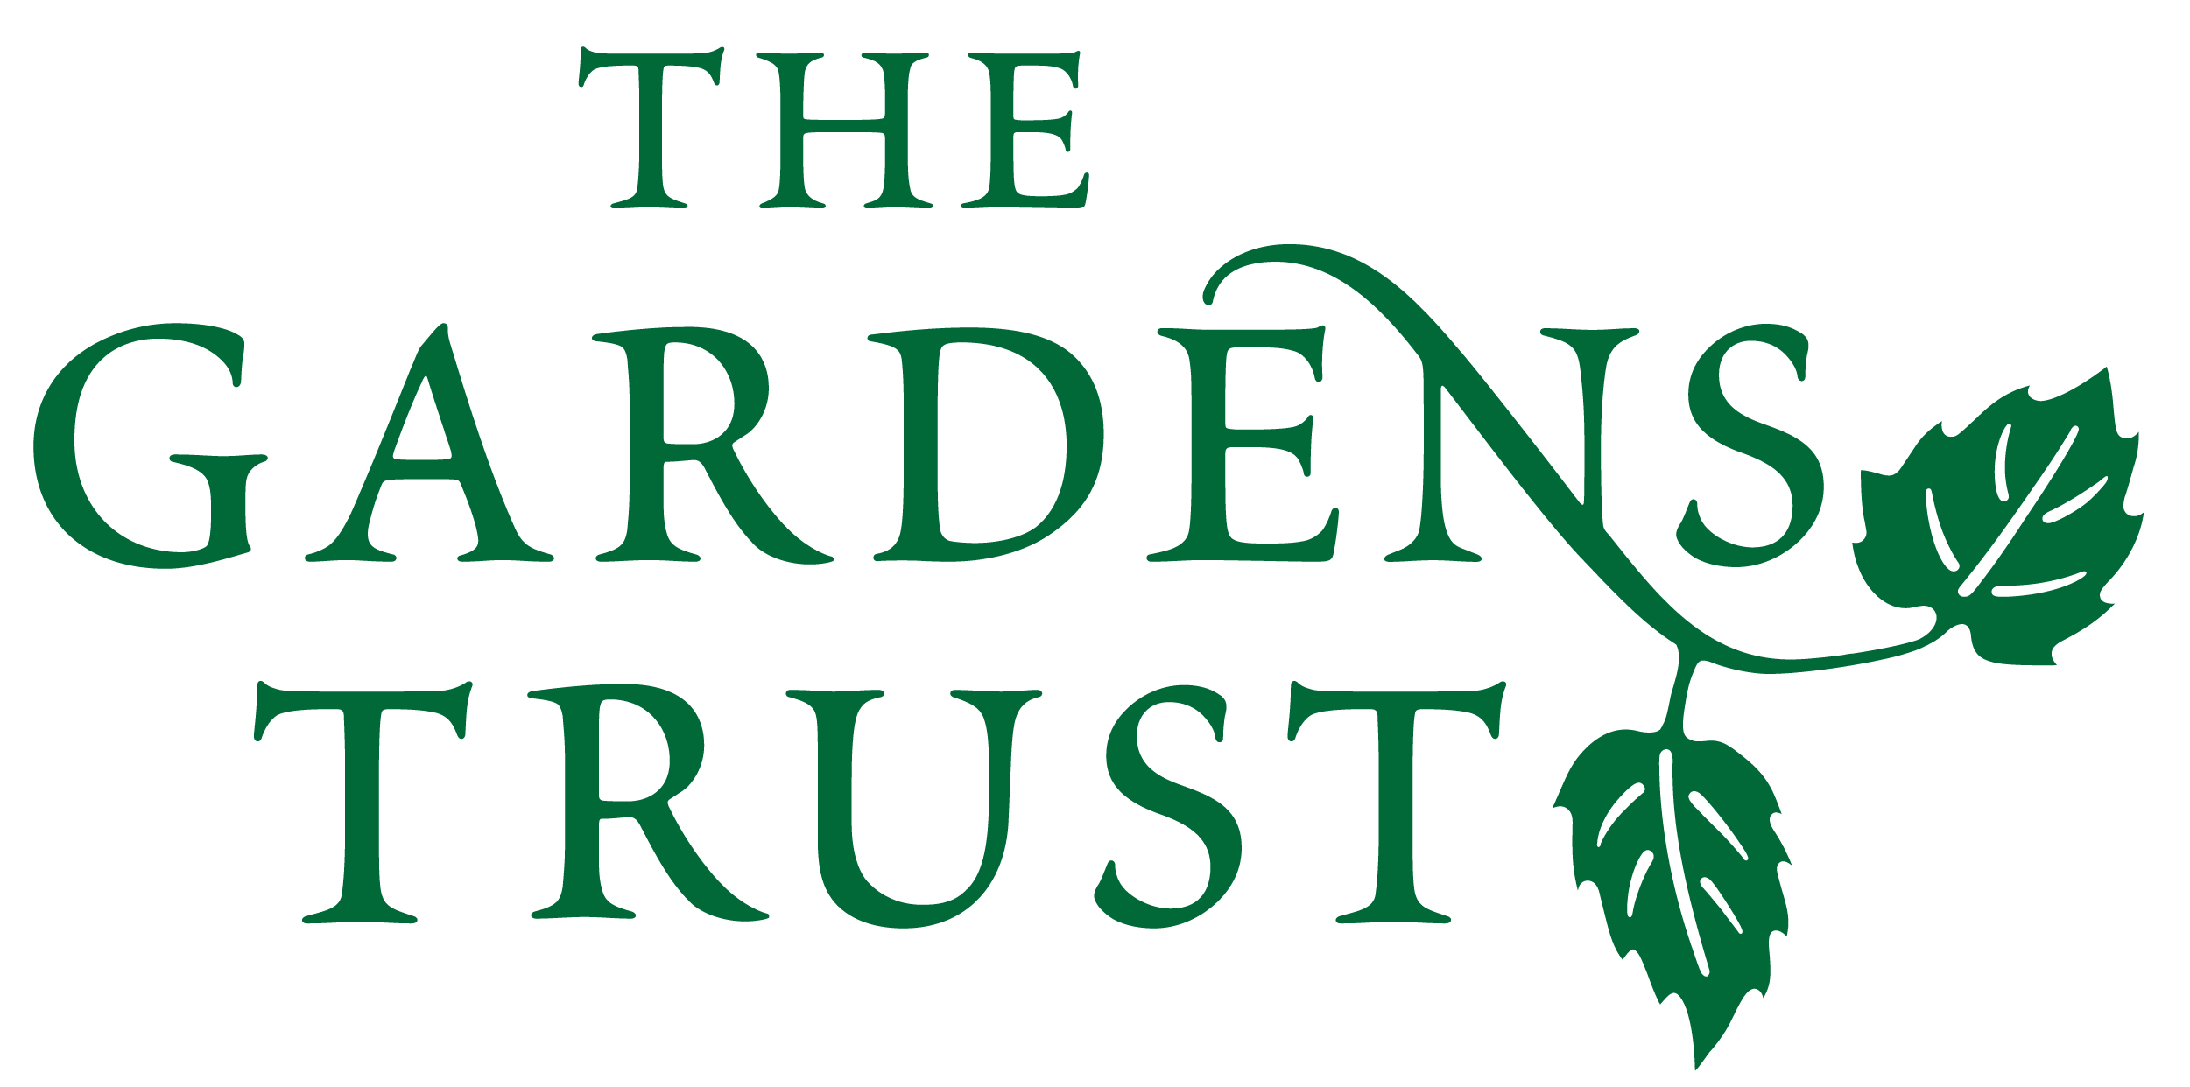

19th Annual Mavis Batey Essay Prize

2023

**Deadline for submissions is 6pm on Sunday 3rd September 2023**

Our annual essay competition is intended to encourage vibrant scholarly writing and new research, especially by those who have not yet had their work published. It is open to all students throughout the world registered with a *bona-fide* university or institute of higher education, or to those recently graduated from such an institution. Submissions must be in English and between 5,000 to 6,000 words and the only restriction on subject matter is that it must be of relevance to some aspect of garden history, which could include explorations of little-known gardens, or an aspect of botany, ecology, horticulture, archaeology, social history, architecture, design, art history or sculpture. The prize will consist of a cash sum of £500 plus free membership of The Gardens Trust for one year. If the winner is already a member of The Gardens Trust, their subscription will be renewed for a year. The winning entry will be considered for publication in ***Garden History***. The judging panel will consist of the Editor of ***Garden History*** and members of the Gardens Trust’s Education and Events Committee, and other invited outside academics. For short reports on previous winning entries etc, see: <http://thegardenstrust.org/research/prize/>.

The rules for submitting an essay are:

1. Authors should have *bona fide* student status at a university or other recognised qualification-awarding institution of higher or further education or have graduated from such an institution in 2021 or 2022.
2. The essay should be between 5,000 and 6,000 words in length, exclusive of endnotes, captions to illustrations and bibliography. Up to eight illustrations may be included. Essays longer than the permitted word count will not be considered.
3. The essay should be set out in the format recommended by ***Garden History,*** the journal of The Gardens Trust, with a short (200-300 word) abstract and endnotes, plus a bibliography of works consulted. Our submissions guidelines can be found at <http://thegardenstrust.org/wp-content/uploads/2016/07/00>_Garden_History_submissions_guide.pdf or see recent issues of ***Garden History. Garden History*** is available on-line at https://www.jstor.org/.
4. There are no restrictions on the subject matter except that it must be relevant to some aspect of garden history.
5. Applicants from any country may apply, but submissions must be in English.
6. Applicants **do not** have to be members of The Gardens Trust.
7. The essay must be submitted in electronic format as a PDF (.pdf). No more than 2 files should be sent.
8. The prize will be judged anonymously so please do not write your name in the text. The application form (with name, address and proof of student status, i.e. scanned copy of student card) should be completed and attached separately to your email.

Checklist:

* Essay
* Illustrations (no more than 8)
* Abstract
* Bibliography
* Check length
* Check it is as anonymous as possible
* There should be no appendices
* Don’t forget to include proof of status



19th Annual

Mavis Batey Essay Prize

Entry Form

Entry Form and Submission Details

Please return this form with your essay by 6pm on 3rd September 2023

to : essayprize@thegardenstrust.org

Name: (block capitals please)

Address:

Post code: Country:

phone: /mobile:

email:

**Student status:**

Institution of Study:

Department:

Student number:

**NB: do not forget to provide proof of student identity**

Title of submission:

Are you a member of The Gardens Trust or an affiliated County Gardens Trust? Yes/No

If your answer is ’No’, please tell us how you heard about The Gardens Trust Essay Prize?

When you have filled in this form, please add it to your email, either as a pdf or scan/photograph it.

This will only be revealed to the judges after the prize has been decided.