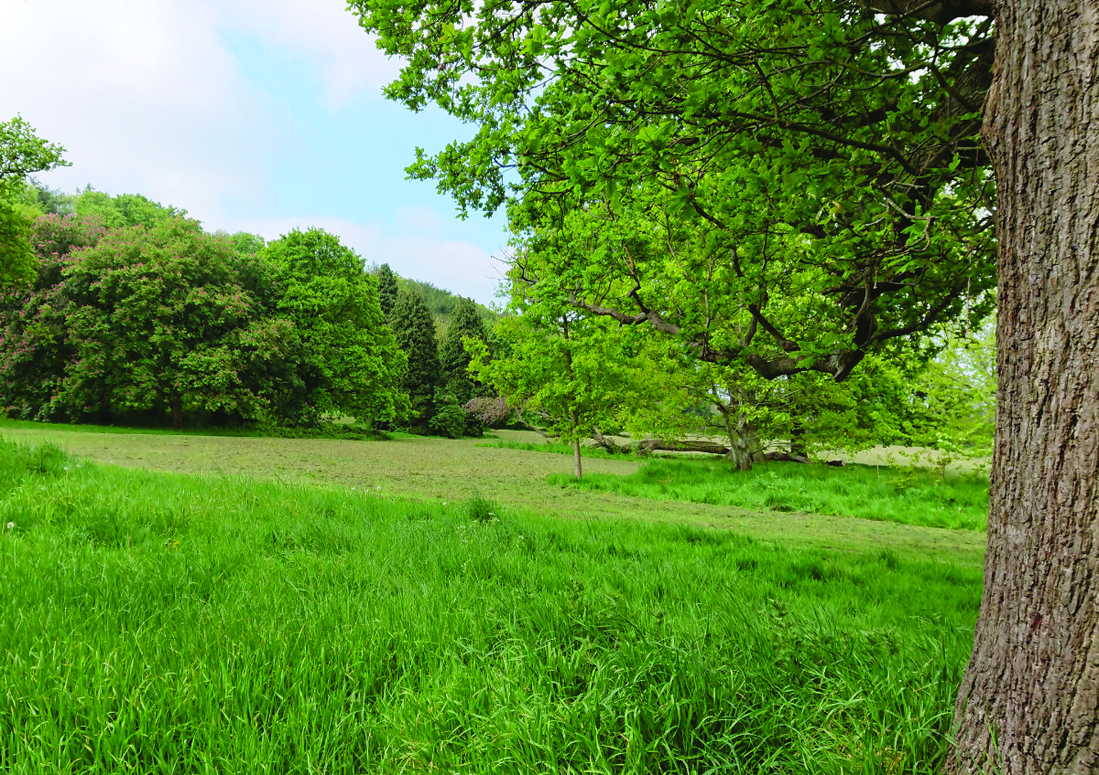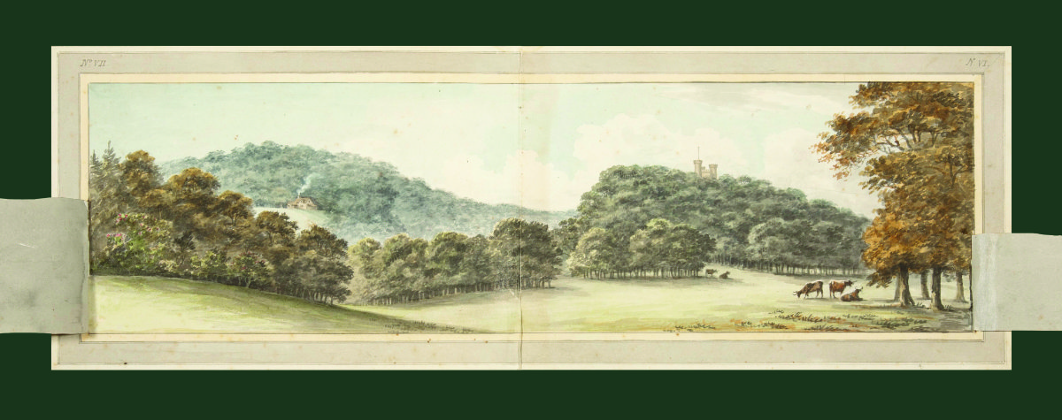

HUMPHRY REPTON

BLAISE CASTLE &

Then as Humphry Repton proposed it could be improved.

*Illustration courtesy of Bristol Culture, Blaise Museum*