CELEBRATING REPTON TIMELINE OF EVENTS 2018
MARCH
NORTHAMPTONSHIRE GARDENS TRUST
15.03.18 Wicksteed Park: A Celebrating Repton Talk The park’s story from Humphry Repton to Charles Wicksteed, and talk about recent Heritage Lottery Fund work https://sites.google.com/view/northamptonshiregardenstrust2/home

CELEBRATING HUMPHRY REPTON IN NORFOLK
20.03.18 Repton Red Book & Family Tree Exhibitions Humphry Repton and his impact in Norfolk through his legacy of ‘Red Books’ in the county. Also, a display on Repton’s family tree which showing the strong connections the Repton family had with East Anglia and particularly the historic town of Aylsham http://norfolk.humphryrepton.org.uk/
NATIONAL TRUST/CELEBRATING HUMPHRY REPTON IN NORFOLK
20.03.18 Repton Walks at Sheringham Park Regular volunteer led walks throughout the year taking in the views and structures of his most favourite work. Down the Repton designed arriageway with glimpses of the coastline before moving into the parkland. Throughout the year https://www.nationaltrust.org.uk/sheringham-park
BERKSHIRE GARDENS TRUST
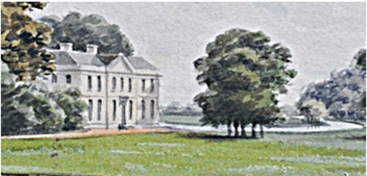
22.03.18 The Purley Red Book: A few days in the company of Anthony Morris Storer & Humphry Repton BGT Spring Lecture Ben Viljoen on the events surrounding Repton’s visit to Purley on Thames, the time he spent there with Anthony Morris Storer who had just purchased Purley Park, and the production of the Purley Red Book, one of the best preserved and finest of the Red Books https://www.berkshiregardenstrust.org/
BROADLAND DISTRICT COUNCIL, THE GARDENS TRUST & AYLSHAM PARISH CHURCH
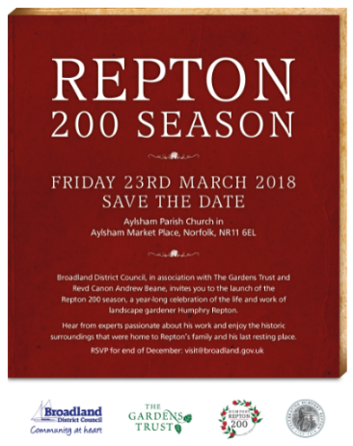
23.03.18 Save the Date; Launch of Repton200 Season of Celebrations
LONDON BOROUGH OF REDBRIDGE
23.03.18 Humphry Repton in Redbridge Talk by Georgina Green outlining the life and work of Humphry Repton in Redbridge, to mark the bi-centenary of his death
NATIONAL TRUST/CELEBRATING HUMPHRY REPTON IN NORFOLK
23.03.18 Repton and the Landscape of Attingham Walk How Humphry Repton changed the landscape of Attingham. Gentle strolls along the river and through the Park. Twice daily 11.00 and 14.00. Approx 1½ hours 3 miles max https://www.nationaltrust.org.uk/attingham-park
NATIONAL TRUST/BROADLAND DC/CELEBRATING HUMPHRY REPTON IN NORFOLK
24.03.18 Blickling Garden Tours featuring Repton links The National Trust’s Blickling Estate special garden tours on the links Blickling had with Humphry and especially his son, John Adey Repton, who became a well-known architect and landscape designer in his own right. Special artefacts linked with Repton and Blickling also on display. Throughout the year https://www.nationaltrust.org.uk/blickling-estate
YORKSHIRE GARDENS TRUST
24.03.18 Yorkshire Gardens Trust AGM 200 years to the day after Repton’s death Stephen Daniels will talk about Repton at Rudding Park where Repton produced a Red Book, now lost in c.1791 https://www.yorkshiregardenstrust.org.uk

LINCOLNSHIRE GARDENS TRUST
24.03.18 Humphry Repton Anniversary Walk Scrivelsby Court, Horncastle. Guided walk by Steffie Shields with Red Book https://sites.google.com/view/lincolnshiregardenstrust/home?authuser=0

FRIENDS OF CATTON PARK/ CELEBRATING HUMPHRY REPTON IN NORFOLK
25.03.18 Catton Park Exhibition and Guided Walk A special exhibition about the history of the park with a guided walk http://norfolk.humphryrepton.org.uk/
APRIL
CELEBRATING HUMPHRY REPTON IN NORFOLK
07.04.18 Repton Art Exhibition A special exhibition showcasing the paintings, drawings and photographs of local artists inspired by Repton, his life and landscapes. Also on a drawing of Wood Dalling Hall, on loan from Norfolk Museums Service http://norfolk.humphryrepton.org.uk/
MANNINGTON ESTATE/CELEBRATING HUMPHRY REPTON IN NORFOLK
15.04.18 Mannington Open Garden & Humphry Repton Watercolours Lord and Lady Walpole’s special opening of their Mannington gardens, with an opportunity to view their original Humphry Repton drawings of Aylsham Market Place. Also, the opening of the 2018 exhibition The Garden Exhibition, a historical review of Walpole Gardens, on view in the Stable Yard Gallery http://norfolk.humphryrepton.org.uk/
TATTON PARK/CHESHIRE EAST
18.04.18 Repton Rides, Tatton Park Repton’s design of 1792 on a 2 mile cycle ride led by Tatton’s head gardener www.tattonpark.org.uk
NATIONAL TRUST/CELEBRATING HUMPHRY REPTON IN NORFOLK
19.04.18 The College Series: Repton at Attingham How Humphry Repton helped shape the landscape of Attingham you see today. Richard Wheeler, National Specialist in Garden History for the National Trust explaining Repton’s ideas for improvement and showcasing the beautiful watercolours from Repton’s Red Book https://www.nationaltrust.org.uk/attingham-park
NORTHAMPTONSHIRE GARDENS TRUST
19.04.18 Landscapes of the Imagination: the art and gardens of Humphry Repton (1752–1818) Northamptonshire Gardens Trust Annual General Meeting followed by a talk by Keir Davidson https://sites.google.com/view/northamptonshiregardenstrust2/home
WOBURN ABBEY
21.04.18 Humphry Repton Study Day, Woburn Repton and his work by landscape historian Keir Davidson, with his most complete landscape and the Woburn Red Book, on display for the first time www.woburnabbey.co.uk

CELEBRATING HUMPHRY REPTON IN NORFOLK
22.04.18 Repton Bicentenary Choral Evensong Rededication of Humphry Repton’s grave following its recent restoration and the replanting of Repton’s rose garden
FRIENDS OF CATTON PARK/CELEBRATING HUMPHRY REPTON IN NORFOLK
22.04.18 Letters from Humphry Repton & other stories Exploration of the life and times of Humphry Repton through creative writing in the park where Repton started his career as a landscape designer. Examples of letters written between Repton and Robert Marsham of Stratton Strawless also available http://norfolk.humphryrepton.org.uk/
AVON GARDENS TRUST & GLOUCESTERSHIRE GARDEN AND LANDSCAPE TRUST
25.04.18 Repton Study Day: ‘by Nature so Romantic’ A celebration of the work of Humphry Repton; the last great landscape designer of the 18th century and bellwether of the 19th century garden. Repton’s designs for Leigh Court crystallise the transition from the Picturesque to the Gardensque https://www.avongardenstrust.org.uk/
NATIONAL TRUST/CELEBRATING HUMPHRY REPTON IN NORFOLK
27.04.18 Repton Lecture & Walk Richard Wheeler, the National Trust’s garden history specialist, at the home of Humphry Repton’s favourite work. Richard explored the life of Humphry Repton with a talk and guided walk highlighting the Repton features of his design for Sheringham Park https://www.nationaltrust.org.uk/sheringham-park
BEDFORDSHIRE GARDENS TRUST
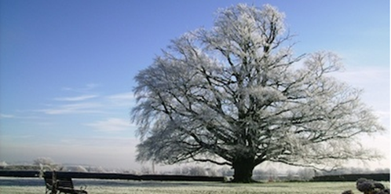
27.04.18 Repton in Bedfordshire Repton worked at Woburn Abbey, the Hazells in Sandy, Moggerhanger Park and Battlesden Park. Kate Harwood on Repton as a landscape artist, research on sites in Bedfordshire and tours of Moggerhanger http://www.bedsgardenstrust.org.uk/
MUSIC MATTERS
29.04.18 Ensemble East presents An Afternoon Concert: Repton’s Choice Music Matters introduced ENSEMBLE East, a new chamber orchestra based in East Anglia performing a range of works, written in Humphry Repton’s lifetime: the genius of Mozart, the prolific Joseph Haydn, known as the father of the symphony, and the passion of Felix Mendelssohn http://musicmattersservices.co.uk/
MAY
RHS/WRITTLE COLLEGE
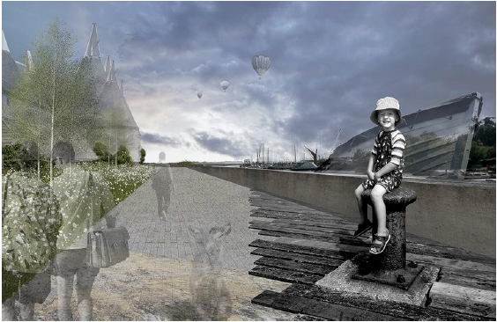
03.05.18 Rethinking Repton Presenting the results of a collaboration between RHS Libraries and Writtle University College, exhibition displaying original Repton materials from RHS Libraries collections alongside responses from Landscape Architecture and Garden Design students 03.05.2018-22.06.2018 Lindley Library, London www.rhs.org.uk/libraryevents
SALING GROVE
06.05.18 Repton and Late Georgian Society Exhibition about Repton travelling across the country for clients and friends; from The Portland Whigs to Prime Minster William Pitt; from the Prince of Wales to Duke of Bedford; from theoretical challenges to his landscape designs to Jane Austen The Orangery, Saling Grove, Great Saling, Essex http://www.salinggrove.com
YORKSHIRE GARDENS TRUST
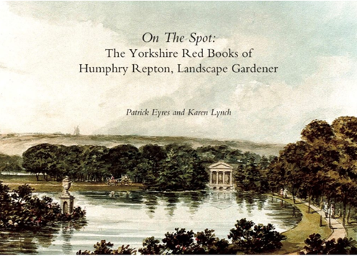
08.05.18 Repton in Yorkshire Book Launch Launch of new book on Repton in Yorkshire by Dr Patrick Eyres and Karen Lynch followed by lecture at the Yorkshire Museum, York https://www.yorkshiregardenstrust.org.uk
MUSIC MATTERS/CELEBRATING HUMPHRY REPTON IN NORFOLK
12.05.18 Performance Matters Music presents An Evening Concert: Come into the Garden – A Gardener’s Delight A concert of garden related music and poetry as part of the Repton 200 Season. Also on display the original play of ‘The odd whims, or, Two at a time; a comedy in five acts by Humphry Repton, courtesy of Norfolk Record Office http://norfolk.humphryrepton.org.uk/
CELEBRATING HUMPHRY REPTON IN NORFOLK
12.05.18 Garrick Green Infant School Exhibition Catton Park exhibition at Garrick Green Infant School. Also a display of miniature gardens created by the students of Garrick Green School but inspired by Humphry Repton http://norfolk.humphryrepton.org.uk/
SCOTLAND’S GARDEN AND LANDSCAPE HERITAGE
12.05.18 SGLH: A Repton Celebration at Dunfermline Broomhall House, Charlestown, Dunfermline Humphry Repton – Theatrical Self-promotion through Red Books and Printed Publications by Patrick Eyres; The Valleyfield Red Book by Christopher Dingwall; Guided tour of Valleyfield www.sglh.org
CELEBRATING HUMPHRY REPTON IN NORFOLK
13.05.18 Worship in the Park Church of St Margaret, Old Catton,a special service held in the beautiful Repton landscape of Catton Park, with live music performed by a brass band http://norfolk.humphryrepton.org.uk/
CELEBRATING HUMPHRY REPTON IN NORFOLK
18.05.18 The Humphry Repton Memorial Lecture Stephen Daniels, Professor of Cultural Geography, University of Nottingham, and leading international Repton expert, the first biennial Repton Memorial Lecture looking at the way that Repton has been interpreted and commemorated.. In addition, Repton’s beautiful drawing Celebration of Peace in Aylsham, on loan from Lord and Lady Walpole. Aylsham Parish Church http://norfolk.humphryrepton.org.uk/
BUCKINGHAMSHIRE GARDENS TRUST
19.05.18 Walk round Chalfont Park, Buckinghamshire Chalfont Park a little known gem, just off the A413 near Gerrards Cross, which has suffered from neglect in recent years, despite being an important landscape. The gardens were created over a period of 150 years by Lancelot ‘Capability’ Brown, Humphry Repton and Edwin Lutyens http://www.bucksgardenstrust.org.uk
KENT GARDENS TRUST
20.05.18 “The Unlikely Genius of Humphry Repton” by John Phibbs Kent Garden Trust Spring Lecture given by renowned garden historian John Phibbs, Riverhill House, Sevenoaks and tour of garden https://www.kentgardenstrust.org.uk
FRIENDS OF CATTON PARK/CELEBRATING HUMPHRY REPTON IN NORFOLK
20.05.18 Create a Repton ‘Red Book’ for Catton Park Catton Park was Repton’s first commission, but no ‘Red Book’ exists. An opportunity to paint and draw in a Repton landscape. Repton’s original drawing of Catton Park, also be available to view http://norfolk.humphryrepton.org.uk/

NORFOLK RECORD OFFICE/CELEBRATING HUMPHRY REPTON IN NORFOLK
22.05.18 Behind the Scenes Garden Themed Tour Norfolk Record Office series of tours exploring areas usually out of bounds to members of the public, including the strong rooms and conservation studio. Commemorated Humphry Repton’s bicentenary by exploring documents showcasing some of Norfolk’s impressive gardens http://norfolk.humphryrepton.org.uk/
MUSIC MATTERS/CELEBRATING HUMPHRY REPTON IN NORFOLK
23.05.18 Sound the Trumpet: Music from the Baroque to 21st century A selection of exciting music arranged for trumpet and organ from Jeremiah Clarke’s Trumpet Voluntary to the Haydn Trumpet concerto as heard during Humphry Repton’s lifetime, and onwards to present day http://norfolk.humphryrepton.org.uk/
YORKSHIRE & NORTHUMBRIA GARDENS TRUSTS
23.05.18 Visit to Mulgrave Castle Visit to Mulgrave Castle where Repton produced a Red Book in 1793. Members of Yorkshire or Northumbria Gardens Trust only https://www.yorkshiregardenstrust.org.uk
NORFOLK GARDENS TRUST
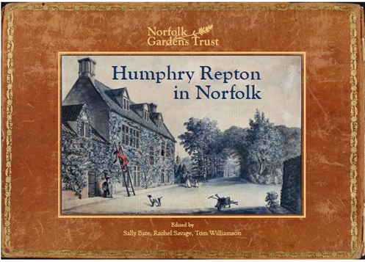
29.05.18 Humphry Repton in Norfolk – Book Launch Norfolk Gardens Trust launch of new book ‘Humphry Repton in Norfolk’ St Michael’s Church, Aylsham www.norfolkgt.org.uk
JUNE
WESTON PARK
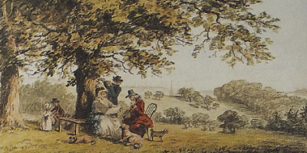
01.06.18 Repton Exhibition In The Granary Art Gallery Weston Park, Shropshire. An exhibition about Humphry Repton and his significance as a landscape gardener including his Red Book, of ‘before’ and ‘after’ watercolours of his proposals for Babworth, Nottinghamshire, generously loaned to the Weston Park Foundation by its private owner http://www.weston-park.com
NORFOLK GARDENS TRUST & THE GARDENS TRUST CONFERENCE
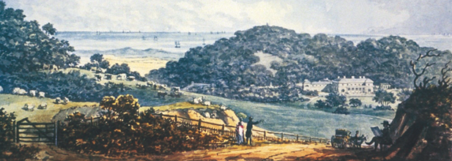
01.06.2018 - 02.06.2018 The Prophet in his own Country: 3 Repton gardens in Norfolk To mark the bi-centenary of the death of Humphry Repton, the Norfolk Gardens Trust in association with The Gardens Trust two-day conference focused on Sheringham Hall and Park, Barningham Hall and Honing Hall http://thegardenstrust.org/event/prophet-country-3-repton-gardens-norfolk/
CELEBRATING HUMPHRY REPTON IN NORFOLK
02.06.18 Aylsham Gardener’s Market a gardening theme, in honour of Humphry Repton, and a treat for all gardeners and non-gardeners alike. Also, the Repton exhibition in Aylsham Parish Church http://norfolk.humphryrepton.org.uk/
FRIENDS OF CATTON PARK/CELEBRATING HUMPHRY REPTON IN NORFOLK
04.06.18 Catton Park Guided Walk with Tom Williamson Dr Tom Williamson, professor of landscape history and archaeology at the University of East Anglia, guided walk around Catton Park, Repton’s first commission as a landscape gardener http://norfolk.humphryrepton.org.uk/
RHS
04.06.18 Repton in his own words A special viewing of the exhibition ‘Rethinking Repton’ and an opportunity to go behind the scenes at the RHS Lindley Library. Humphry Repton’s ‘Red Books’ and original writings, these tours telingl his story in his own words https://www.rhs.org.uk/shows-events/viewevent?EFID=1000&ESRC=CMS
YORKSHIRE GARDENS TRUST
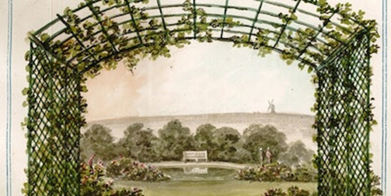
05.06.18 On the Spot: the Yorkshire Landscapes of Humphry Repton Free illustrated talk by Dr Patrick Eyres at Wakefield History Centre and a chance to see Repton’s Red Book for Oulton Hall https://www.yorkshiregardenstrust.org.uk

SUFFOLK GARDENS TRUST
06.06.18 Repton Study Day at Henham Park Suffolk Gardens Trust Study Day to celebrate Repton’s bicentenary. Speakers Hektor Rous, George Carter, Laura Mayer and Edward Martin www.suffolkgardenstrust.org
BURLINGHAM GARDENS
10.06.18 Burlingham Open Gardens Over twenty gardens in Main Road and The Green (linked by the woodland path past St Andrew’s Church) including an opportunity to see ‘Repton’s Gate’ in the walled garden at Burlingham Hall http://www.burlinghamhall.co.uk
SUSSEX & KENT GARDENS TRUSTS
16.06.18 Repton Study Day, Brightling Park Study day, one part of the Gardens Trust’s national celebration of the life and work of Humphry Repton. During his lifetime (1752-1818), he worked on hundreds of estates across England including Brightling Park originally known as Rose Hill http://www.sussexgardenstrust.org.uk
FRIENDS OF CATTON PARK/CELEBRATING HUMPHRY REPTON IN NORFOLK
17.06.18 Repton & Catton Park: 200 Years On Catton Park was one of Humphry Repton’s early commissions. Creation of images using digital cameras showing how the park has evolved since Repton’s day http://norfolk.humphryrepton.org.uk/
HEYDON, NORFOLK
17.06.18 Heydon Open Gardens A wonderful opportunity to explore the gardens of Heydon Hall and a variety of gardens in historic and picturesque Heydon village. Also on display in the church, Humphry Repton’s drawing of Heydon Hall, provided by Norfolk Museum Service https://www.facebook.com/heydonvillage
THE KEEP, BRIGHTON
21.06.18 Humphry Repton and his designs for the Royal Pavilion Talk by Alexandra Loske about Repton’s plans for the Royal Pavilion. ‘Designs for the Pavillon at Brighton’ and the Red Book of Heathfield on display https://www.thekeep.info/
PENTILLIE, CORNWALL
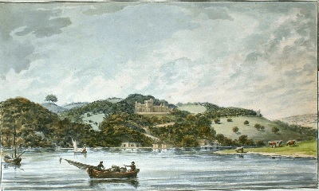
22.06.18 Repton Garden Walk, Floral Workshop & Lunch Celebrating Humphry Repton at Pentillie Castle, Cornwall with a guided walk through the Repton designed Pentillie gardens, a two hour floral workshop with artisan florist Miranda Hackett, delicious lunch and opportunity to view Pentillie’s Repton Red Book www.pentillie.co.uk

NORTHAMPTONSHIRE GARDENS TRUST & THE GARDENS TRUST
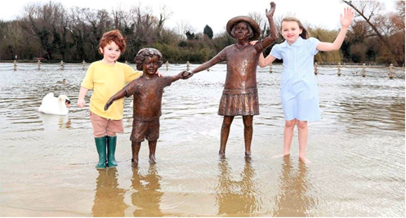
30.06.18 Gardens Trust Celebrating Repton Family Picnic 2018 18th century games, gardening fun, cake and a train ride! The Gardens Trust Family Picnic 2018 with Northamptonshire Gardens Trust at Wicksteed Park to celebrate the bicentenary of Humphry Repton http://thegardenstrust.org/event/gardens-trust-family-picnic-2018/
JULY
GLEMHAM HALL
08.07.18 Repton Open Gardens at Glemham Hall part of Repton 200, Glemham Hall in Suffolk will be opened its glorious gardens to celebrate Humphry Repton’s work on the bicentenary of his death https://www.glemhamhall.co.uk
WARLEY WOODS
08.07.18 Warley Woods Picnic in the Park The largest community celebration of the year involving live music, fun family activities and joined by special guest, Humphry Repton. Visitors able to learn more about how Warley Woods came to be the beautiful site it is today https://www.warleywoods.org.uk/
NATIONAL TRUST/ CELEBRATING HUMPHRY REPTON IN NORFOLK
14.07.18 History comes to life at Sheringham Park A journey back in time to see the history of the Sheringham estate come to life. The influence of landscape gardener Humphry Repton on Sheringham Park, and a look at the role of Sheringham Park in the defence of the North Norfolk coastline during World War 2 https://www.nationaltrust.org.uk/sheringham-park

AUGUST
ASHRIDGE HOUSE CONFERENCE
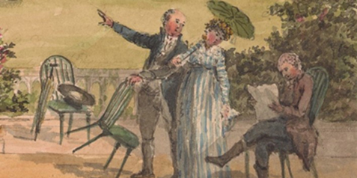
10.08.2018 - 11.08.2018 Celebrating Humphry Repton Conference to cast new light on the life and works of Humphry Repton and consider his legacy in landscape design. Series of lectures on the first day followed by a tour of the gardens at Ashridge. The second day, a similar format with a series of lectures in the morning followed in the afternoon by a tour of Woburn Abbey gardens led by Gardens Manager Martin Towsey www.ashridge.org.uk
BENSLOW MUSIC, HITCHIN
18.08.18 On the Spot One day course led by Judy Tarling to examine Repton’s place in garden history, get to know him as a man and look at his relationship with his clients and other landscape gardeners of the 18th century https://www.benslowmusic.org
SEPTEMBER
NATIONAL TRUST/ CELEBRATING HUMPHRY REPTON IN NORFOLK
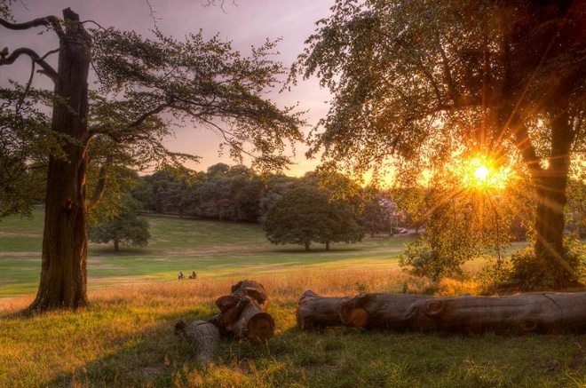
01.09.18 International Garden Photographer of the Year the world’s premier competition and exhibition specialising in garden, plant, flower and botanical photography, returns again to Sheringham Park. Showcasing brand new images from all over the world including, as part of his 200 year anniversary, a section on Humphry Repton landscapes https://www.nationaltrust.org.uk/sheringham-park

RHS HARLOW CARR

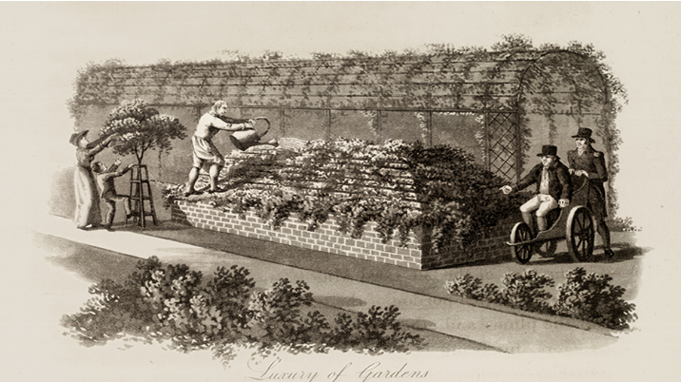
01.09.18 Library Display: Introducing Mr Repton exploring the work and life of Humphry Repton through interpretive exhibition panels and biographical works from RHS Libraries Collections, including facsimile copies of his Red Books for Sheringham Hall, Anthony House, and Attingham Park https://www.rhs.org.uk/gardens/harlow-carr/
THE MUSEUM OF FINE ARTS, HOUSTON
03.09.18 Celebrating Humphry Repton Rienzi’s curatorial assistant Misty Flores in an exploration of the great English landscape architect Humphry Repton (1752-1818) on the bicentenary of his death at the Museum of Fine Arts, Houston https://www.mfah.org/visit/rienzi/
HERITAGE OPEN DAYS/CELEBRATING HUMPHRY REPTON IN NORFOLK
06.09.18 Catton Park Heritage Open Days Hayman open with an exhibition about the history of the Park and exhibits from the creative afternoons held over the summer in the Park http://norfolk.humphryrepton.org.uk/
CELEBRATING HUMPHRY REPTON IN NORFOLK
06.09.18 Aylsham Parish Church Heritage Open Days Repton Rose Tour around the Church and churchyard and visit to Humphry Repton’s final resting place — a spot he chose himself http://norfolk.humphryrepton.org.uk/
BERKHAMSTEAD LOCAL HISTORY AND MUSEUM SOCIETY/HERITAGE OPEN DAYS
06.09.18 & 13.09.18 Repton’s Ashridge: two guided tours of the gardens at Ashridge Two guided tours in the gardens of Ashridge house, 6th September and 13th September led by the Gardens Manager. Arranged as part of celebrations of Repton’s bi-centenary https://berkhamsted-history.org.uk/
THE GEORGIAN GROUP
06.09.18 ‘All Around is Fairy Ground’: Repton and the Regency Garden To celebrate the bicentenary of Humphry Repton, The Georgian Group evening lecture at Keats House, Hampstead, given by Dr. Laura Mayer tracing Repton’s designs from their Picturesque beginnings to the progressive Gardenesque style https://georgiangroup.org.uk
MOGGERHANGER PARK
07.09.18 The Soane Lecture. Modesty or Display? The place of flowers in the gardens of Moggerhanger Park Lecture by renowned historic landscaper John Phibbs. How beautiful vistas were created in Georgian England https://www.moggerhangerpark.com/
THE MOSELEY SOCIETY
09.09.18 Bicentenary Poster Exhibition to commemorate Repton, who died in 1818,
and his work in Moseley on display in the Moseley Exchange, by the Post Office http://moseley-society.org.uk/wp-content/uploads/2018/07/Moseley-Society-Summer-Newsletter-2018-.pdf
THE MOSELEY SOCIETY/HERITAGE OPEN DAYS
09.09.18 Moseley Park Repton theme, icehouse and dovecote open http://moseley-society.org.uk/wp-content/uploads/2018/07/Moseley-Society-Summer-Newsletter-2018-.pdf
WARLEY WOODS COMMUNITY TRUST
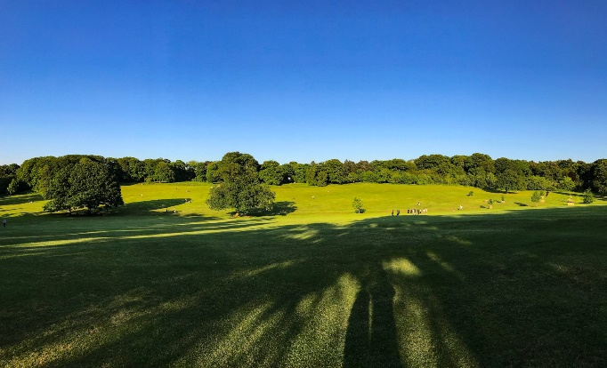

13.09.18 Guns and Roses: Humphry Repton at Warley Woods A specially devised talk on Humphry Repton’s design for Warley Woods for Samuel Galton Junior, local entrepreneur, member of the lunar society, quaker and gun-maker. Devised and delivered by Advolly Richmond. Lightwoods House, Smethwick https://www.warleywoods.org.uk/
FRIENDS OF THE BOTANICAL GARDENS, SHEFFIELD, UNIVERSITY OF SHEFFIELD & THE GARDENS TRUST CONFERENCE
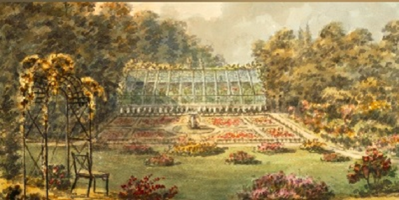
20.09.18 - 21.09.2018 Repton Conference, Sheffield Botanical Gardens Two-day conference exploring the often-overlooked aspects of Reptonian and late Georgian horticulture, with speakers including Camilla Beresford, Mark Laird, Kate Felus, Brent Elliott, Jan Woudstra and Patrick Eyres, plus a tour of the nearby Repton landscape at Wentworth Woodhouse
THE GARDENS TRUST BIRMINGHAM LECTURE
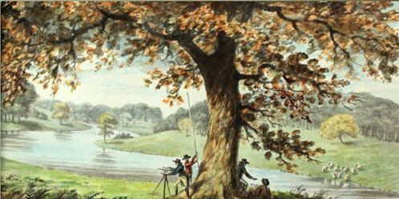
26.09.18 Revealing Repton: Approaches to the Art of Landscape Gardening Stephen Daniels, author of Humphry Repton: Landscape Gardening and the Geography of Georgian England (1999), examining the way that Repton has been interpreted and commemorated www.thegardenstrust.org
OCTOBER
HEREFORD AND WORCESTER GARDENS TRUST
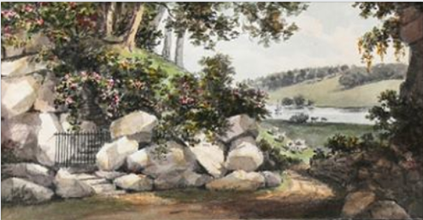
06.10.18 ‘In the Enemy’s Quarters’ – Repton in the West Midlands An Exhibition by Hereford & Worcester Gardens Trust to celebrate the bi-centenary of the death of Humphry Repton (1752- 1818) and his work. The Art Gallery, Broad Street, Hereford. Entrance free and illustrated catalogue available. Three Red Books on display including Hewell Grange http://www.hwgt.org.uk
YORKSHIRE & NOTTINGHAMSHIRE GARDENS TRUSTS
10.10.18 Visit to Langold Study day looking at Langold where Repton worked, and neighbouring Firbeck. Members of Yorkshire or Nottinghamshire Gardens Trust only https://www.yorkshiregardenstrust.org.uk
FRIENDS OF BRUNSWICK SQUARE
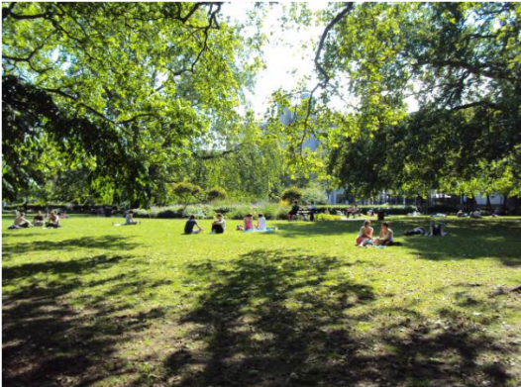
17.10.18 Repton’s London Squares Friends of Brunswick Square talk, UCL School of Pharmacy, Brunswick Square by Susan Jellis, who contributed a chapter to the LPGT book, Repton in London https://bloomsburysquares.wordpress.com/brunswick-square/friends-of-brunswick-square/
OXFORDSHIRE GARDENS TRUST
19.10.18 Repton’s Legacy – The Red Books Oxfordshire Gardens Trust: Lecture by Jane Bradbury about the pervading influence of the Red Books https://ogt.org.uk
KENT GARDENS TRUST
22.10.18 Repton Study Day at Cobham Hall Featuring a keynote address from Professor Stephen Daniels, and further contributions from those involved with the restoration of Cobham Hall https://www.kentgardenstrust.org.uk
RHS HYDE HALL
29.10.18 Garden Display: Rethinking Repton RHS Libraries collaboration with students from Writtle University College taking a fresh look at Repton’s gardening principles to respond to their own public landscape design projects. Garden Display featuring the students’ final project designs, with their own take on Repton’s famous ‘before and after https://www.rhs.org.uk/gardens/hyde-hall/
NOVEMBER
THE GARDEN MUSEUM & THE GARDENS TRUST
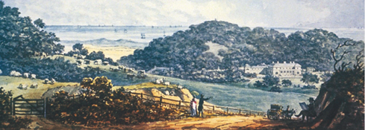
05.11.18 Some surprising things about Humphry Repton A one-day Symposium, a joint event between the Garden Museum and the Gardens Trust and a highlight of the ‘Celebrating Repton’ year; County Gardens Trusts researchers from across the country presenting illustrated talks on their research findings http://thegardenstrust.org/event/repton-symposium-garden-museum/ https://gardenmuseum.org.uk/
JANUARY 2019
PAUL MELLON CENTRE & THE GARDEN MUSEUM
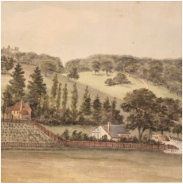
31.01.19 Repton Revived: The Landscape Gardener’s Legacy and Influence Symposium exploring how Repton and his work have been variously recalled, restored and refashioned in the two centuries from the nineteenth century to the present https://www.paul-mellon-centre.ac.uk

