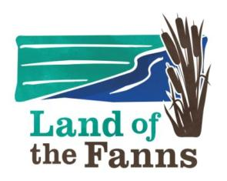

**LAND OF THE FANNS: KNOW IT LOVE IT**

**HANDOUT: List and Explanation of Acronyms we may use and you may want to know**

**CB300:** ‘Capability Brown’ 300 anniversary of his birth:UK-wide Project

**CMP:** Conservation Management Plan

**EGT:** Essex Gardens Trust

**ERO**: Essex Record Office (archives in Chelmsford)

**EWT:** Essex Wildlife Trust

**GT:** (The) Gardens Trust

**HE:** Historic England (was part of English Heritage)

**HER:** Historic Environment Record

**LCAP**: Landscape Conservation Action Plan (There is an LoF LCAP which is full of information! It is on-line via the website for Thames Chase, the links on the right hand side of the Land of the Fanns Landscape Partnership Scheme. )

**LoF:** Land of Fanns

**LPGT:** London Parks and Gardens Trust

**NE:** Natural England

**NHL (E):** National Heritage List for England

**P&G:** Park and garden

**PMP:** Parkland Management Plan

**RPG**: Register of Parks and Gardens (now part of NHL)

**SoS:** Statement of Significance

**TPO:** Tree Preservation Order

**WG:** Walled Garden (!)