**Land of the Fanns: The Know It, Love It Project**

*\*This text is based on material provided by Essex Gardens Trust (essexgardenstrust.org.uk) as part of their publication ‘A Gazetteer of Sites in Essex associated with Humphry Repton’,* published 2000, edited by Fiona Cowell and Georgina Green, revised by Jill Plater and Georgina Green 2018 (awaiting publication).*

**Note the clear way it has been laid out!**

|  |  |
| --- | --- |
| **Name** | **STUBBERS**, North Ockendon London Borough of Havering, |
| **OS grid reference** | TQ 576 847 |
|  |  |
| **Designer: Repton Red Book** | For Client William Russell, 1796, fire damaged and partly illegible. (Albert Sloman Library, University of Essex) . Also in Peacock’s Repository 1804) |
| **Historic England Registered** | No |

**History of site and family**

Stubbers earliest claim to fame is as the home of William Coys the plantsman and botanist, who by the end of the sixteenth century had established his garden as an important centre for the culture of rare and interesting plants. *Yucca gloriosa* first flowered at Stubbers.

Stubbers was sold out of the Coys family in 1642, and thereafter passed through several owners until it was bought in 1689 by Sir William Russell.

His great grandson William inherited the estate in 1787 and lived there until his death in 1810.

The property had been enlarged and improved during the course of the eighteenth century, but many of the walls built in William Coys’ time were still standing when the designer Humphry Repton was called in. (see Chapman and André 1777 for pre Repton)

**Repton’s design suggestions**

* Most of the walls should be retained ‘in defiance of modern taste as there was no great prospect to compensate for the loss of their security and shelter, and distant hills are better viewed through a small opening than a large one.
* Nevertheless, the walls should be hidden by plantations, arranged like the wings of a stage set.
* The lime walk should also be spared, again contrary to fashion, for its Gothic associations and the shady walk it provided in the heat. An extra wall should be built to ‘make the kitchen garden intire’.
* The road on the east boundary should be diverted.

**Discussion of Red Book**

Repton’s main insistence in this Red Book is on ‘comfort rather than prospect’, showing him at his most pragmatic. The site of Stubbers did not lend itself to sweeping away all the enclosures of the old garden layout to make a small landscape park; instead Repton retained much of what was already there to create the illusion of enticing prospects and open spaces.

Nevertheless, . . . his illustration of the view from the house towards the temple (see illustration next page), described as ‘an anticipation of what may be expected after a lapse of only two or three seasons’ looks very optimistic.

The road that Repton suggested should be diverted was moved in 1814, thus giving the house more space to the west, which by the mid nineteenth century had been incorporated into the park.

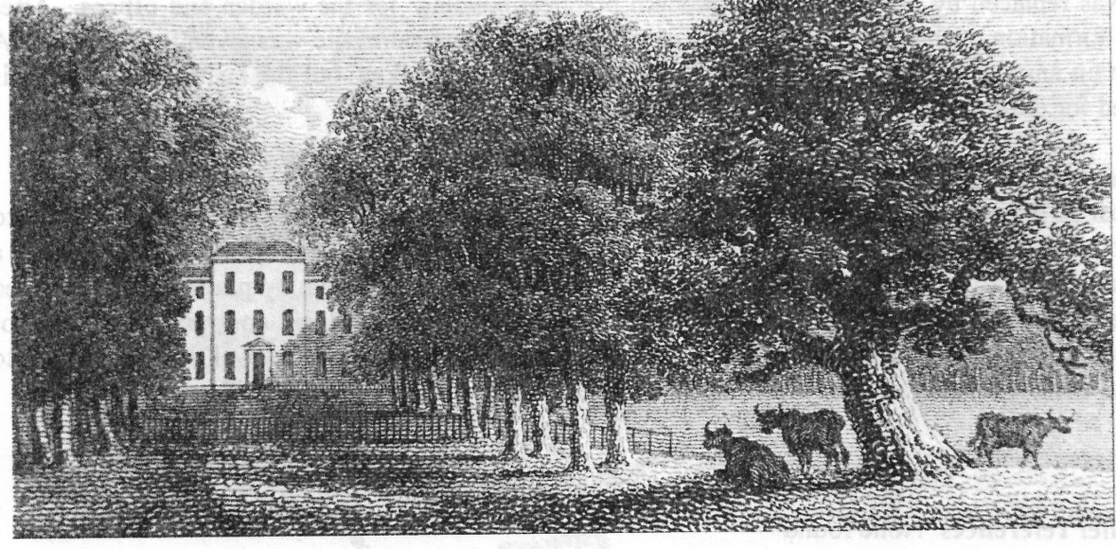

Engraving of Stubbers after Repton from *The Polite Repository* 1804 (Courtesy of the Nigel Temple Collection, The Gardens Trust)

**1810** William Russell (who had consulted Repton) died in **1810.**

**Essex Education Cttee 1947** Stubbers remained in the Russell family, through a sideways inheritance, until in 1947 the house, by then in bad repair, was sold to the Essex Education Committee for use as a Youth Centre.

**House Demolished:** The outbuildings were demolished in 1954, but the house itself survived until 1960, when it was replaced by a typical sixties ‘modern practical building’ for the warden and offices.

After the formation of the London Boroughs in 1965, the Stubbers camp site was given to Havering. A certain amount of restoration of the old walls has been undertaken.

**Supporting material used by EGT for the history etc**

*Maps*

Chapman and André 1777. Comparison with the Tithe Map shows which walls were demolished.

OSD 1799

Tithe Map 1841(Essex Record Office: D/CT 260)

2nd. edition 25” OS, surveyed 1864, revised 1895 (see map)

*Documentary evidence*

Road diversion order, 1814 (Essex Record Office: Q/RHi 3/76)

*Contemporary pictorial evidence*

Drawing entitled ‘Stubbers the seat of John Russell Esq’, 1810-25 (Essex Record Office: Mint Binder)

**Printed Sources**

Red Book for Stubbers, 1796 (Albert Sloman Library, University of Essex)

VCH Vol.VII, 1978

Val Body, *Stubbers: a short history*, (Havering Libraries 1989)

*Transactions of the Essex Archaeological Society*, New Series 21, 1937