
Historic Landscape Project

Social Media Handout

Why use social media?
- Infinite readership – massive marketing potential (Even if your own Facebook page only has 40 Likes (followers), you can post something on it and ask for people to Like and Share, and if it captures their imagination, within 12 hours it can have been seen by 750 people. Brilliant free advertising – the cost of the equivalent stamps would be immense!)
- Reaching a new audience – often hear ‘but none of our members would use social media’ and this is agreed, but it is still a brilliant tool for reaching a new audience
- Shows users to be a presence in the modern world – for example, HLPOs tweet about a forthcoming meeting with Historic Environment Record teams, which they pick up, and it heralds before we get there that we and the CGTs are dynamic modern people who understand how the bigger, professional organisations in the sector need to operate
- Genuine ‘business’ is being done via social media, why miss out?

Whether or not pursue your own social media presence, do at least find the Historic Landscape Project at:

Twitter: @leapthehaha
Facebook: www.facebook.com/historiclandscapeproject

Twitter

Helpful Resources
These websites might be useful:
http://www.wikihow.com/Use-Twitter
http://mashable.com/guidebook/twitter/

Terminology
There are certain words and jargon native to Twitter that are essential for understanding the network.
- Tweet: A 140-character message.
- Retweet (RT): Re-sharing or giving credit to someone else's tweet.
- Feed: The stream of tweets you see on your homepage, comprised of updates from users you follow.
- Handle: Your username.
- Mention (@): A way to reference another user by his username in a tweet (e.g. @leapthehaha). Users are notified when @mentioned. It's a way to conduct discussions in a public realm.
- Direct Message (DM): A private, 140-character message between two people. You can choose whether to accept a Direct Message from any Twitter user, or only from users you are following. You may only DM a user who follows you.
- Hashtag (#): A way to denote a topic of conversation in a larger linked discussion (e.g. #Obama). A hashtag is a discovery tool that allows others to find your tweets, based on topics. You can click on a hashtag to see all the tweets that mention it — even from people you don't follow.

Twitter has a great online glossary that you can refer back to, should you get mired in a vocab morass.

To set up a Twitter account:
- Make sure you set up a ‘generic’ type email address for your CGT eg shimmygardenstrust@gmail.com or similar – this can be useful for a lot of CGT work and the password and address shared amongst a number of ‘working’ members if wished.
- Go to https://twitter.com
- Under New to Twitter? Sign Up: Fill in the name of your Trust
- Fill in your email
- Create a password that you are happy to share with others if need be
- Click on ‘Create account’.
- Check through the info and suggestions it gives you – make any changes you want and then CHOOSE YOUR USERNAME.
- Keep your Username short if possible but to reflect your Trust if you can eg ShimmyGT.
- Choose ‘Create Account’.
- You are then likely to get a little introductory guide on screen like this:

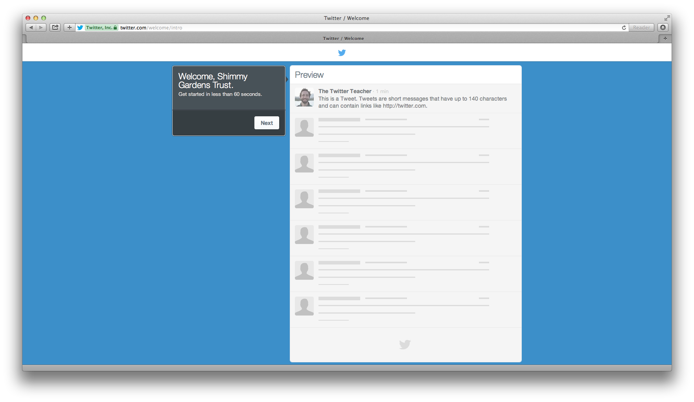
You can work through their introductory screens to familiarise yourself with it and create your account properly.

- The next screen suggests finding some people to follow. Search on leapthehaha to kick off with – click on Follow when it pops up - and you could also try searching with key words like ‘historic landscape’ or ‘capability brown’ too. You can see the name of the person or company with that account eg when you find @leapthehaha you can see it is run by ‘HLPO’ ie the Historic Landscape Project Officers. You can even click on their name to see their Twitter profile ie who they are. Find 4 more to follow. Each time you click on ‘Follow’ you’ll see their latest status update appear.

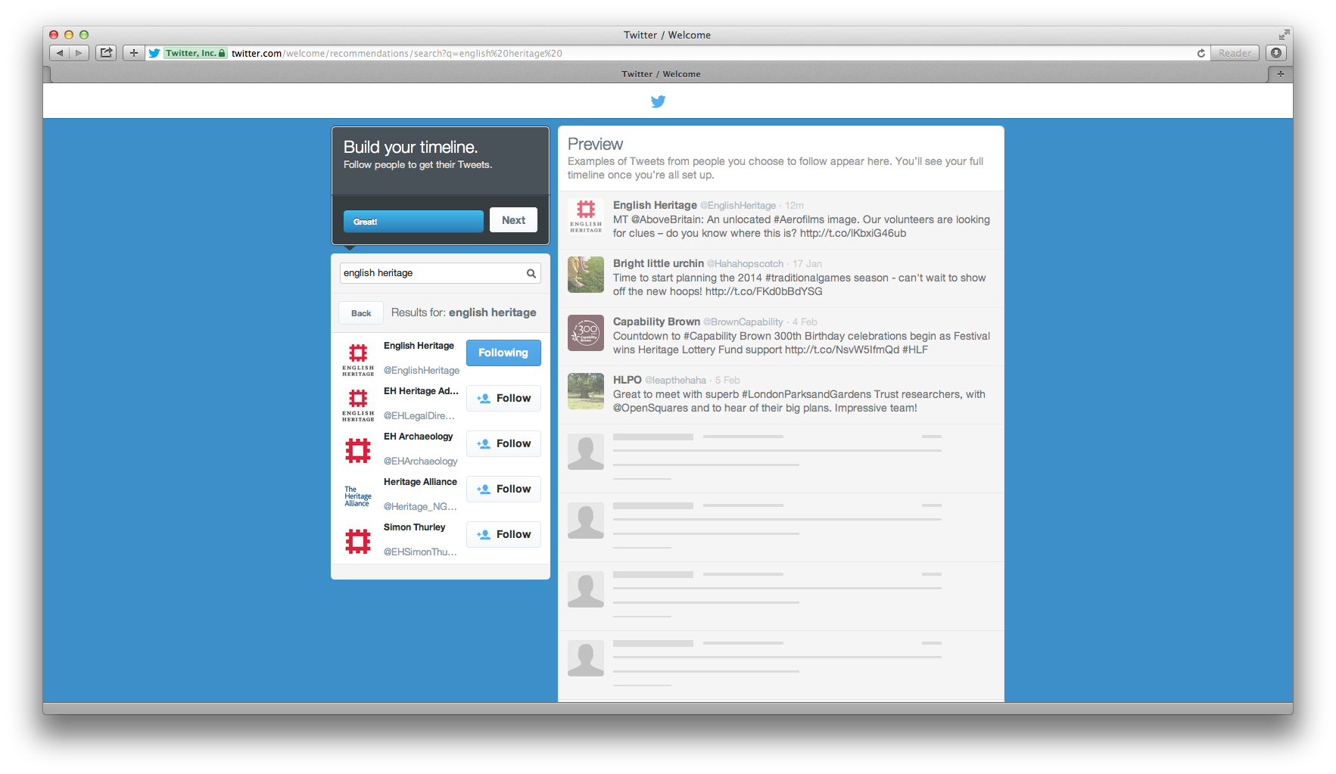
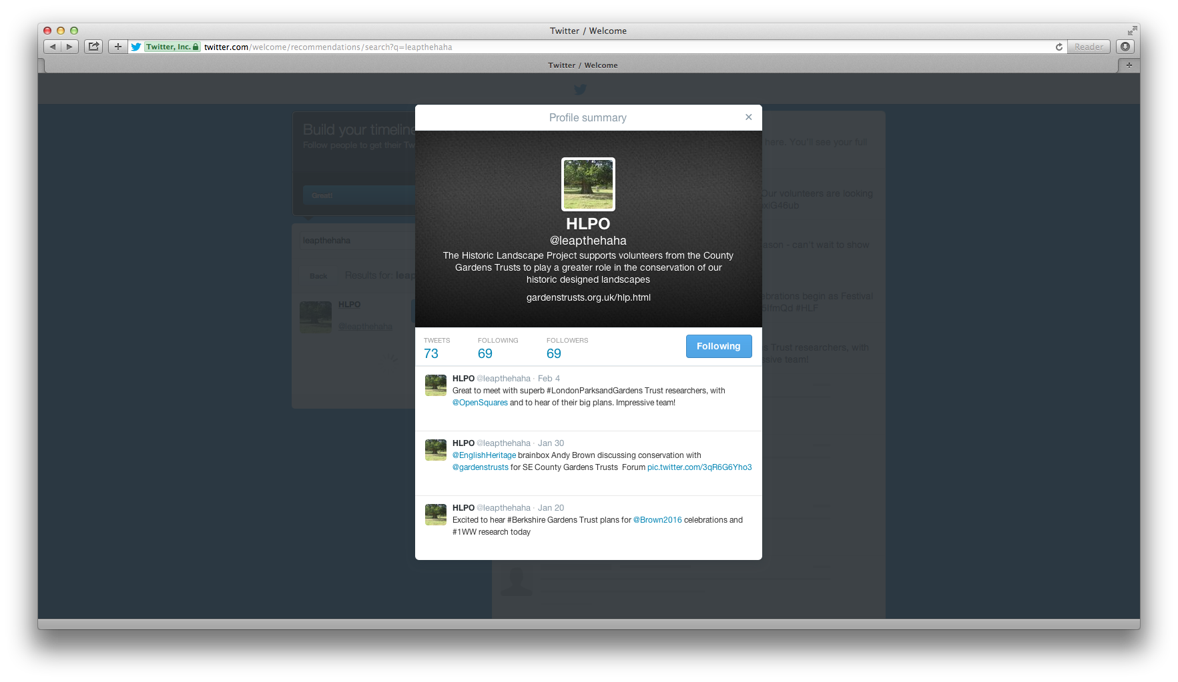
- The next screen makes more suggestions as to who else you might wish to follow. You could pick up some useful government agencies here and other national organisations.
- On the next screen you can choose to find people using your contacts list. This could be useful if you are using a CGT email address that has members etc linked to it in that you can quickly find out if they tweet and then choose to follow them or not. This has the great advantage that they will be notified that you are following them and become aware that this is now a Twitter feed from their Gardens Trust. They’re bound to be pleased! Already you’ll start to find an audience.

You can choose to skip this stage using the box on the bottom left hand side.

- Now you get to personalise your account with a photo and a short but interesting bio of your trust – say what it does and even why it’s interesting. But, as with all things Twitter, you’ve only got 140 characters (NB not words!) to do this in! To upload a photo, click on ‘Upload Image’ and follow the instructions (it will take you into your computer’s ‘Finder’ or ‘Explorer’ box to pick a file to upload so it helps if you know where the image you want is saved).

Again, you can skip this step but it will make your CGT a lot less interesting on Twitter and sort of misses the point!

- When you move into the next screen, you’ll see that you need to confirm your email address in order to gain access to all Twitter’s features. Do this now by going in to the email account for the email account that you used to register your new Twitter account and follow the instructions.
- At any time you can click on the cog wheel symbol at the top RHS of the screen and choose ‘Settings’. From here you can update your profile by choosing a background – under ‘Design’. You can also come back to this point at any time to change your photo, bio, email etc at any time – you can find these under the ‘Profile’ menu under ‘Settings’.
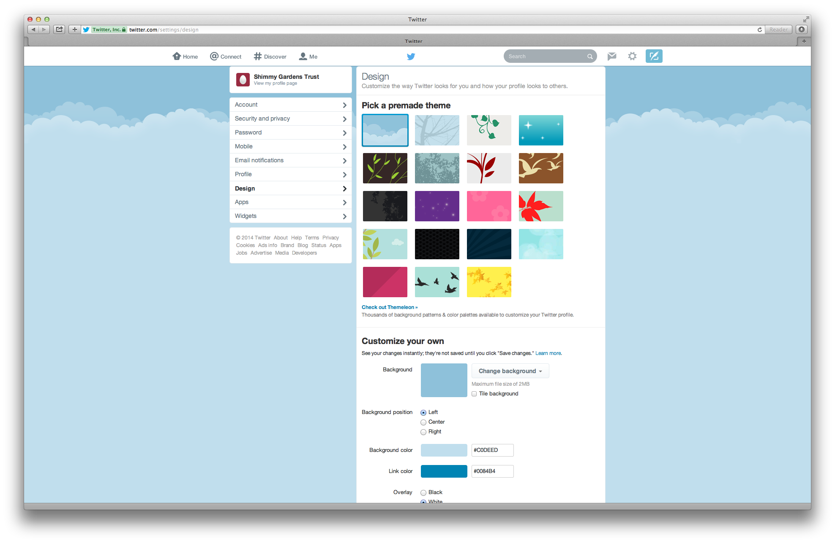
- You can click on ‘Home’ at the top of the screen at any time to return to your homepage. On this page you can see the number of times you’ve tweeted, how many people you are following, and how many followers you have. You can also see what topics are trending ie are the most popular at the moment. If any of these interest you, you can click on them to have a read.
- You might also want to click through the various symbols at the top of the page to see what each one does – they are self-explanatory, giving a description of what you are seeing.
- The Feather on the RHS enables you to write a message yourself - so now you’re ready to tweet!

To tweet and run a Twitter account:
- There are a few symbols that you will see:
@ - Mention – it prefaces a user’s username eg @leapthehaha
# - Hashtag – a topic or conversation subject eg #CB300
RT – Retweet – this indicates that a tweet has been picked up by someone else who thinks it is interesting and wants everyone following them to see it too. These posts have a little recycle arrow symbol and then ‘Retweeted by xxxx’ just above a tweet.
- Click on the Feather symbol in the top right hand corner of the screen – the writing box will pop up. You have 140 characters and it counts down how many characters you have left. You can get an idea of what people tweet by looking at the twitter feed that you can see on your home page.
- Ready to tweet? REMEMBER: Everyone will see what you write so make sure you get it right and double check it before you submit it.

How about:

We’re launching on Twitter today! Excited about creating all sorts of new connections in the #landscape world.

Or even:

At last we’re joining all the other #gardenstrusts on Twitter! Thanks @leapthehaha for showing us how!

And off you go!

- If you see a tweet by someone that you are following that you think looks interesting, you can retweet it by clicking on the ‘retweet’ symbol underneath the tweet you like.
- You can also ‘favourite’ a tweet – this will make that tweet stand out from the crowd and the person/organisation that posted that tweet will be pleased that it gets a higher profile.
- You can reply to a tweet by clicking on reply and putting their @name in your reply so that they will see it – but remember that EVERYONE will see your reply.
- If you want to include a link to a website, remember that every character in a web address counts as one of your 140 total characters so you will usually want to reduce them in length. You can do this using a website that specially does this – you could try http://goo.gl or https://bitly.com but there are others. eg For http://www.bbc.co.uk/news/uk-england-coventry-warwickshire-25150343 put into http://goo.gl becomes http://goo.gl/UPwt6w and therefore takes up far fewer characters!

There are other features that you can use but get used to these basics before you go off exploring – it’s important to gain the essentials and be able to maintain a Twitter presence first – then you can consider refinements such as lining up all your tweets to go out in a timed way using such websites at Hootsuite!

Remember – there is Twitter etiquette:
Do’s and Don’ts for Twitter (from Robin Saklavatla LP&GT)

DO
- Update regularly (at least a few times a week if possible – you can use http://hootsuite.com/)
- Let your (or a defined) personality come through
- Encourage and engage in, conversation and debate
- Retweet and share funny, interesting and relevant posts of others
- Follow local MP's & journalists, those who work you admire, people who support you
- Interact - ask questions, listen and respond
- Try to find a volunteer who can do this for you – perhaps a family member or contact your local college/university and see if there are students studying media and looking to gain work experience.
DON'T
- Follow everyone who follows you (on Twitter) – you can pick and choose
- Ignore your followers
- Forget it's a public space and you are representing your organisation (be polite, don't swear etc)
- Forget that tweets can be accessed via Google and watch for things being taken out of context by those who don't understand twitter conventions
- Log on every now and then when you want something (i.e. purely to promote an event or recruit volunteers)
- Not post anything for a while and then make up for it by posting 2 or 3 times in quick succession.

Facebook

Resources
These websites might be useful to you:
http://www.wikihow.com/Use-Facebook
http://mashable.com/guidebook/facebook/

Terminology
There are certain words and jargon native to Facebook that you may already have heard in passing. These terms and their abbreviations (in parentheses) are essential for understanding the network.
The following is taken from http://sproutsocial.com/insights/facebook-terms-definitions/
Friend: Your Facebook Friends are the people you connect with (or “Friend”) and share content and updates with on Facebook. You can send Friend requests to other Facebook members. You also receive Friend requests from other members which you can accept, decline, or ignore.
Like: You can click the Like link on any Facebook update to show that you like the content. When you Like something, the action appears as an update on your Facebook Wall (see “Wall” below). You can also Like any piece of content that you find across the Internet whenever it’s accompanied by the Facebook Like button.
News Feed: Your Facebook News Feed is the continually appended feed of status updates that appears on your Facebook Profile home page. It shows the most recent activities from your Facebook Friends and Facebook Pages that you follow.
Profile: Facebook refers to your Profile as your complete picture and story on Facebook. It includes your Profile picture, biography, personal information, and more. Your Profile can be public or private. It’s your personal piece of “real estate” on Facebook.
Timeline: Your Facebook Timeline shows all of your Facebook updates and activities in reverse chronological order.
Wall: Your Facebook Wall is where you can publish updates and where your Friends can post updates directly to you.

There is also a handy glossary on Facebook itself - https://www.facebook.com/help/glossary
To set up a Facebook account:
- You need to set up your own personal Facebook account and wall in order to be allowed to manage a page that your CGT can use – you don’t need to ever use this personal account though. Go to www.facebook.com and enter your personal details as requested on screen for ‘Create an account’.
- During the process of starting an account, you will be given a choice of privacy settings and need to choose Friends rather than Public but for your CGT Facebook page you will probably want the public to see it, as unlike on your personal Wall you will probably only be posting things that you want as many people as possible to see (see box below).
Privacy
You may be concerned about the privacy implications of having a Facebook account, and of attaching a CGT page to yours.

Be reassured that the Historic Landscape Project Facebook page is linked to the personal Facebook accounts of the Historic Landscape Project Officers but they have set their personal privacy settings in such a way that it is not possible for viewers who are not their personal friends to see anything about their Wall. If we can do it, so can you!

During the process of starting an account, you will be given a choice of privacy settings and need to choose Friends rather than Public. This means that you can choose to allow people to see your Wall (ie, you have to accept someone’s Friend Request before they can see your material).

Retrospectively, you can change your privacy settings by clicking on the cog shape in top right hand corner, follow it down to get to Settings, then Privacy.

But for your CGT Facebook page you will probably want the public to see it, as unlike on your personal Wall you will probably only be posting things that you want as many people as possible to see. So even without joining Facebook, you can see the HLP’s page by going to www.facebook.com/historiclandscapeproject. (But you cannot see this kind of stuff for most private Walls, without being their ‘Friend’)

- Once you have your own Facebook set up, you need to create a page for your CGT.
Click on the arrow shape in the top right hand corner.
Choose ‘Create page’
- On the ‘Create a Page’ page, click on ‘Cause or community’. Give your page the name of your CGT.

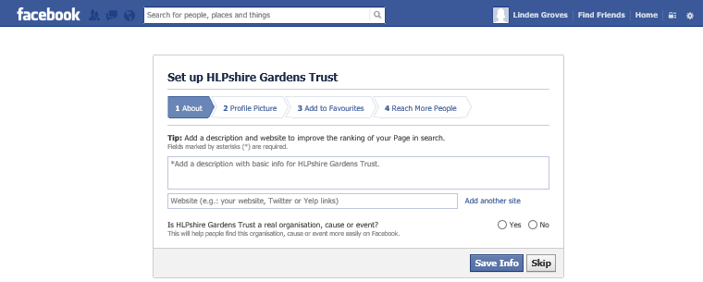
- You will then move through to an About screen where you can write a description of your CGT
- The next screen allows you to choose a picture to head your page
- You will probably be given the choice of issuing an advert about your CGT across Facebook. This is cheap and has many benefits in spreading your profile, but can be done at any time so is probably best skipped at this point.

YOU NOW HAVE YOUR COUNTY GARDENS TRUST FACEBOOK PAGE!

Running your Facebook page:
- Now you need to find people or pages to Like – you can do this by going to their websites, finding the Facebook logo and clicking on it (often on the Homepage or the Contact page), or by searching for their names in the search box at the top. By Liking pages, you flag up to them and others your support of their work, but are also automatically notified of content updates to their pages, providing a regular tailor-made news stream (to see this, go to the Home tab in the top right hand corner of your screen).
- Responding to other people’s posts: You are free to simply read other people’s posts, but you can let them know that you are reading, build a relationship with them, and create some kind of online activity for your CGT by responding to their post. You can do this with a:
- Like – this signifies support, agreement or simply interest in what they have said and is a good way to attract their attention
- Comment – you can make a comment at the bottom of their post. This is a good way to initiate a conversation, attract attention for yourself amongst their readers, plus it comes up on your page too so people can see how engaged you are
- Share – this will put the post onto your page too, so you are spreading news which will then make your page more interesting to your readers, and also be an appreciated gesture of support to the original poster.

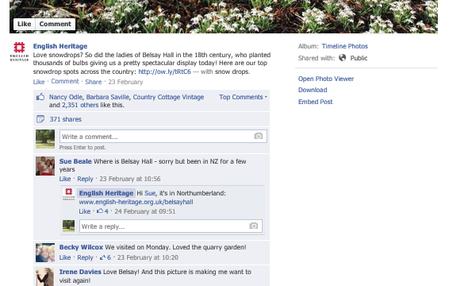

- It is worth exploring the symbols on the top right hand of your screen.

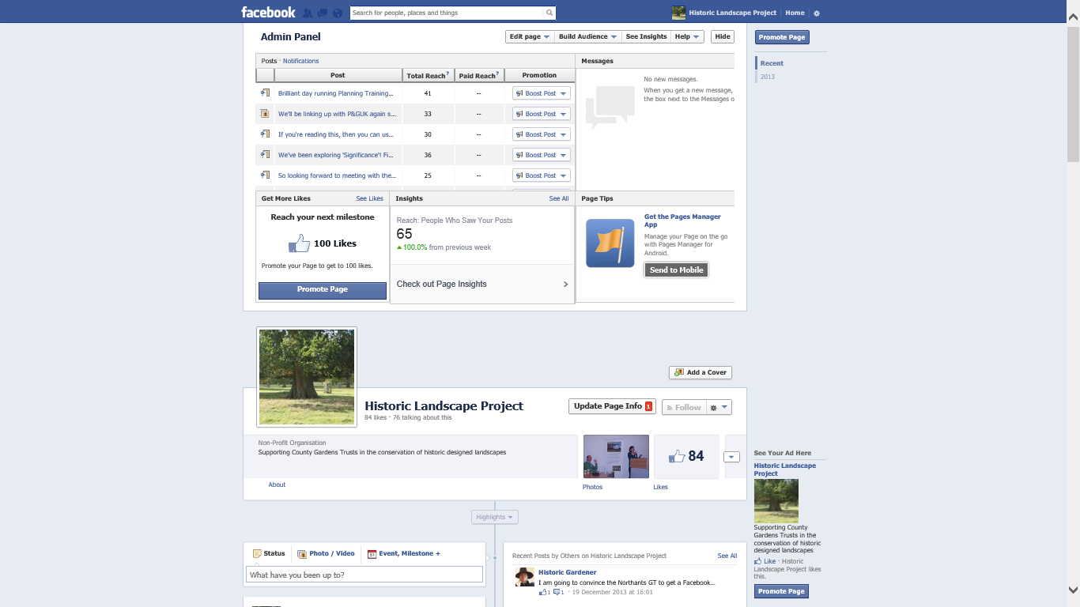

- Likes – Symbol of 2 heads: this tells you who Likes your page.
- Messages – Symbol of square speech bubble: Facebook Messages are similar to private email messages. They appear in your Facebook Inbox and can include text messages, chats, emails, and mobile messages from your Facebook Friends. They are only visible to invited recipients, so cannot be read by standard readers of your page.
- Notifications – Globe symbol: Let’s you know when certain activities happen on Facebook, eg you have been mentioned, or someone has commented on one of your Posts, or liked a comment that you have made.

- Time to write a post! When you log in and go to your page, the screen will always have a little ‘Status’ box at the top of all your posts, asking you a whimsical question about yourself along the lines of ‘What have you been up to?’ Click here to type in a Status Update (also known as a Post).

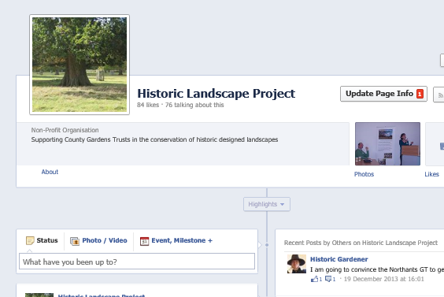

Facebook posts are usually between 1 sentence and 2 paragraphs long.
- You can add pictures to the Status – this usually guarantees far more interest.
- Include a website link within your post and Facebook will format it to add an attractive view of the relevant website
- Tag Facebook users mentioned: If you mention any organisations or people who also have Facebook pages and are linked to yours via a Like, do make sure you type their name exactly as they include it on Facebook, as the two will then automatically link and readers can click through from one to another. (Plus, that person will know that you have mentioned them.)

Click on ‘Post’ once you’ve finished typing and it will be published.

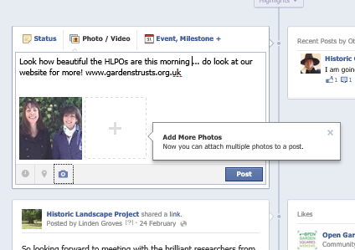

How about:

Here we are on Facebook at last! Do visit our website www.hlpshiregardenstrust.org for more on HLPshire Gardens Trust, and Like this page for updates on our events and work

or

Love this Facebook training with the Historic Landscape Project [tag so links to HLP Facebook] and can’t wait to start page for www.hlpshiregardenstrust.org

LinkedIn

To set up a LinkedIn account:
- To sign up, go to www.linkedin.com and follow the registration instructions

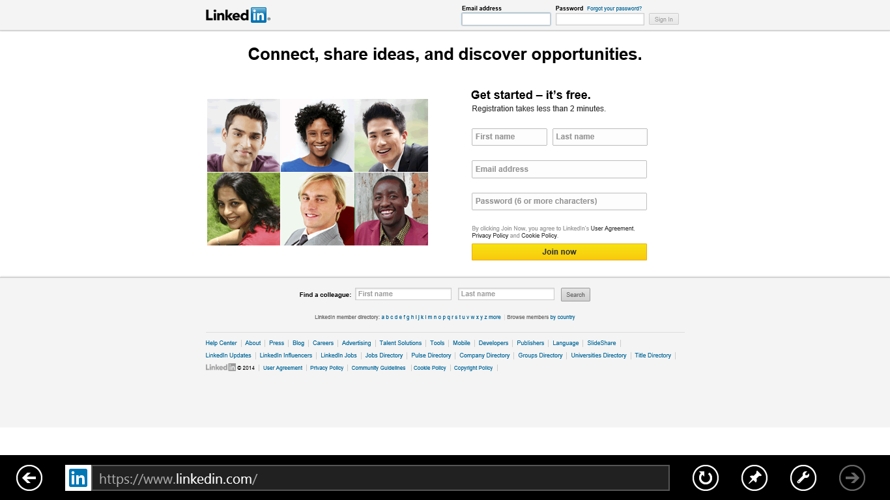

- Create your personal profile. Click on ‘Profile’ at the top, and you can write your own profile with pictures and prose describing your professional life, experience, skills, education, awards, contact details etc. (Your LinkedIn profile acts like an online CV in some ways.)
- Make connections. Top right hand corner of main screen has a ‘People you may know’ option – click on this and it brings up a lovely wall of people it thinks you may know, second guessing by your profile and, in time, your existing network of connections. This changes all the time, so every now and again click into your account and scroll through. If you want to invite any of these people to connect with you (and be able to read your profile etc), click Connect. This sends them an invite which they may in due course decide to accept.

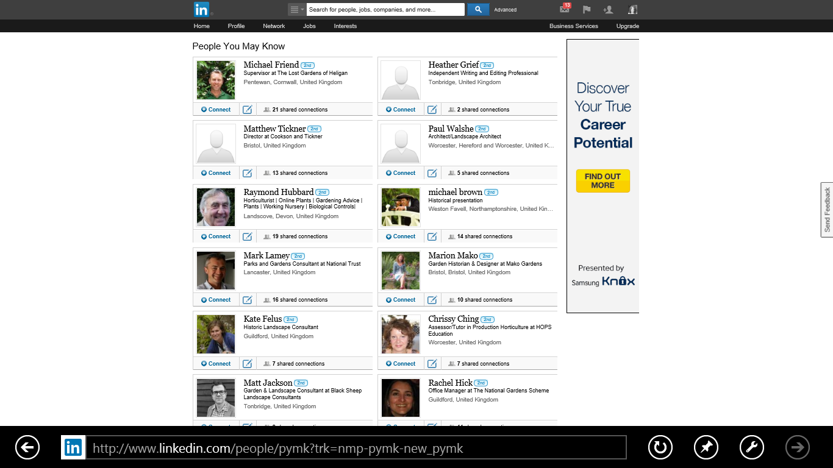

- Explore your network. If you click on the network button at the top, you get to scroll through everyone who is currently in your network. You can click on any of them to see their profile.
You can build up a really useful list of contacts, whom you probably have a bit of a connection to in real life, but not enough to previously pick up the phone and call on a first name basis – ie garden historians, National Trust staff, estate managers, local authority staff, other CGT folk.

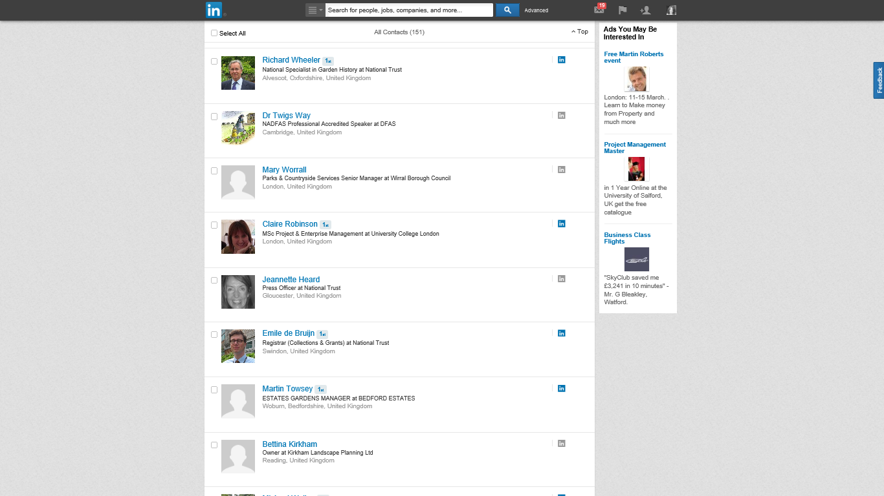

Historic Landscape Project
March 2014
Revised December 2015

