Subject Line: Capability Gardens Trusts: Festival Update, July 2016

The Festival is still generating lots of publicity on a national level, and hopefully this is having a positive effect on your local events and activities. Expect a big push for coverage in August with various activities planned to celebrate Brown’s birthday month, and this momentum will keep us going to the end of the tercentenary year. The Festival is thinking hard about the legacy that will be left after 2016, and the research by CGTs will form a large part of this, available on PGUK and on the Festival website, which will be maintained by the Landscape Institute when the festival funding ends.

At the latest CBF Board meeting, there was an illustrated presentation about the Audience Development Projects, centring on the exemplary work being done by Northamptonshire Gardens Trust at Castle Ashby, and Carol Fitzgerald and Elaine Johnson were warmly praised for their commitment, enthusiasm and ability to successfully put ideas into practice. It was recognised that projects such as this are having an enormous benefit in the community that will endure as a legacy of the Festival.

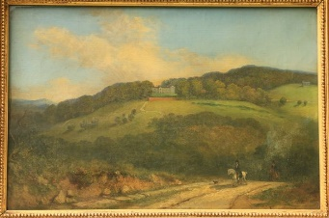
Another successful project coming to fruition is the Noble Prospects exhibition organised by Yorkshire Gardens Trust, now showing at the Mercer Art Gallery in Harrogate. This has also provided a lovely example of CGTs working together. Stephen Beaumont of Suffolk Gardens Trust contacted Yorks GT to discuss a painting of Whitley Beaumont in his collection which shows the house (now demolished) in its Brown landscape. This is the only known view of the landscape and the painting complements Yorks GT’s new research confirming Brown’s involvement. Stephen has kindly agreed to loan the painting to the exhibition and it is currently on display, handsomely illustrating the story of Brown’s influence on the Yorkshire landscape.

Promotion of CGT research
As many of you will have seen from the latest festival newsletter, our blog post on CGT research has been published http://www.capabilitybrown.org/news/county-gardens-trusts-packed-capabilities. We hope this will be the first in a series of posts highlighting the huge contribution by County Gardens Trusts to the CB Festival, and would like to follow up our post with others from you all featuring research you’ve been doing, promoting your Brown publications, and publicising your events and activities. The monthly newsletter, which includes all the recent blog posts, goes out to 2245 subscribers, so this is a great bit of free publicity sent straight the inboxes of a large and enthusiastic audience! Please send blog posts of around 350 words to us and we will arrange for them to be uploaded to the CBF website and added to the newsletter, which is issued at the beginning of each month. If you don’t have time to write something yourself, send us your ideas and a few facts and we’ll shape it into a blog post for you. We’re really keen to capitalise on this publicity.

More blogging…
As a result of all the publicity surrounding the CB Festival, Heritage Open Days asked us to write a blog for their website to introduce CGTs to their audience. We were delighted to be asked and you can read our blog post here: https://www.heritageopendays.org.uk/news-desk/news/gardens-trusts-fan-clubs-for-our-heritage-landscapes. Now that Brown has made our introduction to HODs, we hope to make more of this relationship in future.

PGUK Research Launch
As you know, we are planning to officially ‘launch’ the amazing CB research that CGTs have been sending to PGUK at the Gardens Trust AGM weekend in September, hopefully with a bit of pizazz. This will include a display of CGT Brown research material - do please let us know if you have any books, leaflets, illustrations, or other display material that you would be able to contribute. We intend to produce press releases and have a social media blitz to highlight the launch, and will include a suggested template for you to send to your local press too. We feel it is important that this huge achievement by CGTs gets the attention it deserves, and this research will form one of the key legacies of the Festival.

In response to our recent email asking you send your research reports to PGUK in time for the launch, Rachael is very pleased to have been sent contributions from Bucks, Essex and Yorkshire GTs and is ever-hopeful that there are many more to come! Please do keep sending your research to PGUK (rachael.stamper@parksandgardens.org) and if you have something in the pipeline but not quite finished it would be helpful to know which sites you are working on, so Rachael can update her list.

Impact of research
We are pleased to reports that Buckinghamshire GT have requested that Historic England consider upgrading Wotton Underwood to Grade I on the National Heritage List for England. We’re still waiting to hear the final decision but whatever the outcome, the register entry will be amended to reflect research by Bucks GT, which is a fantastic achievement.

Leaflet Maps
As reported in the last update, the leaflet map concept has been rethought by the Festival team. Rather than producing a downloadable map for each site, there will now be a link from the map pins on the Festival website to a page of information on each site, which has the potential to be linked to more detailed research records where these are available. We have been asked by the Festival to help put together a list of around 100 sites to be given an information page. The information on each site will be gathered on a research form, which we hope most CGTs will have the resources to complete. These will then be passed to a writer to present in a consistent house style ready to upload to the website. Illustrations will also be included, and it would be helpful if sources of images were listed on the research form for the Festival to arrange permissions to reproduce. As soon as the list has been prepared, we will circulate it to you along with the recording form and further information. The Festival has offered a donation of £50 to CGTs for each research form completed with the required information.

The Hub sites will each have a leaflet with a map showing Brown’s influence on the landscape. The production of this batch of leaflet maps is currently underway using existing research, and these sites will therefore not be included on our list. The production of bespoke maps for each site proved too costly to be rolled out to all sites, as explained in an earlier update.

Publications
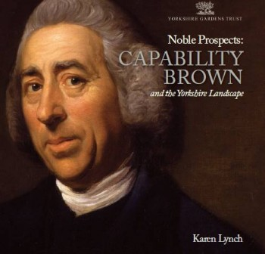
The Yorkshire Gardens Trust exhibition, ‘Noble Prospects: Capability Brown and the Yorkshire Landscape’ is now showing at the Mercer Art Gallery in Harrogate. An excellent book by Karen Lynch to accompany the exhibition has also been published and can be bought from the YGT website http://www.yorkshiregardenstrust.org.uk/capability-brown-2016. The exhibition and book are a fantastic achievement for Yorkshire GT and both have been highly praised by the Festival Board.
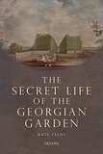
Another recently published book is The Secret Life of the Georgian Garden by Kate Felus, a member of Sussex Gardens Trust. The book puts Brown’s work into a social context and reveals how the landscapes were actually used by their owners and guests https://historiclandscapes.wordpress.com/publications.
Northamptonshire Gardens Trust has published a leaflet entitled, ‘Lancelot ‘Capability’ Brown: The man and his work in Northamptonshire’ which gives a brief summary of Brown’s work in the county and encourages people to explore the landscapes for themselves. The leaflet can be downloaded from the Northants GT website and is also available on the Gardens Trust website alongside the increasing number of CGT Brown publications http://www.thegardenstrust.org/cgt-publications.html.
HHA website links
The Historic Houses Association has created a microsite for presenting their properties in relation to the Capability Brown celebrations - http://www.hhacapabilitybrown.co.uk/ - and we are delighted that they have agreed to put a link from the pages about Brown properties to the relevant CGT website. Even if your website doesn’t contain information specifically on Brown, we think this could be a good bit of publicity for your work and Trusts, without involving much effort at your end. We will be sending the HHA a list of all CGT website links, so do please let us know urgently if you want to opt out.
Improvements to CBF website
The events page on the CBF website has been improved following comments from users, and now displays events in calendar format with a tile for each event, making it much clearer to see what’s on. Details of new events can be entered easily by the organiser using an online form which is then uploaded by CBF. The interactive map has also been improved and the Board has asked us to pass on any feedback about these changes, so do have a look and let us know what you think.

Georgian Group Architectural Awards
The Georgian Group’s Architectural Awards recognise exemplary conservation and restoration projects in the UK and reward those who have shown the vision and commitment to restore Georgian buildings and landscapes. This year they are especially looking to receive entries relating to the restoration of the Brown legacy in the categories: Reuse of a Georgian Building and Restoration of a Georgian Garden or Landscape. If you know of a project which may qualify, do send a description and some photos to the Georgian Group at david@georgiangroup.org.uk by 29 July.

Brown on the radio
There have been several Brown-related pieces on the radio which you can access on BBC iPlayer. Radio Solent did a piece on Milton Abbey in Dorset http://www.bbc.co.uk/programmes/p03yxq3w and Radio York looked at Brown in relation to country estates and farming in Yorkshire http://www.bbc.co.uk/programmes/p03qxf2d while Radio Wales focussed on Brown’s involvement in Wales http://www.bbc.co.uk/programmes/b07k0q4r. The Fringe in the Fen at Fenstanton was featured on Radio 3’s In Tune, in which Graham Ross the composer of ‘The Fallen Elm’ was interviewed http://www.bbc.co.uk/programmes/b07j3zsz (starts at 57:00). This music was commissioned to mark the tercentenary of Brown’s birth and premiered at the Fringe in the Fen festival on 10 July. Also, Nature Magazine’s weekly podcast featured Leslie Pearman from Natural England (and CB Festival Board) talking about Brown, nature and biodiversity at Syon Park http://www.nature.com/nature/podcast/index.html. On 28 July BBC Radio 4’s Open Country will be all about Mr Brown, recorded at Wrest Park and Fenstanton, and will include the Festival’s music commission http://www.bbc.co.uk/programmes/b07lhh73.

Capability Brown’s birthday picnic
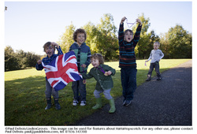
If you’re looking for some family fun this summer, The Gardens Trust has teamed up with Hahahopscotch to throw a family party at Gatton Park in Surrey on 2 August 11am-3pm to celebrate Brown’s birthday. Children and grown-ups from Gardens Trusts and beyond are invited to come with a picnic and enjoy traditional garden games, special activities and a child-friendly explore-tour of Gatton Park. Tickets are £8 for adults and children, or £20 for a family ticket (1 adult and 2 children). Book at http://www.eventbrite.com/e/capability-browns-birthday-picnic-tickets-25522968887.

And finally…
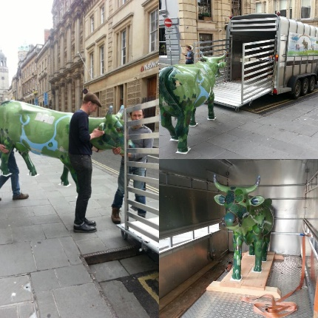
Capability Brown joins the Cow Parade! The artist Emily Ketteringham has been commissioned to paint a cow inspired by Brown’s landscapes. The photographs show the cow being transported to its home at Claremont in Surrey where it will be admired until the end of August http://www.nationaltrust.org.uk/claremont-landscape-garden/features/surrey-hills-cow-parade-comes-to-claremont?platform=hootsuite.
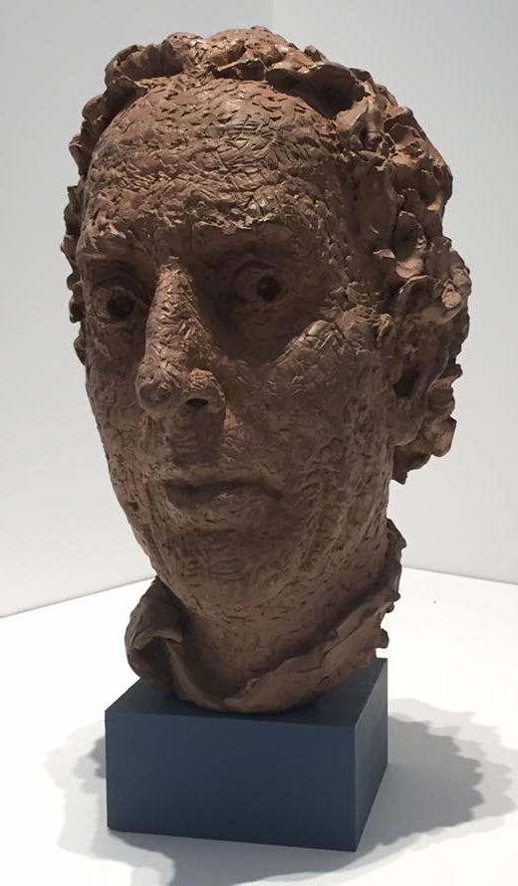

Do you recognise this man? This sculpture of Capability Brown by Jon Edgar was unveiled at the ‘Lenses on a Landscape Genius’ exhibition at the Building Centre in London and can be seen there until 25 August http://www.capabilitybrown.org/news/bringing-brown-life-bust-nears-completion.

Caroline is off to prove her capabilities by studying for a PhD, so this will be her last CBF update. There are a couple of changes in the Festival team too, as Laura Smith is leaving to start a new role with Visit Britain and Catherine Hempenstall has been appointed as the new Festival administrator to replace Lindsay McPherson.

With best wishes for a summer full of capability,
Linden and Caroline

