**Email update for CGTs, April 2017**

Dear CGT main contacts and HLP mailing list,

In an effort to keep the County Gardens Trusts up to date with the Historic Landscape Project’s key messages and information we want to share, but not to bombard you with numerous emails, Linden, Margie and I are trying a new system. We’ll aim to group everything into one email update, sent to you perhaps four times a year. We hope this works better for you.

You can expect to find here news of previous and upcoming HLP training and networking events; information about Gardens Trust conservation campaigns, with which CGTs might like to be involved; updates on information-sharing platforms, including our Resource Hub; and news from external landscape heritage organisations, which is of relevance to the work of the CGTs. Information about Gardens Trust visits, talks and conferences will not be included here but is readily available on the Gardens Trust website.

Although this update is aimed principally at those who are actively volunteering for their CGT in some way, we are more than happy for it to have a wider audience, so please do forward it on far and wide, to anyone who may have in interest.

So, what have we been up to in the last few months and what’s going to be happening next?

**Another year of funding for the HLP**

We’re delighted that the Historic Landscape Project has won another year’s funding from Historic England, taking us through to April 2018. During the coming year we’ll be examining a range of additional funding sources, from event sponsorship to other grant schemes, to secure long-term financial support for the project, so that we can continue our role in supporting and training CGTs in their important work.

**CGT Meet Ups**

As many of you felt that the old Regional Forums were overly dependent on guest speakers, leaving too little time for CGT-led discussion, we reworked these into a new format – the Meet Up. Meet Ups are more casual gatherings, to which members of any CGT may come, no matter where in the country they are held. They are dominated by CGTs’ presentations and discussion, with only one external speaker per session.

Highlight speakers at these first three Meet Ups have updated us on conservation struggles at Warwick Castle, and Panshanger, Hertfordshire; Sussex Gardens Trust’s use of the Gardens Trust’s new leaflet on the planning system to forge new partnerships; support for gardening in schools in Lincolnshire and Wiltshire; new research into Lancelot ‘Capability’ Brown in Yorkshire; the East Midlands’ CGTs’ joint plans for an HLF-funded research and recording project; using IT solutions to manage a large research project in Hampshire; and the progress of ‘Grapevine’ - a new initiative to establish more garden history and horticulture courses in this country.

Our guest speakers from external organisations are really important in updating us on heritage conservation in the national arena and have, so far:

* let us know how CGTs’ support will be vital in keeping conservation and landscape work on Natural England’s agenda, during the reinvention of Environmental Stewardship due to funding cuts and Brexit (see ‘Conservation 21’, NE’s conservation strategy for the 21st century: <https://www.gov.uk/government/uploads/system/uploads/attachment_data/file/562046/conservation-21.pdf>);
* described how we can all contribute to Historic England’s ‘Enriching the List’ programme, adding valuable detail to the Heritage List of Listed Buildings and Registered Parks and Gardens <https://historicengland.org.uk/listing/enrich-the-list/>;
* and examined ways in which Heritage Open Days can work for your Trust, including by attracting visitors (and potential new CGT members!) who wouldn’t normally engage with landscape heritage. See the attached leaflet for more details.

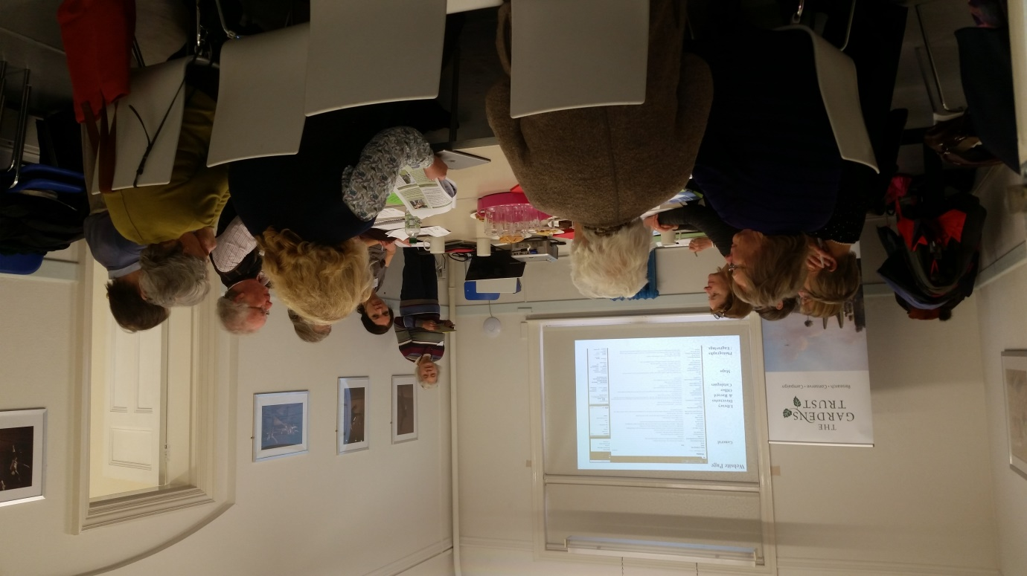

So far, 50 CGT members, representing 18 counties, have attended a Meet Up. Feedback from the first three – in York, Swindon and London – has been positive, with CGT members really welcoming this chance to meet, network and compare problems and successes. Given such an encouraging response, we will be organising four more Meet Ups this year. We are looking for locations which will give as many people as possible a chance to attend. Please do let us know if you have any suggestions for venues or for highlight speakers who would be willing to discuss their CGT’s role in research and recording, education, or conservation.

**HLP Training Days**

Attendance at our CGT Training Days has been fantastic, reflecting a surge in enthusiasm for active volunteering in research, conservation and education.

In October we launched a new three-part planning training package in Gloucestershire, aiming to offer different levels of training for CGT volunteers involved in responded to planning applications affecting historic parks and gardens. The first session, called ‘Protecting Historic Parks and Gardens: It’s a Piece of Cake’, was held at Westonbirt House and was aimed at those with no prior experience of planning and conservation. Presentations from external speakers and HLP Officers were combined with a tour of Westonbirt’s gardens, during which attendees were asked to imagine how a variety of horrific, but perfectly feasible hypothetical planning applications might affect this beautiful landscape. The event was highly popular, with 48 guests, and feedback from many expressing an enthusiasm to start commenting on planning applications.

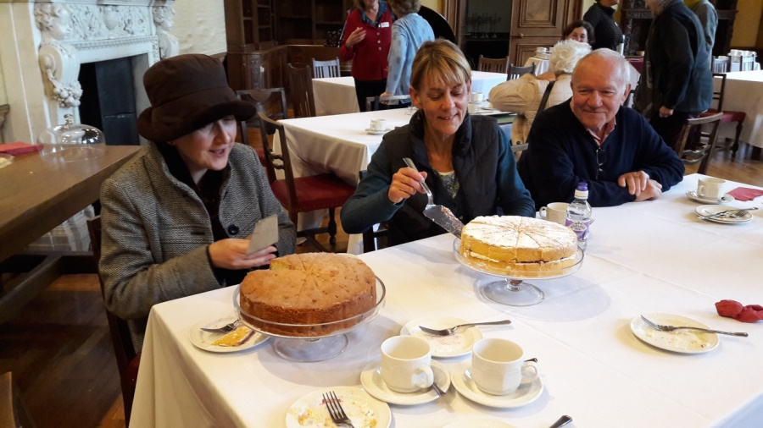

*Well how else would you end an HLP event?! Westonbirt House*

Part Two of the planning package, ‘A Recipe for Success’, was held in March, and included a very wet and windy tour of beautiful Stancombe Park, near Dursley. After working through a real planning application, delegates left with the skills needed to assess the impact of a proposed development or change on a historic park or garden, to develop a recommendation to the local planning authority, and to frame this in an authoritative and persuasive planning comment letter.

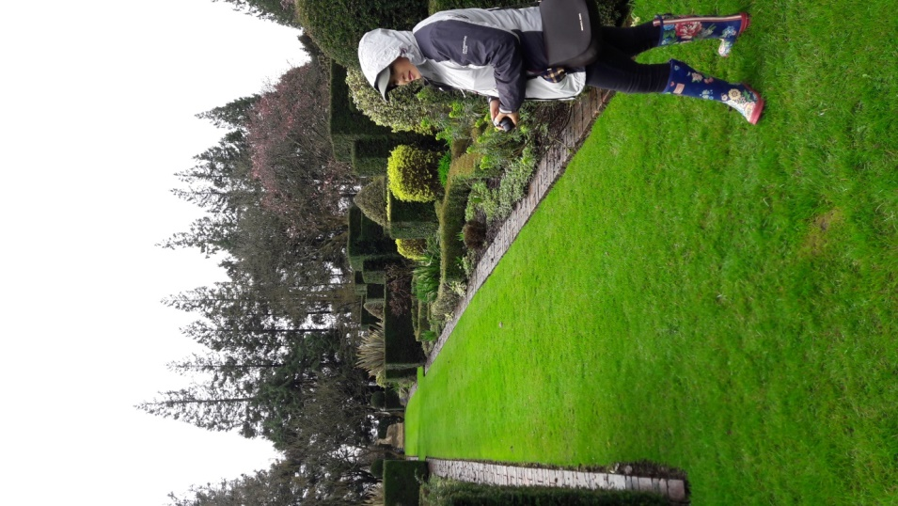

*Getting drenched at Stancombe Park*

The third day, which will also be in Gloucestershire, will look in more detail at the planning system and those attending will go away with a thorough understanding of how they can use this system to protect historic designed landscapes, and the confidence to get involved.

We will be repeating this training package around the country so please do let us know if this would be timely for your CGT now.

In January, our ‘Running a Research and Recording Project’ workshop in Birmingham was fully booked, with 27 delegates from 18 CGTs! Presentations by members of five CGTs gave a really useful and detailed insight into the nuts and bolts of running a project, from seeking funding, to recruiting and training volunteers, and step-by-step guidance on desktop research and site survey.

In February, we got a chance to enjoy the famous snowdrops at Hodsock Priory, Nottinghamshire, when we ran another workshop ‘Knowledge is Power: using research to conserve historic parks and gardens’. Speakers from CGTs, as well as heritage organisations including Historic England and local councils, described the ways in which research undertaken by CGTs really is at the heart of the conservation effort to protect historic parks and gardens. The 44 delegates, from 9 CGTs, left with an understanding of how research and conservation are intrinsically linked, and a clear idea of how to make these connections in their county. The event also provided a great opportunity for CGTs to network with delegates from several external organisations, including the National Trust and local authorities.

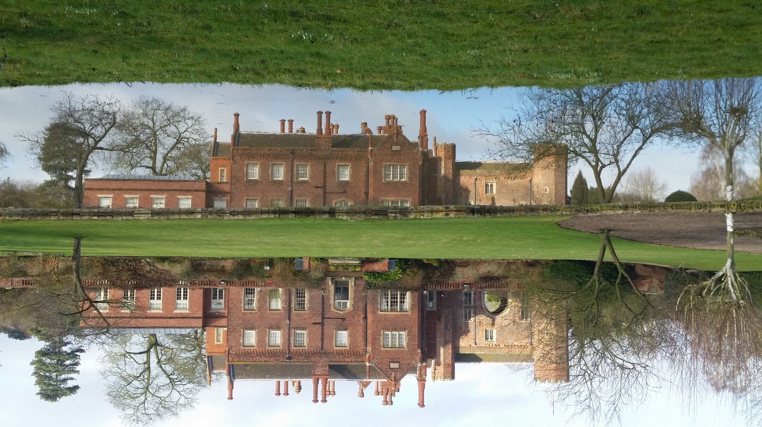

David Marsh, garden historian and Trustee of the Gardens Trust, organised an opportunity for the HLP to pilot a new half day training session in March, at the Institute of Historical Research, designed at showing garden history researchers how their work can be used for conservation. Huge thanks go to Christine Addison for putting this together with us. We will be refining this training event - perhaps adding in a site visit to make it a full day - and making it available on the Hub for CGTs to re-use themselves.

Some of you have been disappointed that, simply due to travel logistics, you have not been able to get to these events. Never fear!: we’ll be repeating all our training packages around the country, to try and reach as many of you as possible. We also make all presentations and handouts available online, via our Resource Hub (see below).

**Resource Hub**

As ever, keep an eye on our Resource Hub, which you can find on the Gardens Trust website at <http://thegardenstrust.org/conservation/hlp-hub/>. Here, you can find presentations and handouts from all our training and networking days, as well as up to date guidance by both the Gardens Trust and external heritage organisations, on all aspects of designed landscape research, conservation and education.

Most recently, we have updated the Planning section (under Guidance) and added presentations from HLP events to the Networking Materials and Training Events sections. Please find attached a full list of documents added during the last six months.

The Hub can be a little confusing to navigate and are aware that it has developed a few glitches, after its move to our new website. We plan to make it much more user-friendly very soon.

**Website Forum**

We are excited to announce that the Gardens Trust website ([www.thegardenstrust.org](http://www.thegardenstrust.org)) now has a facility for an online discussion group for County Gardens Trusts.

Click the link on the website’s home page and you will find full instructions for registering, starting new discussion threads and commenting on existing ones (see *How to use the Forum*, at<http://thegardenstrust.org/conservation/forum/> ). Any user will be able to read existing posts, but will need to register if they would like to post. Registration is quick and simple, requiring only an email address and a username.

Anyone can use the Forum – you do not have to be a member of the Gardens Trust or a County Gardens Trust. We expect, however, that most users will be those who are actively volunteering for their CGT in some way and want to discuss issues with their counterparts in other Trusts. Please do consider sharing the attached flyer amongst your members or running it in your newsletter either as the pdf flyer or as the few sentences attached.

The CGT Forum will be an easy-to-use networking platform for sharing ideas, experiences, questions and problems. These may include:

* General networking – tell us all about your CGT’s problems and successes; perhaps plan joint projects/events with other CGTs.
* Advice on how to undertake research and landscape survey; and questions or new information arising from your research.
* Conservation and planning issues affecting historic designed landscapes.
* Publicising your events and sharing ideas for future ones.
* Queries about the set-up and day-to-day running of your CGT.

You will find five additional Forums on the webpage. These are intended mainly for non-CGT queries, but you are more than welcome to use any of them. For example, any CGTs planning events to celebrate Humphry Repton’s bicentenary in 2018 might find the Repton Forum of use.

The new County Gardens Trust Forum will replace our previous Yahoo email discussion group, *LeaptheHaha*, which many found rather confusing to use! This will be closed in due course, after we are confident that everyone has moved across.

We look forward to seeing you on the Forum soon!

**Public Parks**

In light of the funding crisis threatening public parks (see the Gardens Trust’s report *Uncertain Prospects* for details <http://thegardenstrust.org/wp-content/uploads/2016/10/uncertain-prospects-2.pdf>), the HLP is keen to help CGTs get involved with the campaign to protect these irreplaceable landscapes. We are planning a training day on how CGTs can help to protect public parks. Please do contact us if you would be interested in coming to this, and if you have any suggestions for suitable venues in your county.

**Repton Bicentenary**

No sooner have we finished celebrating the tercentenary of Lancelot ‘Capability’ Brown’s birth, than another anniversary is upon us! 2018 is the 200th anniversary of the death of Humphry Repton. The Gardens Trust is keen to support CGTs’ initiatives to celebrate Repton’s life and works, by facilitating a coordinated approach, and invited representatives of interested CGTs to a meeting at Russell Square on 20th April, in order to share thoughts at an early stage.

We were overwhelmed by your enthusiastic response to the idea of a Repton celebration: the meeting was attended by 32 individuals, from 15 CGTs and seven other landscape heritage organisations. Many CGTs have already started thinking about ways of taking part in the Festival and ideas included research, visits, guided walks and even books.

John Phibbs, Debois Landscape Survey Group, has lots of exciting ideas for the Festival and kicked-off proceedings with a fascinating talk on Repton in Russell Square. John has very kindly offered to share with any interested CGT Debois’ transcripts of Repton’s Red Books, as well as their bibliographies of Repton’s sites. See attached letter for more details.

Please email [lindengroves@thegardenstrust.org](mailto:lindengroves@thegardenstrust.org) if you would like to be included in the Repton Festival email update group and/or would like to get in touch with John Phibbs.

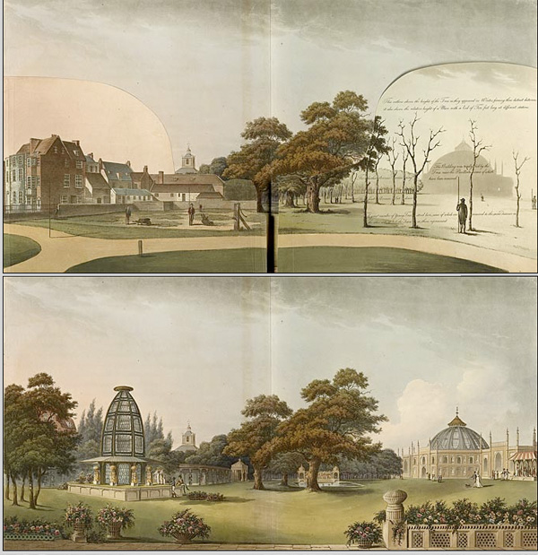

*Repton’s Red Book for the western grounds of the Royal Pavilion, Brighton* <https://s-media-cache-ak0.pinimg.com/originals/1b/74/9b/1b749b7458c0c21696f667404422abb3.jpg>

**Parks and Gardens UK**

The Hestercombe Gardens Trust was pleased to report at the above Repton celebration meeting a that it is now very close to a final agreement with Parks & Gardens UK trustees about the final Deed of Transfer of the database to the Hestercombe Trust. Philip White, Chief Executive, also announced that they are already making plans to consult with County Gardens Trusts about what form a revamped P&GUK website should take and what structural changes need to be made to the database to make it more easily accessible. The Hestercombe Gardens Trust are looking forward to working in partnership with the Historic Landscape Project to organise regional meetings with County Gardens Trusts both to hear members' views and to help develop future strategy. Philip went on to mention that Hestercombe was now ready to receive research undertaken during the Brown tercentenary and looking forward to being fully engaged with the Repton celebrations.

**Casework Log: an update from Alison Allighan**

As you will all probably know the Gardens Trust (Garden History Society) has been compiling a log of planning application and other consultations which have arrived in the office since 2001. The log now contains the records of over 20,000 cases and has its own website. Probably the most public face of the log is the weekly casework list, which is compiled from the data entered over the previous seven days.

The log was originally established to allow the former GHS Conservation Officers to record statutory casework and provide Historic England (English Heritage) with the necessary data reporting annual activities for funding purposes, and other projects including Heritage Counts. After our merger in 2015 it became apparent to the Gardens Trust Conservation Committee that this was a valuable resource and the information held could be of help to all our organisations. However, it was also apparent that the log was over 15 years old, very old fashioned and to put it politely, creaking at the joints. Whilst it had served us well for all those years it was desperately in need of an upgrade. Over the past year, we have been working with an IT company to do just that, and whilst it has taken a bit longer than we expected we are almost ready to launch the new casework log which is a lot more robust and able to accommodate a larger volume of users and traffic.

One launched our first step will then be to offer all Trusts access to see exactly what is stored on the log, e.g. searches can be made by sites, local authority areas, counties, time periods, types of cases, themes, consultation responses etc. Whilst those of you who are already familiar with and using the log will not see any major changes on the surface, we are hoping it is working much more efficiently and powerfully behind the scenes.

CASEWORK LOG SEARCH PAGE

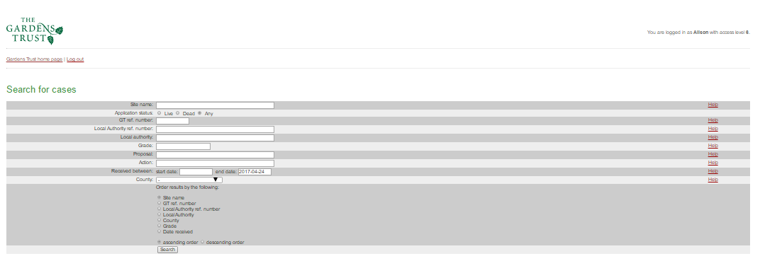

Following on from this we will be opening the log up to enable all Trusts who wish to, to enter and record their own cases and responses. This is quite a large task for us and we will probably have to proceed slowly, on a Trust by Trust basis, to make sure everyone receives the necessary support to log data in a uniform way. (Here at the Gardens Trust we still have to ensure we can extract accurate data for Historic England reporting purposes!)

CASEWORK LOG DATA ENTRY PAGE



CASEWORK LOG CASE DETAIL PAGE

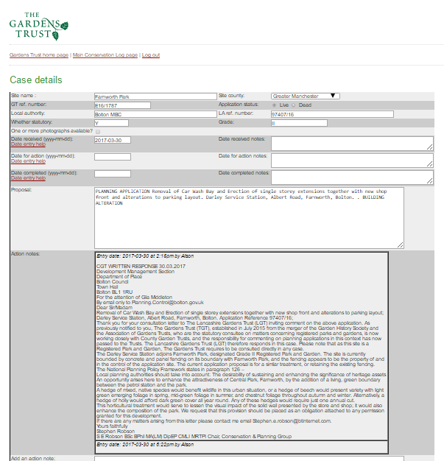

It would really help us to plan things for the next year if you could give us an indication of your Trust’s likely level of interest so that we can start arranging the access and password details needed. For the time being, and until we can gauge the level of use, we will probably have to restrict this to a maximum of two people per Trust.

If you would like any further information or to request access details please contact me on [conservation@thegardenstrust.org](mailto:conservation@thegardenstrust.org). Alison Allighan

**Keep in Touch**

As ever, do let us know how you think the Historic Landscape Project can best help to support your County Gardens Trust. Email me [tamsinmcmillan@thegardenstrust.org](mailto:tamsinmcmillan@thegardenstrust.org), Linden [lindengroves@thegardenstrust.org](mailto:lindengroves@thegardenstrust.org) or Margie [margiehoffnung@thegardenstrust.org](mailto:margiehoffnung@thegardenstrust.org).

Best wishes,

Tamsin

**Attachments:**

Website forum sentences for CGTs’ newsletters

Website forum flyer pdf

Additions to resource hub

HODs handout

Phibbs’ Repton transcriptions offer