The Gardens Trust
70 Cowcross Street, London EC1M 6EJ
Phone: (+44/0) 207 608 2409 Email: info@thegardenstrust.org


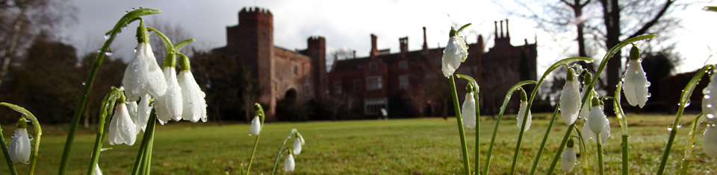

Knowledge is Power:
using research to conserve historic parks and gardens
28th February 2017, 10-4pm
Hodsock Priory, Blyth, Worksop, Nottinghamshire S81 0TY
County Gardens Trusts are a unique repository of information on local historic parks and gardens, thanks to their invaluable research and recording work. This inspiring day will look at ways in which such research is at the very heart of the conservation effort to protect historic parks and gardens.
This event is aimed at County Gardens Trust researchers, or those interested in getting involved in research or conservation. Delegates will leave with an understanding of how research and conservation are intrinsically linked, and a clear idea of how to make these connections in their county.
Programme
10.00am Arrival, with tea and coffee
10.20am Welcome and Introduction (Linden Groves, The Gardens Trust, Historic Landscape Project Officer)
10.30am Defence by designation (Historic England speaker, tbc)
11.00am Arming the Historic Environment Records (Christine Addison, Northamptonshire Gardens Trust and previously Historic Environment Record Officer)
11.30am Discussion
11.45pm Understanding Hodsock’s History (George Buchanan, Hodsock Priory)
12.00pm Tour (George Buchanan, Hodsock Priory)
1.15pm Lunch (provided)
2.00pm Designating Hodsock (Jason Mordan, Nottinghamshire GT)
Gardens Trust)
2.40pm Discussion
2.50pm Case Study: Designation experiences in Nottinghamshire
(Michael Tagg, Conservation Officer, Bassetlaw District Council)
3.20pm Case Study: Louise Wickham, Yorkshire Gardens Trust
3.45pm In a nutshell: key points to take away
4.00pm Tea and Close

This is a free day, with lunch and a snowdrop garden tour provided.

Booking and enquiries via tamsinmcmillan@thegardenstrust.org
The deadline for booking is 9th February 2017.

From George 13/7/16:
Hodsock Priory is booked for your exclusive use on Tues 28th Feb 2017 Venue hire including morning and afternoon refreshments and lunch is £20 a head including VAT You and your guests would park in the Wedding Car Park and walk into the Priory (indoor shoes please)

Coffee, tea and water will be available for you to help yourselves to The Pavilion will be laid out in a cabaret arrangement with tables and chairs, and a screen and extension lead You will bring your own projector and laptop There are blinds in the Pavilion to cut out daylight and make the screen projection visible You can take a virtual tour here http://www.virtutour.com/jobs/hodsockpriory/virtual_tour/tour.htm

I will take you on a private tour of the gardens (change into outdoor boots) at a time to suit your programme The tour will conclude in the VIP dining area of our heated marquee tearoom Lunch will be a hot home-made vegetable soup and a roll, freshly made sandwiches and home-made cake with coffee or tea

After lunch I will escort your guests back to the Priory (indoor shoes again) and there'll be tea and coffee to help yourselves to

I hope that meets your expectations. Let me know if you need anything else. Do you need any publicity photos? Feel free to download them from our website http://www.hodsockpriory.com/snowdrops/groups-and-coaches/

