HUMPHRY REPTON PUBLICATIONS BY THE COUNTY GARDENS TRUSTS
BUCKINGHAMSHIRE
Humphry Repton: Just what did he do for us in Bucks?
Based on several years of research by members of the Buckinghamshire Gardens Trust this book explores just what Repton did in Buckinghamshire and links beyond the county too. http://www.bucksgardenstrust.org.uk/our-publications/humphry-repton-just-what-did-he-do-for-us-in-bucks/
ISBN 978‐1‐5272‐2348‐6, August 2018, 160 pages, 80 illustrations, many full colour
Price £20 + £3.50 postage and packing
HAMPSHIRE
Humphry Repton at Herriard Park ‘Improving the Premises’ by Sally Miller, with Sheila Carey-Thomas, Dee Clift and Eleanor Waterhouse
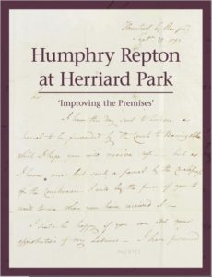
Herriard Park in Hampshire in the rolling downland south of Basingstoke owned by the Jervoise family since the beginning of the 17th century. In 1792 George Purefoy engaged Humphry Repton (1752-1818) to produce plans for a new walled kitchen garden, pleasure grounds and plantations.
ISBN 978-1-916190-10-8 Published by Hampshire Gardens Trust, 2019, pp.96. Price £12 including postage and packing from http://www.hgt.org.uk/wp-content/uploads/2019/11/Book-Order-Form_Humphrey-Repton-at-Herriard-Park.pdf

HERTFORDSHIRE
Humphry Repton in Hertfordshire by Susan Flood and Tom Williamson
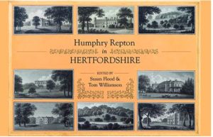
Repton made a particularly significant contribution to the landscape of Hertfordshire, working at no less than eighteen places in the county, ranging in size from great mansions like Cashiobury and Panshanger to more modest ‘villas’ owned by wealthy businessmen and industrialists, such as Wood Hill in Essendon. www.hertsgardenstrust.org.uk
ISBN 978-1-909291-98-0, March 2018, hardback, 304pp
Price £25 plus postage and packing. Available to order https://www.herts.ac.uk/uhpress/books-content/humphry-repton-in-hertfordshire.
Structure and Landscape William Wilkins and Humphry Repton at Haileybury 1806 – 1810 edited by Toby Parker and Kate Harwood
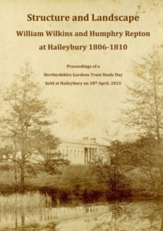
The proceedings of a study day, organised by HGT at Haileybury in 2015 with some additional papers, provide new insights to both the buildings and Repton’s landscape and his considerable involvement in the site.
£14.00 including postage and packing from: Hertfordshire Gardens Trust, 78 Broadstone Road, Harpenden, Herts AL5 1RE conservation@hertsgardentrust.org.uk

KENT
Humphry Repton in Kent
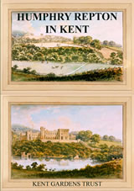
Members of Kent Gardens Trust research team have produced a beautifully illustrated book describing Repton’s five commissions in Kent with a short introduction to his life and artistic principles.
Price £10 (£8 for Kent Gardens Trust members) ISBN 978-0-9934044-1-2
From Kent Gardens Trust www.kentgardenstrust.org.uk or from bookshops.

LONDON
REPTON IN LONDON: The Gardens and Landscapes of Humphry Repton (1752-1818) in the London Boroughs
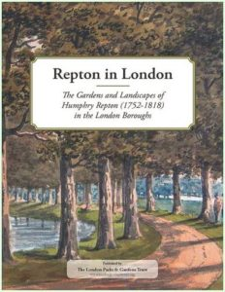
A fascinating insight into the unique range of gardens and landscapes Repton designed in and around the capital.
Price £15 plus postage and packing. Available to order at www.londongardenstrust.org/publications/repton.php

NORFOLK
Humphry Repton in Norfolk
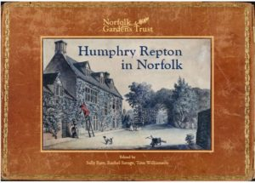
A richly illustrated A4 hardback book contains 228 pages displaying 305 colour images, describing Repton’s life, work and art in his favourite county.
£20 available in Norfolk bookshops and by post from City Bookshop, Norwich or Norfolk Gardens Trust via peterwoodrow235@btinternet.com or sally.bate@ngs.org.uk

SUSSEX
A Collection of Research Papers on Humphry Repton’s Work in Sussex
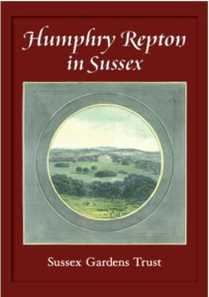
Edited by Susi Batty
Published November 2018
Price £15 plus postage and packing
Contact: information@sussexgardenstrust.org.uk or susibatty@hotmail.com
WEST MIDLANDS
‘In the Enemy’s Quarters’: Humphry Repton in the West Midlands by David Whitehead and Jane Bradney
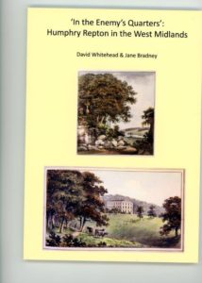
Repton exhibition catalogue published by the Hereford and Worcester Gardens Trust 106 pages with c.90 colour illustrations – mostly from the relevant Red Books. Principally about Herefordshire but covers Repton landscapes in the suburbs of Birmingham, Worcestershire, South Shropshire and Radnorshire.
£5 plus £2 postage from David Whitehead at 60 Hafod Road, Hereford HR1 1SQ
YORKSHIRE
On The Spot: The Yorkshire Red Books of Humphry Repton, landscape gardener by Patrick Eyres and Karen Lynch
This book explores all the places attributed to Repton in Yorkshire:- Armley, Bessacre, Harewood, Langold, Mulgrave Castle, Oulton, Owston, Rudding and Wentworth Woodhouse. www.yorkshiregardenstrust.org.uk
May 2018 New Arcadian Press.
Price £20 plus postage and packing from http://www.newarcadianpress.co.uk/

