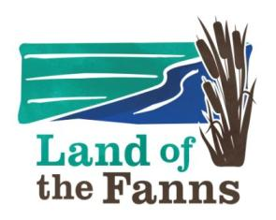
Land of the Fanns: The Know It, Love It Project

HANDOUTS IN YOUR FILE FOR WORKSHOP 2:
ESSEX RECORD OFFICE

- List of Websites for Historic Landscape Researchers with descriptions of what is covered (plus extra for Land of the Fanns specific)

- List of Resources at Essex Record Office and elsewhere for Essex parks and gardens (courtesy of the Essex Gardens Trust)

- Essex Record Office Handout on Maps (not on Resource Hub)

- The Site Description for Thorndon Park taken from the Parks & Gardens website (linked to Historic England National List) to demonstrate the type of material on-line, plus their references of some sources which might be used to compile a basic history

- An Ordnance Survey 1st Edition Map (25inch) with a range of features shown indicative of what you might find on a map of this scale and date for a park/garden. NB Maps of the sites you will visit will be handed out on the day of visit.

- Invitation to a Day on Researching House History (Essex County Council Place Services) (not on Resource Hub)

You will receive further handouts at each of our sessions so please bring the plastic files back with you each time that were handed out in Session 1!

