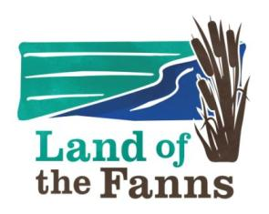

LAND OF THE FANNS: KNOW IT LOVE IT

HANDOUT: Summary of Threats to Historic Parks and Gardens

- Neglect: Overgrowth and Silting

- Neglect: Deterioration of built features

- Change of Use: Minor or Major

- Development within the site: Housing/marquees etc

- Development immediately outside of site

- Split Ownership : no overall control or direction or finance

- Conflicts with other Aims (eg wildlife)

- Lack of Funds to carry out restoration or maintenance

- Lack of Knowledge about the site

- Lack of Appreciation of site role and history

Solution? Local People to Research, Record and Care!

