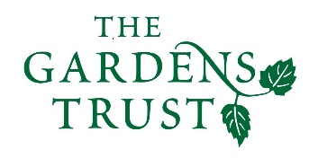
Historic Landscape Project

Setting up Volunteer Projects (MOVES)

MOVES is suggested as a useful tool for County Gardens Trusts who want to set up a project which will rely on volunteers. It describes how to get volunteers interested and involved and making sure that the project works to the advantage of your CGT as well as making a great contribution to heritage. Such projects can give a boost to the active membership of your trust and provide really good PR opportunities if planned and executed in a systematic way.
MOVES provides a framework for making sure that your project is designed and ordered in a way that makes it appealing and convincing to volunteers, as well ensures a smooth and successful project.

MOVES
Mission Decide project; clarify goals (Heritage outcome; gain for CGT); Make it everyone’s mission

Organise Budget; Method; Timeframe; Roles; Team structure; Recruiting; Publicity; Legacy

Volunteers Revisit old strategies; Lateral thinking; Positive tone; Publicity; Personal approach; Friend of friend; The Too Busy issue; Welcome; Succession

Energise Positivity; Remember what might excite; Launch moment; Allow for different styles; Build structure to allow fun; Momentum; Show off; Smile

Share Communal; Outward looking; Verbal publicity; ‘Formal’ publicity; Keep it fun and interesting; Celebrate milestones; Show off at end.

Historic Landscape Project
January 2017

