Wheresthepath web site – user notes
http://wtp2.appspot.com/wheresthepath.htm

This web site offers free use of modern OS map base tiled with Google Earth image and some selective historical maps. Data on geology and other aspects of the landscape are also available. It provides the option of overlaying one data set over another.

If zoomed out it gives the modern map base with public rights of way (dashed red line), which may offer easy access across, through, or around the perimeter of parkland areas of sites.

The left & right side tiles can be set through the two blue ‘layer’ icons on the left hand side. Pull down menus give access to various maps and images.
Click on blue question mark for more explicit instructions and explanations.

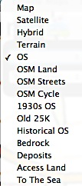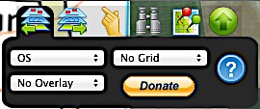

The one drawback to this site is that it has a restricted number of logins per day to view the modern OS map and once it exceeds its daily limit, you can only then set maps to historical options as below: Old 25k is useful one to use

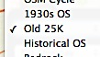
The binoculars icon allows searching, enter a placename,
or NGR e.g. TA 139677
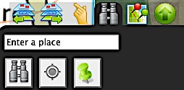

The hand icon sets units for reading NGRs and the height of the land. Keep clicking on the hand to scroll through various options e.g. 6 or 8 figure, or absolute grid references. Click on area map or Google image to display explicit NGR reading.
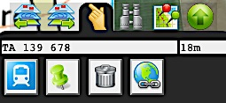

Example of tiled map and Google Earth image:
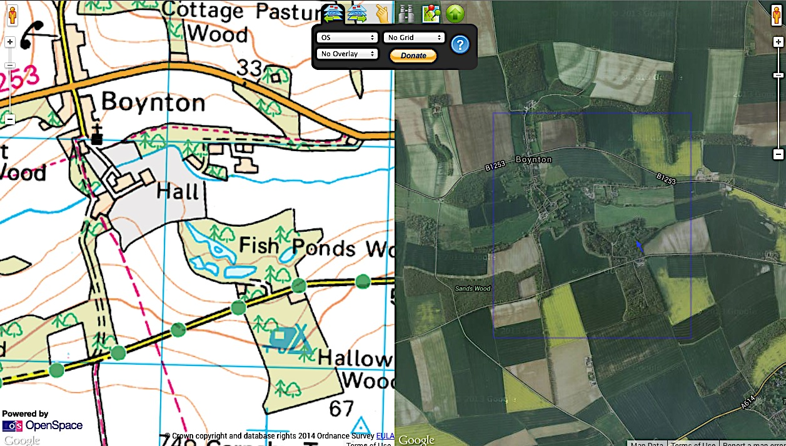

Can set overlays to mapbase e.g. deposits gives superficial deposits, or bedrock gives underlying geology. Press control and click on coloured area to reveal popup box with details.
