HANDOUT 2


Understanding more about Historic Parkland

Historic Landscape Project – Southeast

Historic Parkland – Function, Features and Threats

1. Introduction & Background

A. Deer Parks
The word park originally meant no more than a piece of ground, often woodland, enclosed for the keeping of beasts of the chase. Many of the parks we know started this way including Ashridge, Knowsley and Hatfield. The concept of the deer park was introduced by the Normans and formed an integral part of the manorial system, playing a major role in the economy and the leisure pursuits of the Lord of the Manor.

Deer parks were fenced around with a deer proof boundary: an internal ditch about six feet deep and an outer bank of around six feet in height with a fence or pale along its top. Thus deer could leap into the park, sometimes over a purpose built deer leap, but could not escape. The parks were often round or oval in shape to minimise on fencing, whilst sometimes part of the boundary was terminated by water.

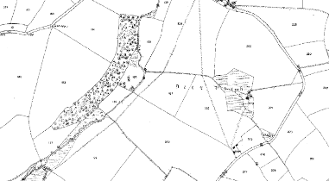
Figure 1: The deer park at Lanteglos mapped in 1880. Although it was disparked in the mid-sixteenth century some of its elements are still clearly visible, such as its curvilinear shape and incorporation of woodland and a stream

A great number of parks were created throughout the 17th century and there was a growing interest in formal designs which were adorned with temples, statues, obelisks, fountains and other water features. The aristocracy became more interested in the development of their houses and estates as they became a direct reflection on their relative wealth and power. Politicians and courtiers were keen to impress the Monarch as there were profitable royal posts, offices and sinecures to be won, for example The Lord Chancellor Sir Christopher Hatton built an enormous palace at Holdenby. As parks grew larger they started to enclose greater areas of land including common land and even villages.

During the 17th century the French style of design associated with the Royal gardener Le Notre influenced design throughout Europe. The emphasis of the axial relationship with the house became more important as did the domination of the landscape as exemplified at Versailles. Throughout the country formal patterns of rides and walks were cut through woodland and for the first 30 years of the 18th century the formal landscape of rides and channelled vistas dominated landscape design.

From the 1730s a new ‘naturalistic’ style of layout influenced landscape parks. The work of William Kent, Lancelot ‘Capability’ Brown, Nathaniel Richmond, Richard Woods, William Emes, and Repton and others transformed the landscape.

B. Landscape Parks
Designs often made use of pre-existing elements: roads were closed and used as drives, mature hedgerow trees were incorporated into planting design to provide instant maturity and in many cases existing planted elements e.g. earlier formal avenues were retained in part, for example to form clumps.

Parkland provided a buffer between a gentleman’s residence and the local population, often being bounded by a perimeter woodland belt that might contain a drive or ride providing a circular tour of the landscape. The landscape park was contrived to provide a number of experiences and provoke a range of emotions:

- Hidden and discovered views surprised and delighted
- Short views and medium views to eye catchers and buildings reminded you of the wealth and power of your host
- Long views to the contextual parkland setting gave the impression of wide land ownership and rooted the design in its locality
- The still water of lakes and ponds with their reflective qualities added a tranquil element, whereas
- Waterfalls and streams added drama and movement

The paths, drives and rides took you through the landscape, carefully unveiling the series of experiences.

Parkland landscapes were and are also productive and this influenced the aesthetic. Permanent pasture grazed and animated by cattle, sheep and deer was visually and productively important. The distinctive browsing line created by grazing animals on the underside of trees is a characteristic feature of parkland.

C. Victorian Additions
As interest in plants and plant collecting grew there was a new influx of tree species for wealthy land owners to collect. Arboreta sprang up and exotic coniferous trees found their way into planting schemes.

D. 20th Century Influences
The creation of new country houses and their associated parklands continued up until the beginning of WW1. Agricultural depression, taxes, death duties and the loss of so many male heirs in WW1, led to the break-up of many great estates – some country houses were demolished and some transferred into institutional ownership. One major change that occurred with the sale of land is the division of parklands into lots leading to multiple land ownership and therefore differing approaches to management and use.

During the later 20th benign neglect and development pressures exerted noticeable changes across UK parkland. Accretions and losses within parkland accelerated in the 20th century with perhaps well-intentioned tree planting (although it was advantageous in terms of grants and tax planning) and pressure to develop parkland for housing, golf courses and other business and leisure uses.

During WWII many country houses and parklands were requisitioned for military use as hospitals, training grounds and command posts. Swathes of parkland were ploughed up in order to “dig for victory” and more visible reminders of this turbulent period of history include pillboxes and tank platforms.

2. Function, Form and Threats

It is important to keep in mind that it is the interconnectedness of all the many features that combine to form parkland, and that they all contribute to the unique character of individual sites, whilst also forming a landscape that is instantly recognizable as a park.

A. ‘Soft’ designed features and ecological value

(i) Wood pasture, veteran/ancient trees

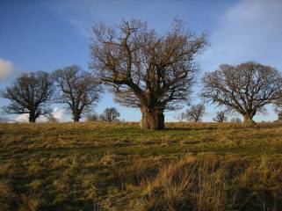
Figure 2: veteran trees at Hamstead Park

Tree planting was not only an essential visual component in the idealised parkland landscape, but also provided cover for foxes and other game and, in time, would provide a profitable source of timber. Great numbers of tree were planted in the 17th, 18th and 19th century, for example at Holkham Hall over 2 million saplings were planted across 720 acres of the estate c.1780 – 1800. The increase in demand for tree stock along with a greater interest in the variety of tree species led to the development of the nursery trade.

Veteran trees are of great value in terms visual interest and provide a dramatic visual reference to historic landscape design and structure. These trees also have immense nature conservation value due to their dead limb, hollows and holes which provide habitat for bats, birds and specialist invertebrate species.

There are threats to this important resource as they are of course living and subject to external forces. The great hurricane of 1987 devastated the treescape across UK parkland, as did Dutch Elm disease in the 1970s. Current problems include the outbreak of oak dieback, pathogenic problems with alder and ash, and leaf miner in horse chestnut.

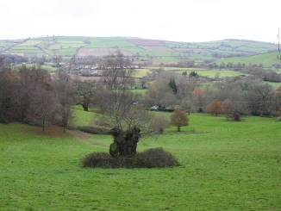
Figure 3: Bramble is beginning to regenerate around an oak at Killerton – it is this type of competition that needs to be avoided.

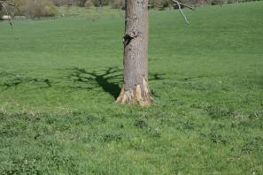
Figure 4: Along with stock damage – a younger tree that has had its bark stripped by grazing animals.

(ii) Woodland, clumps, avenues and perimeter belts
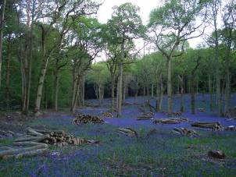
Figure 5: Recently thinned woodland on the Fawsley Estate allowing sufficient light in to encourage great swathes of bluebells to re-emerge.

As well as specimen trees, there are several other tree planting forms that appear in parkland. Woodland would have been the estate’s main source of timber and is usually fenced to exclude grazing animals. It would have provided cover for game and may have been managed under a coppice with standards regime – essentially cutting back underwood on a 7-12 year rotation whilst managing the larger trees for timber over a longer period.
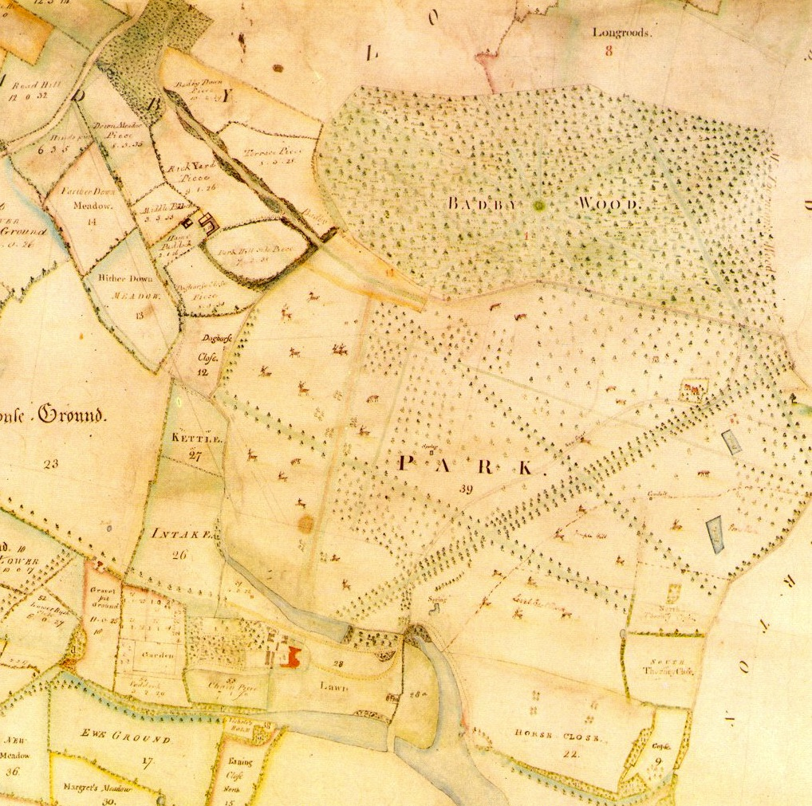
Figure 6: Badby Wood at Fawsley (1741 Survey), Northamptonshire where the woodland was not only productive but also ornamental with its star shaped formation of rides radiating from its centre.

Many woodlands pre-date the creation of parkland and you might find ancient wood banks along their boundaries. Woodland with more regular or geometric outline is often more recent in origin and may have been established for game cover or timber.

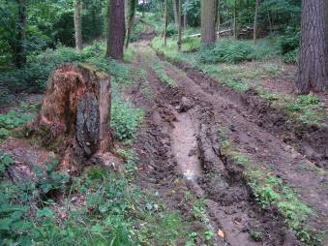
Figure 7: Damage resulting from timber extraction during a period of wet weather.

Woodland management can be quite low of the list of priorities and when it is managed there are risks to its fabric due to the large machinery used to harvest timber. The ideal would be for horses to be employed in timber extraction, which does still happen in some part of the country. However, thanks to rising timber prices, interest in locally produced charcoal and other craft by-products, there is a greater interest in woodland management.
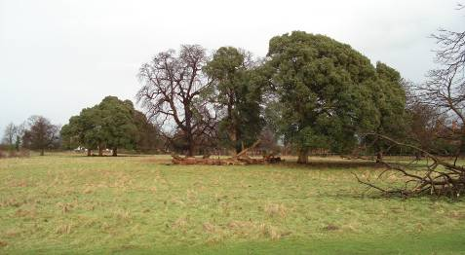
Figure 8: Clumps are groups of three or more trees, ranging in size and species composition and are a characteristic feature of parklands. They are often used to focus views, emphasize topography and create interest.

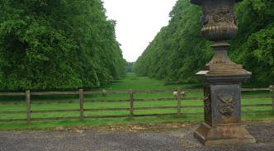
Figure 9: a surviving avenue no longer used to provide an approach to the main residence.

Avenues, a more common feature of the 17th and early 18th century, but many were also planted in the 19th century as the diversity of plant material expanded. Avenues were often used as part of an approach to the house or to frame views to garden or parkland architecture.

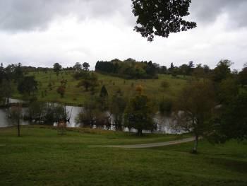
Figure 10: A diverse and confused picture - self sown birch, new planting around edge of lake, scrub on lake islands and a large geometric block of 20th century tree planting which is suffocating a number of veteran trees and upsetting the parkland flow.

The composition of parkland, particularly the balance of open space and planting at various densities, is highly vulnerable. New well-intentioned, but uninformed tree planting can denude the appearance of designed landscapes; views may be lost (see below) and new trees that do not relate to historic precedent in terms of species and location may have an adverse effect. Such adverse interventions may include woodland planting within the parkland context, which can often engulf important historic and veteran trees, causing threat to their vitality and longevity.

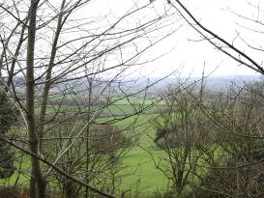
Figure 11: Unchecked tree growth can upset the intervisibility between gardens and park where it is important in the design of the landscape.

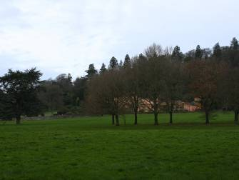
Figure 12: well-intentioned clump planting obscuring views to Killerton House from the park.

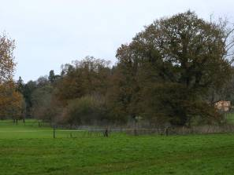
Figure 13 A planting belt emerging around some veteran trees at Killerton causing increased competition and interrupting parkland flow and views

(iii) Unimproved and improved grassland

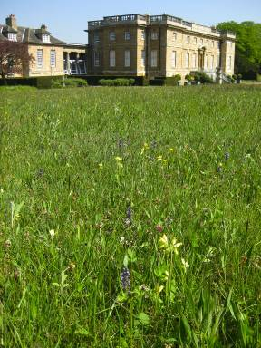
Figure 14: an example of unimproved grassland at Bramham Park.

Unimproved grasslands are likely to be rare especially in the lowlands. They may be rank and neglected, mown or grazed. They may have been treated with low levels of farmyard manure, but should not have had sufficient applications of fertilisers or herbicide, or have been so intensively grazed or drained, as to alter the sward composition significantly. Species diversity is often high, with species characteristic of the area and the soils and with a very low percentage of agricultural species.

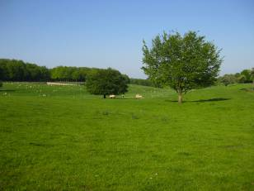
Figure 15: an example of improved grassland.

Improved grasslands are those meadows and pastures which have been so affected by heavy grazing, drainage, or the application of herbicides, inorganic fertilisers, slurry or high doses of manure that they have lost many of the species which one could expect to find in an unimproved sward. They have only a very limited range of grasses and few common forbs (herbaceous plants), mainly those demanding of nutrients and resistant to grazing.

Grazing is the preferred and historically appropriate form of grassland management in parklands. In some areas there might be evidence of overstocking through poaching (evidence of trampled, flattened ground, churned up mud and underlying compaction) of some parts of the park. Problems tend to occur where livestock congregate e.g. under trees, watering points (troughs/lakes and ponds) and feeding points. The aim is for the park to be grazed to produce a tussocky sward to provide maximum visual and ecological value whilst also conserving any archaeological features through low densities of livestock.

(iv) Approaches and Views

Approaches and views may be considered together as they work very closely in tandem. The approach to a park often starts with a lodge or pair of lodges where the private drive and public road meet. Larger parks often had several points of entry with multiple lodges and in some cases lodges can be found within parkland where the designed landscape has been expanded over time. Lodges became increasingly common from 1750 onwards and served to house estate workers, provide security and provide a hint at the grandeur that lay beyond the threshold.

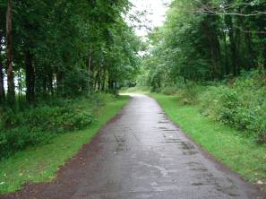
Figure 16: At Saltram in Devon, having entered via the lodges the visitor is enclosed by woodland on either side…

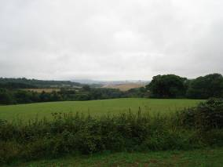
Figure 17: until you are treated to a view of Plymouth to the left hand side of the drive.

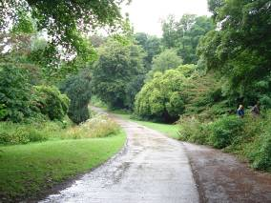
Figure 18: The sequence continues into a more intimate landscape with more a more complex range of ornamental planting including yew and rhododendron along with more familiar tree species.

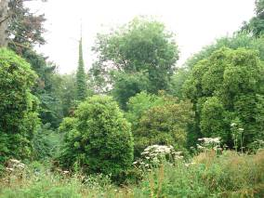
Figure 19: To the left of the drive one should be looking over an ornamental valley garden with exotic planting, a series of pools and walks.

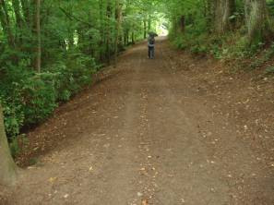
Figure 20: Here is one of the secondary walks that forms a spur off the main drive. The clarity of the design has been lost to self-sown vegetation growth and a lack of active and appropriate management.
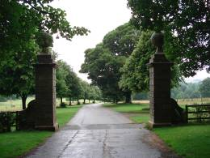
Figure 21: Having been treated to the variety of experiences the park itself is entered, which in this case should be a grand reveal of open parkland with the house visible in the distance. In this case well intentioned but inappropriate avenue planting has completely altered the intended experience.

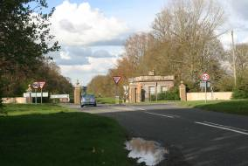
Figure 22: Approaches are vulnerable in a number of ways, not least through the presence and proliferation of highways furniture, landowners’ signage etc.

There are a variety of types of views to be found within designed parkland including:

- Static or set views from the house to a particular point in the landscape to an eyecatcher such as a temple or folly.
- Kinetic views which relate to the changing and unfolding sequence of views along a drive or path.
- Broad or panoramic views which relate to the wider setting of the designed parkland.

(v) Waterbodies

Water has formed a key element in parkland design with features ranging from medieval and later fishponds through to formal canals and the widening a rivers to form great sinuous lakes as Brown and others did at so many of our great parkland landscapes.

Canals and formal ponds featured in 17th and early 18th century parks and gardens. These formal features were conceived in tandem with avenues and cascades and created a variety of moods - still water providing calm, cascades adding drama and fountains creating splendour. From the 1740 and 50s onwards the trend was towards the informal and irregular and became a feature of the Brownian era of parkland.

Vast sheets of water provided for fish and wildfowl, whilst also providing recreational opportunities e.g. boating for the family and visitors and greatly enhancing the setting of their seat. More productive water features survive, often silted up or hidden amongst trees. Duck decoys, osier beds and fish ponds survive in some parts of the country. Importantly, ponds also provide watering points for grazing livestock and were an important part of parkland management.
Management issues that might arise include failure of linings which are traditionally puddled clay, stock poaching, scrubbing up around lake edges thus obscuring the feature and siltation. Cascades between lakes are prone to wear and vegetation growth. Such issues often arise as a result of loss of function and use.

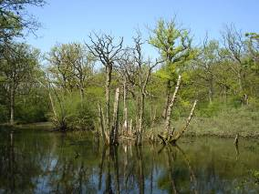
Figure 23: Remnants of a fish pond or possibly a duck decoy where the raising of the water level has led to the loss of islands and therefore drowning of trees.

(vi) Boundaries

Boundaries to parkland are well defined and may be formed of woodland, hedges, park pales and fencing. However when hedgerows are found within a park as an internal boundary, they are more often than not considered to be a negative influence.

The ha-ha is a boundary device to enable long, uninterrupted views from house and garden/pleasure grounds into the wider landscape so that “all of nature becomes a garden” whilst keeping grazing stock out of the garden. These features do require maintenance to ensure that they fulfil their intended function.

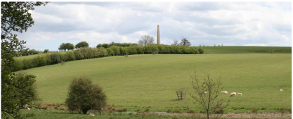
Figure 24: A view from the Kennel site to Wolfe’s Obelisk at Stowe which is interrupted by modern hedgerows.

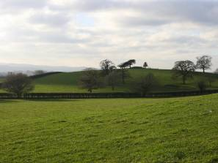
Figure 25: At Killerton a modern hedge interrupts the rolling topography and views up to a knoll where an 18th century folly once stood.

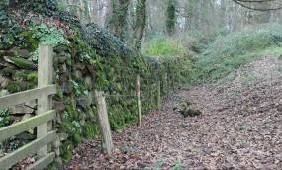
Figure 26: The park pale was a boundary device which enabled deer to enter a park but not get out due to the ditch on the internal park side of its construction.

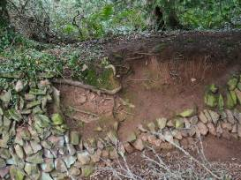
Figure 27: Boundary features require maintenance and as in this case they can be vulnerable.

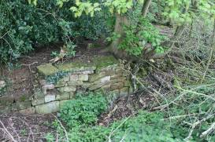
Figure 28 - When vegetation is not kept in check and the function of the ha-ha is no longer required or understood the structure can be highly vulnerable.

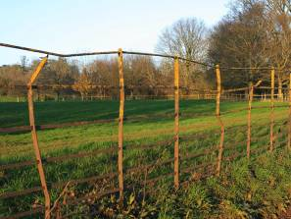
Figure 30: Iron railings became a popular form of parkland stock control as they were ornamental and as well as functional. They retained stock with a very light visual touch which was important in the parkland aesthetic.

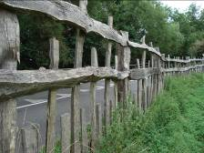
Figure 31: Traditional park paling at Charlecote Park

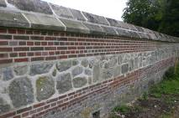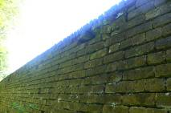
Figure 32: Park boundary walls at Wilton Park.

B. Buildings, garden and parkland architecture and archaeology
(i) Archaeology

The type of archaeology that you might find in parkland is incredibly varied, and visible and below-ground earthworks and remains greatly add to the time depth value and interest of parkland. Common features might include quarries, former field boundaries, ridge and furrow, former driveways, pillow mounds and sites of former occupation such as Iron Age forts or medieval villages.

Quarries of various shapes and sizes often produced materials for buildings, walls, drives and paths across historic estates, thus rooting the local vernacular style within its surroundings. Quarries may also be designated Sites of Special Scientific Interest (SSSIs or triple S Is) on account of their geological interest.

Archaeology can be highly vulnerable to damage through over-grazing, lack of management resulting in tree and scrub growth, new tree planting and heavy vehicles or machinery movement including ploughing.

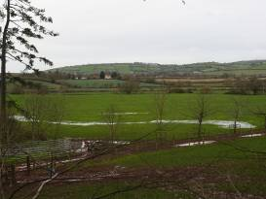
Figure 33: Some times of year help to identify certain features, for example the standing water clearly shows us the former line of a river before it was canalised to power a water mill.

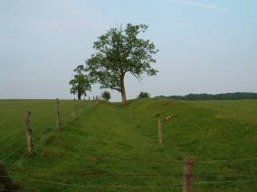
Figure 34: Some historic boundaries are more obvious than others – here an old park boundary within Fawsley Park.

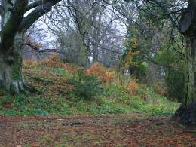
Figure 35: This mound at Killerton is an Iron Age hill fort set on top of volcanic rock. The issue here is that some of the trees are absolutely key in terms of the designed landscape as they form a beech clump planted by the celebrated nurseryman John Veitch which form a local landmark for miles around.

(ii) Walled Gardens

From the early to mid 18th century there was a growing trend to move the walled garden away from the main house and set it within the parkland, particularly as the advances in technology meat that they became semi-industrial in their nature with scores of staff and coal burning to fire boilers and hot walls to ensure that year round produce and cut flowers were provided for the main house.
Walled kitchen gardens are often subject to development pressure with many now having been lost to residential units or car parks. The walls and associated structures all require maintenance and since many of these features have fallen out of regular use, they have dropped in terms of priority for expenditure. However, interest in walled gardens is gathering pace once again and organisations such as the Walled Kitchen Garden Network provide an excellent starting point for interested parties.

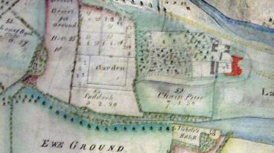
Figure 36: The walled kitchen garden at Fawsley is shown on an estate map of 1741 (the rectangular compartment shown as “Garden”)

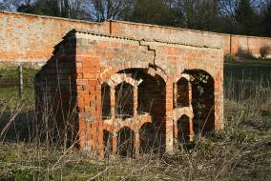
Figure 37: The apiary to the south of the walled garden at Fawsley

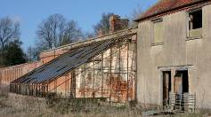
Figure 38: The last surviving glasshouse at Fawsley.

(iii) Garden architecture and (iv) Parkland architecture

Garden architecture, like archaeology, is a vast area of study and interest. The importance of intervisibility between park and garden is often of particular interest. Buildings and follies in the garden were often designed to be seen from the parkland or were sited to enable spectacular views out to the park from the garden.

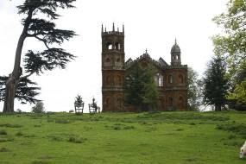
Figure 39: The gothic temple at Stowe (within the garden territory) can be seen from several parts of the park.

The range of parkland buildings is also vast – obelisk, conduit house, lodges, deer houses, boat houses, ice houses and more. Park and garden buildings can be vulnerable to the weathering effects of the elements, development pressure and inappropriate uses.
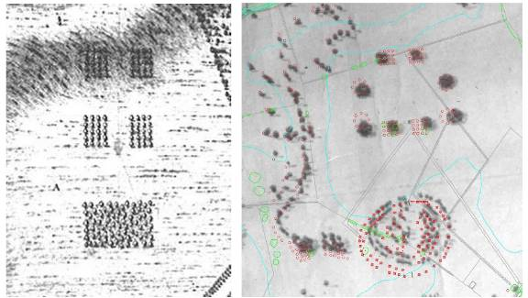
Figure 40: The setting of buildings is of great importance – Stowe: the Bridgeman Plan of 1739 when the Gothic Umbrello and Wolfe’s obelisk were not in existence and to the right by 1843 both were in place. The lower rectangle of planting has been informalised to form a grove setting for the Gothic Umbrello and to the north additional ‘platoons’ have been planted to accompany Wolfe’s obelisk.

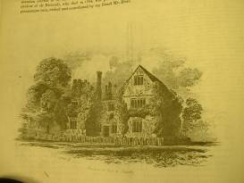
Figure 41: A romantic image of the Dower House at Fawsley

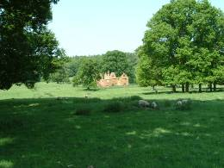
Figure 42: The ruin as it stands in the parkland today – a listed building and scheduled monument.

Selected references and further reading
Publications
- Taigel, A & Williamson, T (1993) Parks and Gardens BT Batsford Ltd, London
- Harvey, G (2002) Parkland The National Trust, London
- Watkins, J & Wright, T et al. (2007) The Management and Maintenance of Historic Parks, Gardens & Landscapes: The English Heritage Handbook Francis Lincoln, London

Websites
- www.historic-cornwall.org.uk
- www.walledgardens.net
- www.gardenhistorysociety.org

Sites and projects cited
Stowe Park, Buckinghamshire
Fawsley Park, Northamptonshire
Bramham Park, Yorkshire
Killerton Park, Devon
Saltram, Devon
Knowsley Park, Merseyside
Charlecote Park, Warwickshire

Matthew Tickner
For Historic Landscape Project
Association of Gardens Trusts
July 2012

