Historic Landscape Project


How to join the County Gardens Trusts’ Email Group (Leapthehaha)

Go to http://uk.groups.yahoo.com/group/leapthehaha/join

Create a yahoo account and email address
Firstly you need a Yahoo ‘ID’ ie a Yahoo email address which you can create for this purpose and then either use or shelve, depending on your preference.
If you are not already logged in to a Yahoo account, it will redirect you in seconds to either sign in or create an account with Yahoo:

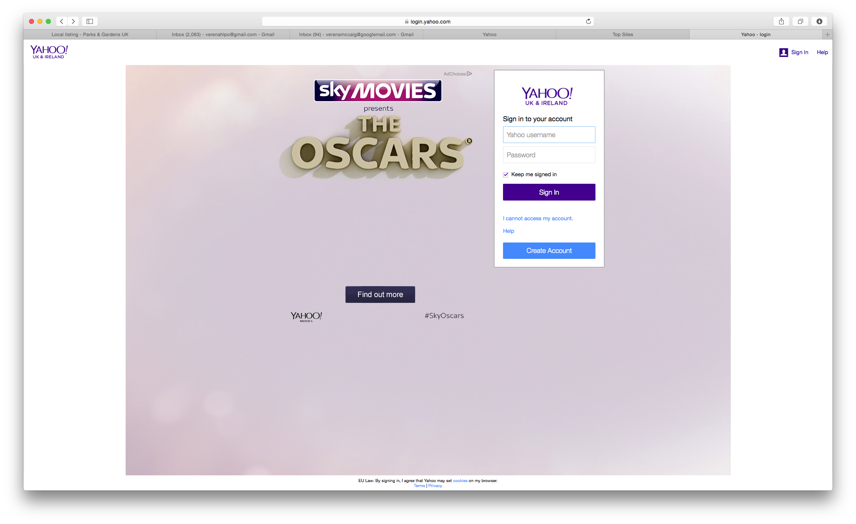

If you already have an account with Yahoo, sign in here. If not, click on ‘Create Account’

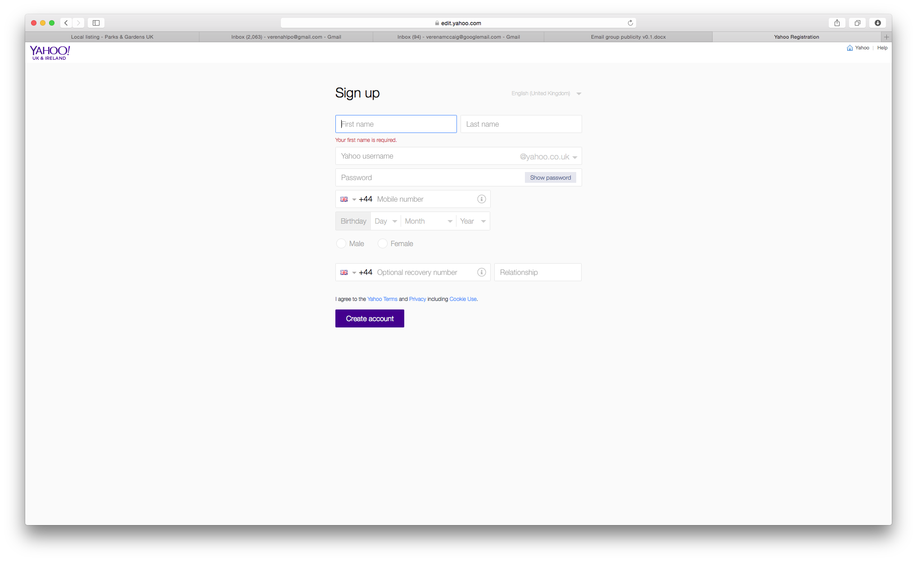
Fill in your details. You don’t need to use your actual date of birth and you can change your email address later – this just links you to the Yahoo group in the first instance.
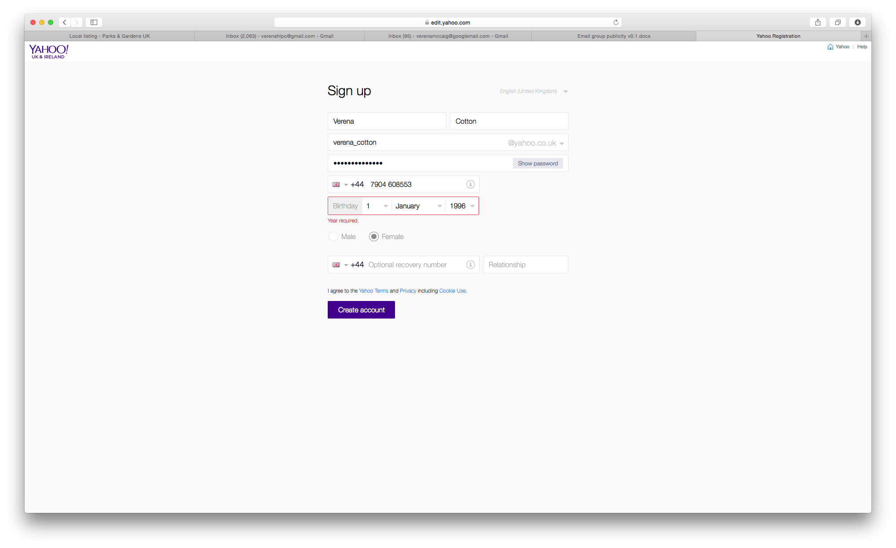
Then click on ‘Create Account’. You will see this congratulatory message.
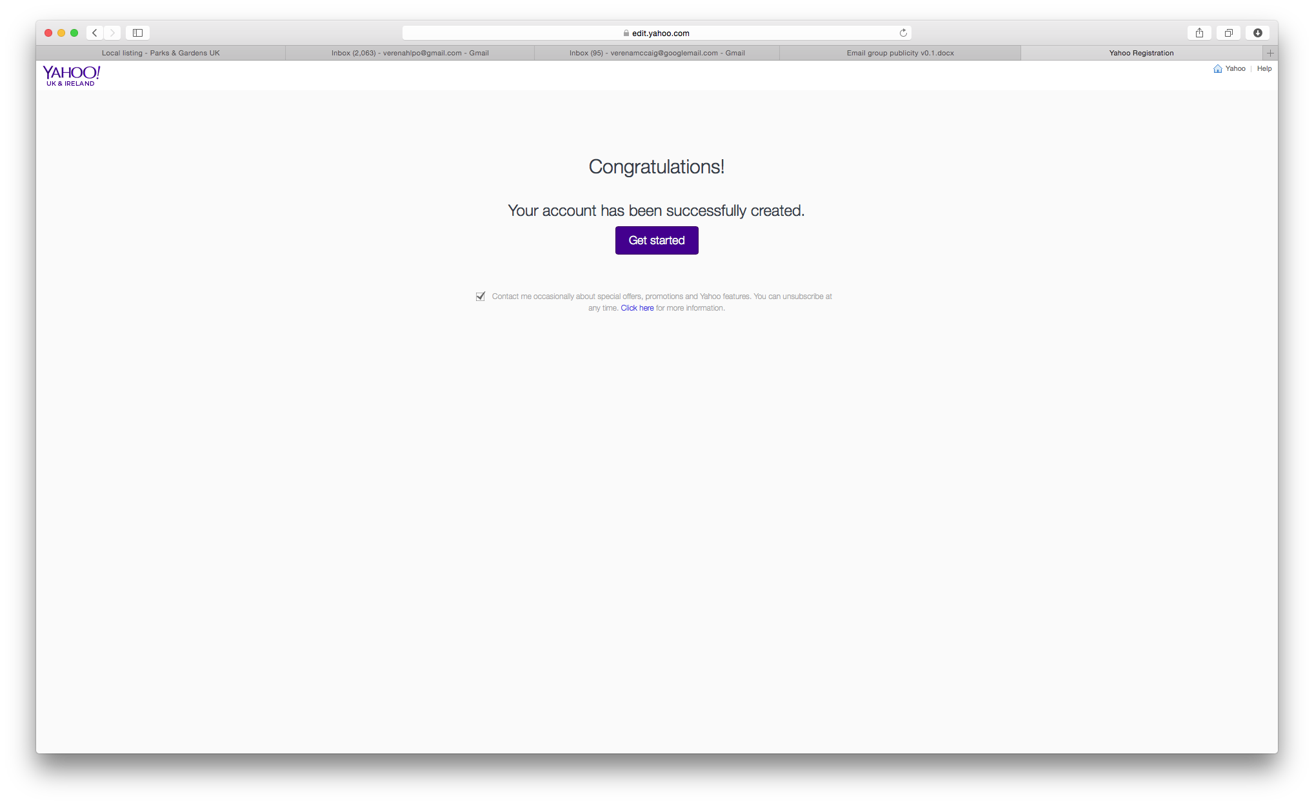

It should now return you to the Leap the HaHa group homepage.

Join the group

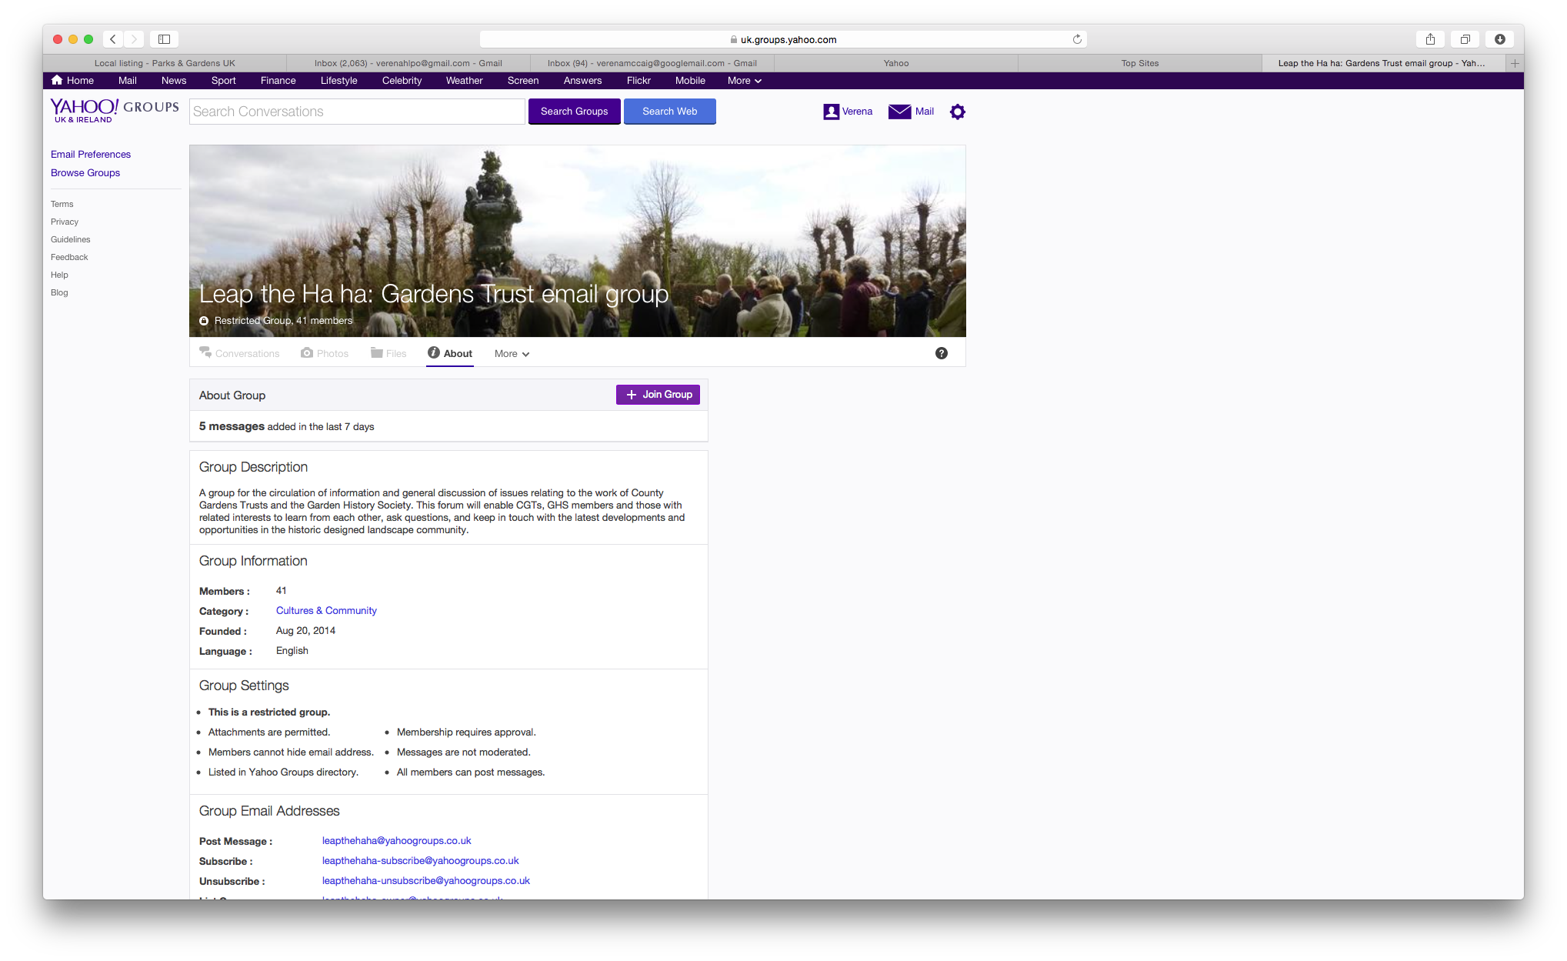

Either click on ‘Join Group’ or you may find it just pops up:

Organise your identity and decide how to use the group

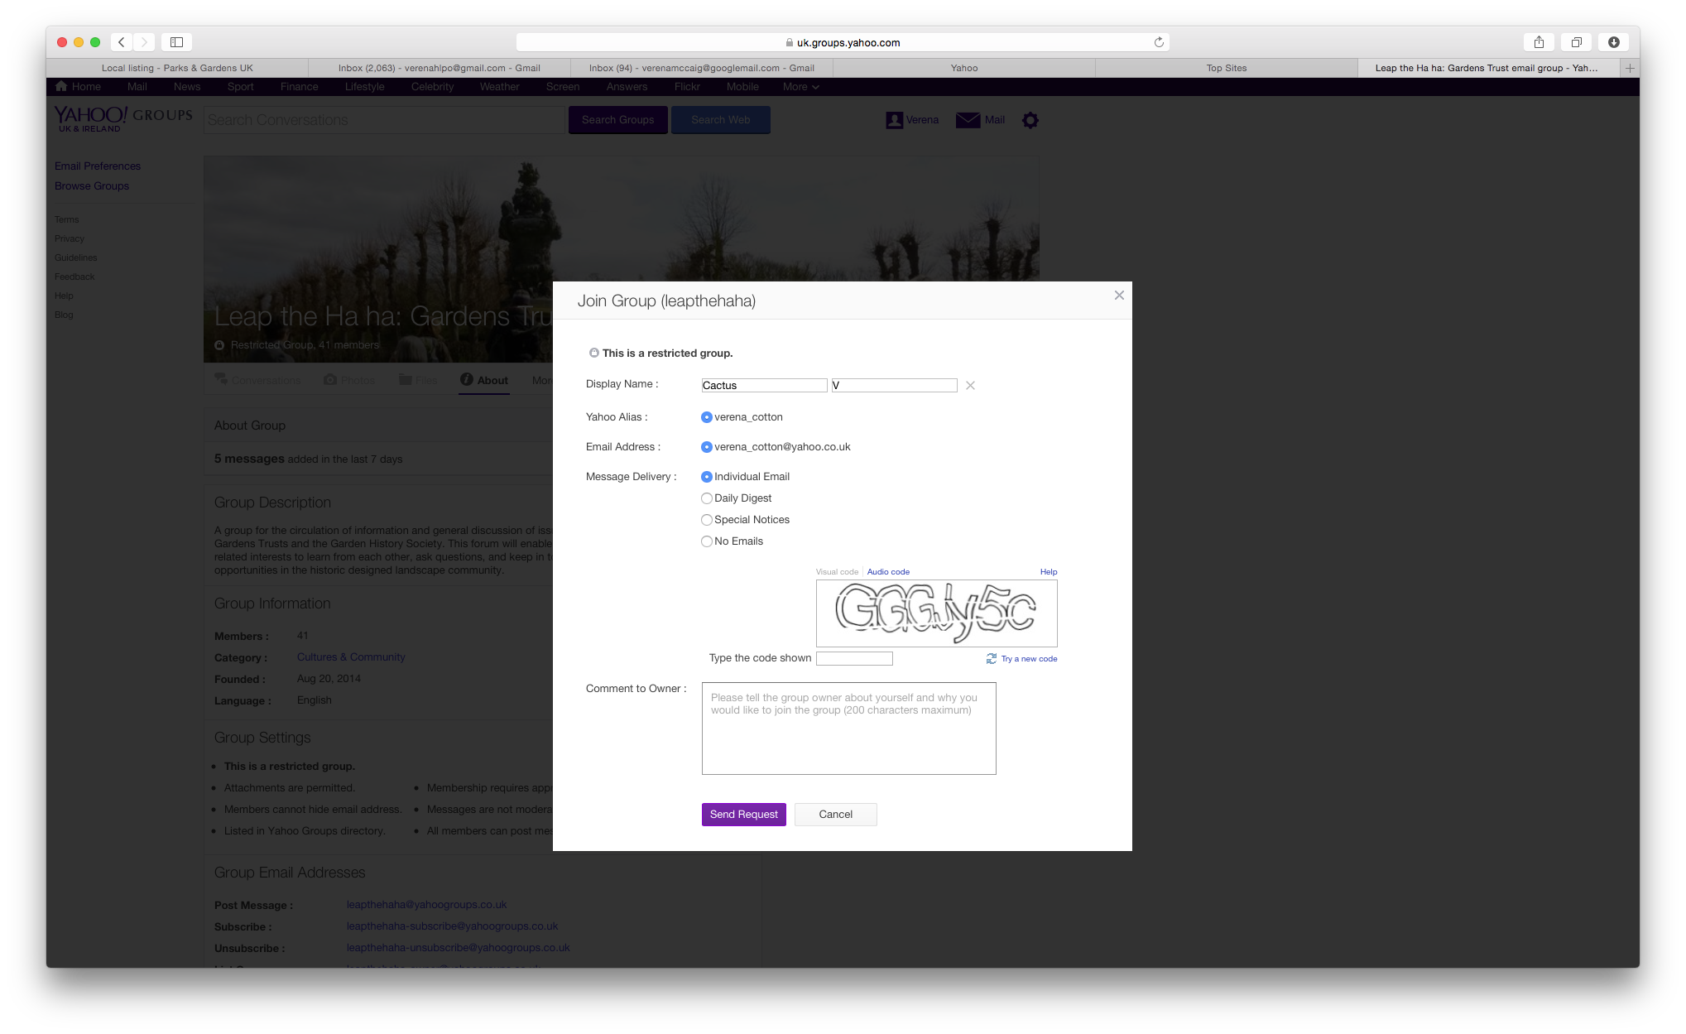

Choose an on screen name: You might want to give yourself a different ‘on screen’ name!
Choose how you want to use the group: You can also select whether you want to receive each email as it gets sent out, a daily digest, no emails at all (so you’d have to come on to the site to look each time) or just ‘Special Notices’ only which perhaps might get sent out on this basis if they are Very Important! We recommend receiving individual emails.

Change the email address to a convenient one
(This is important – many users miss it out and then wonder why they haven’t heard from the group. The answer is that everything’s going to their Yahoo email address!)
If you’re not happy relying on your new yahoo email address and want to change the email address you link to the group, you can, at this point, close the Join Group dialogue box and return to the main group Home Page. You will see that there is a cog symbol next to your name. Click on this and you get a drop down menu which includes ‘Account Info’.

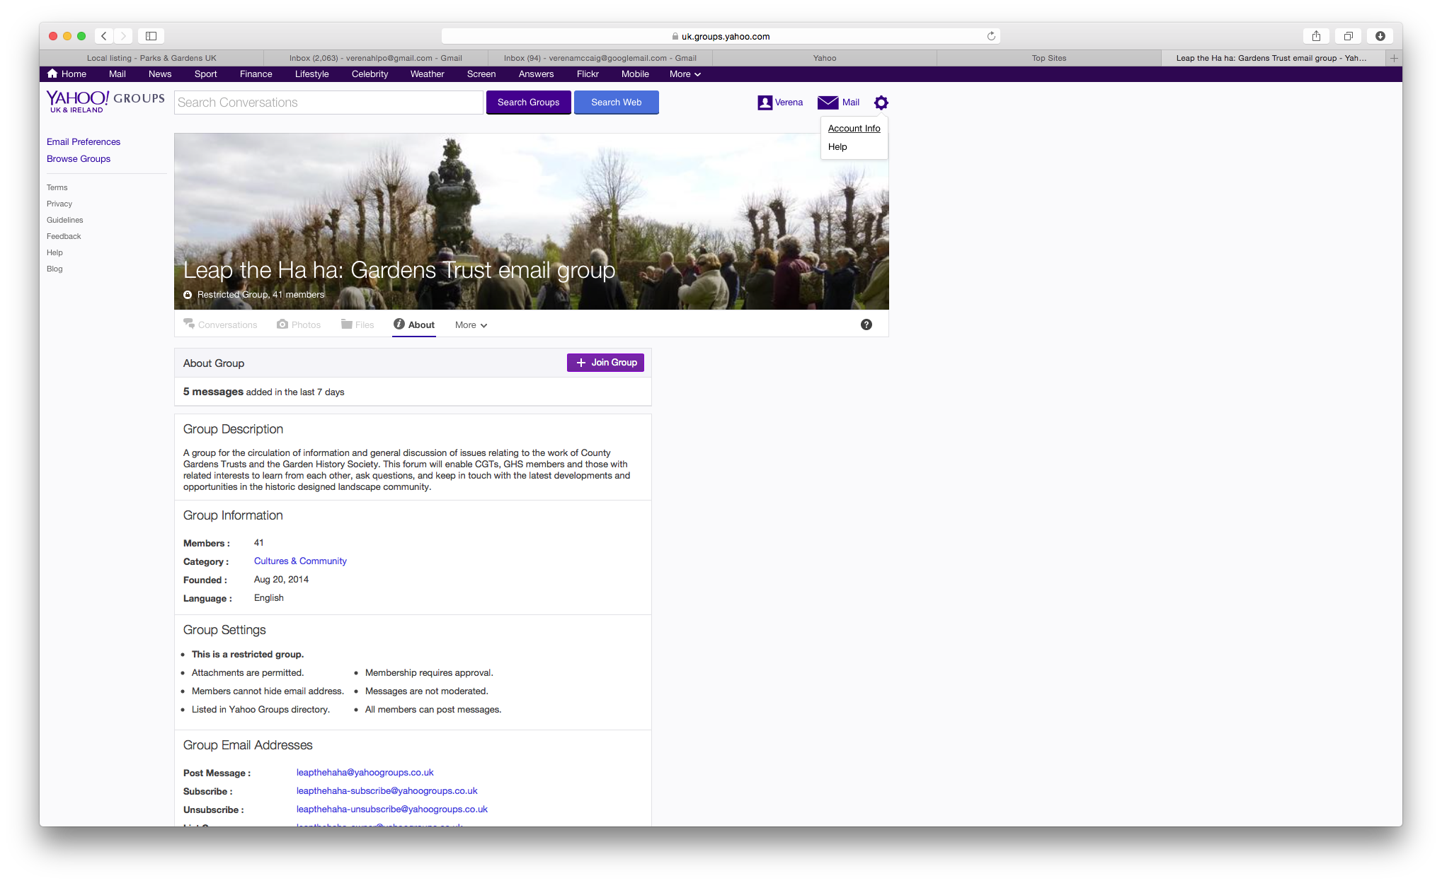
It will take you to all your account information:

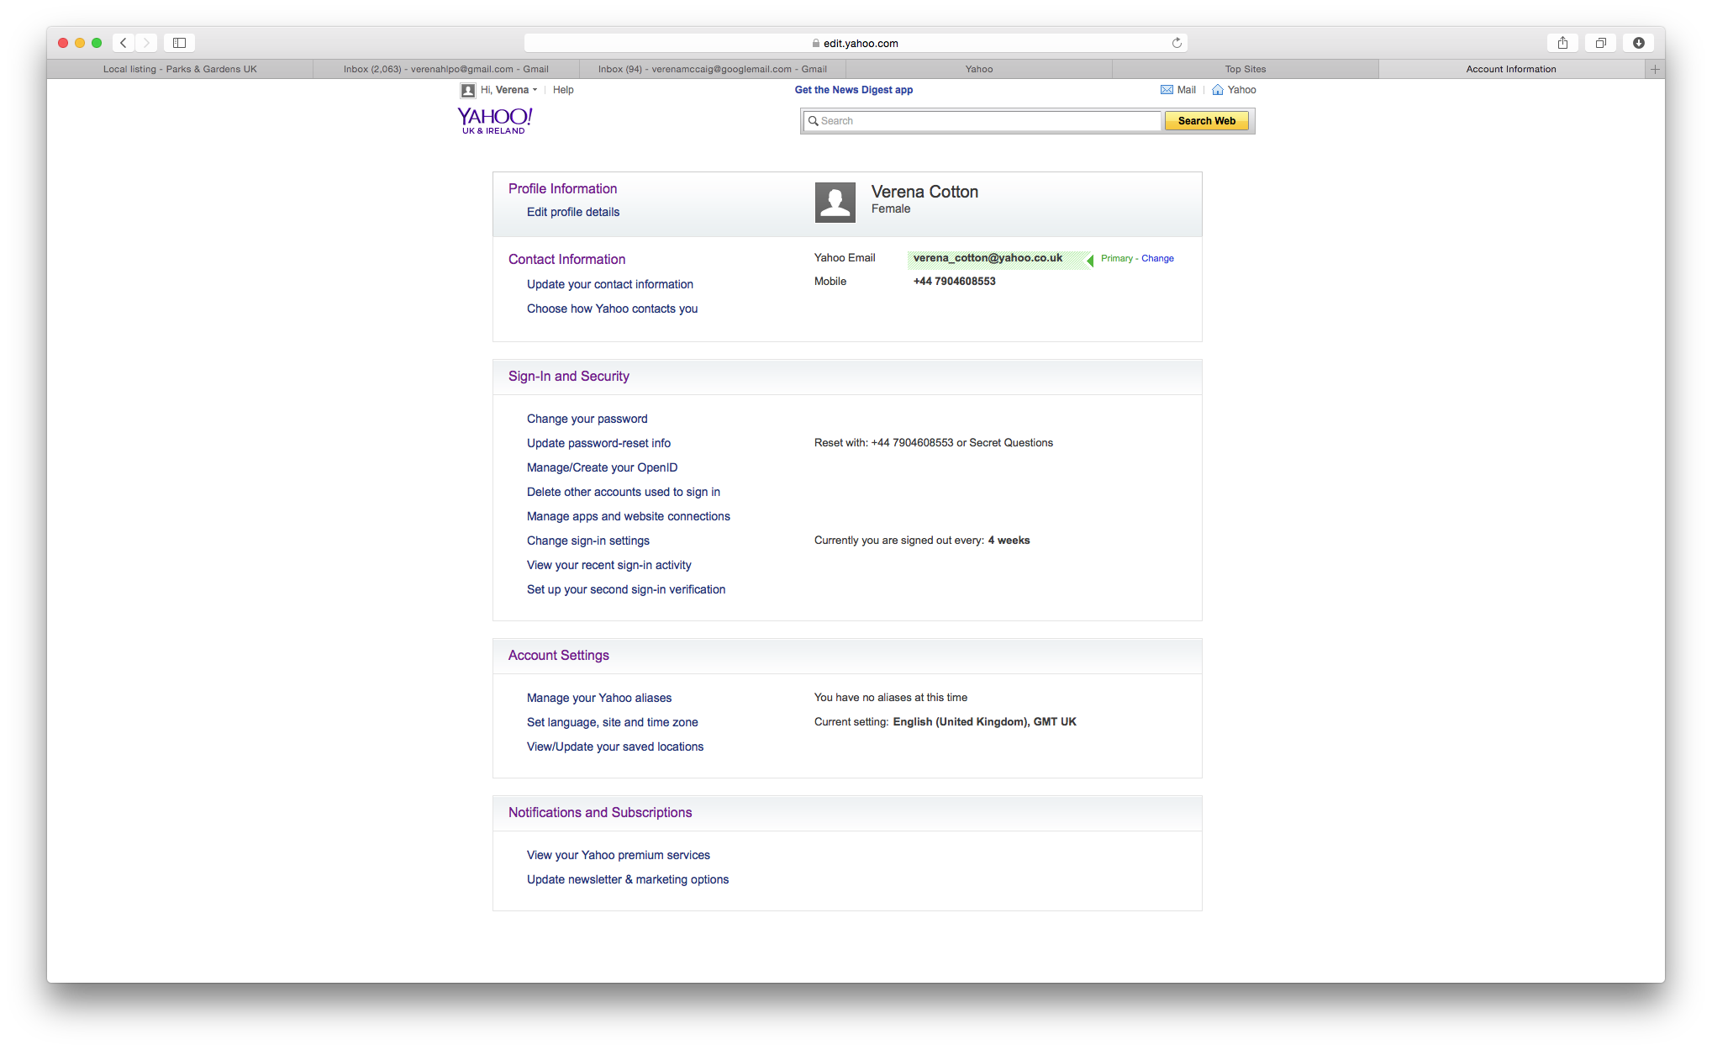
You’ll see it says, next to your email address, that you can change which email address is ‘primary’ ie the one to which the email group will send messages. Click on ‘Change’.

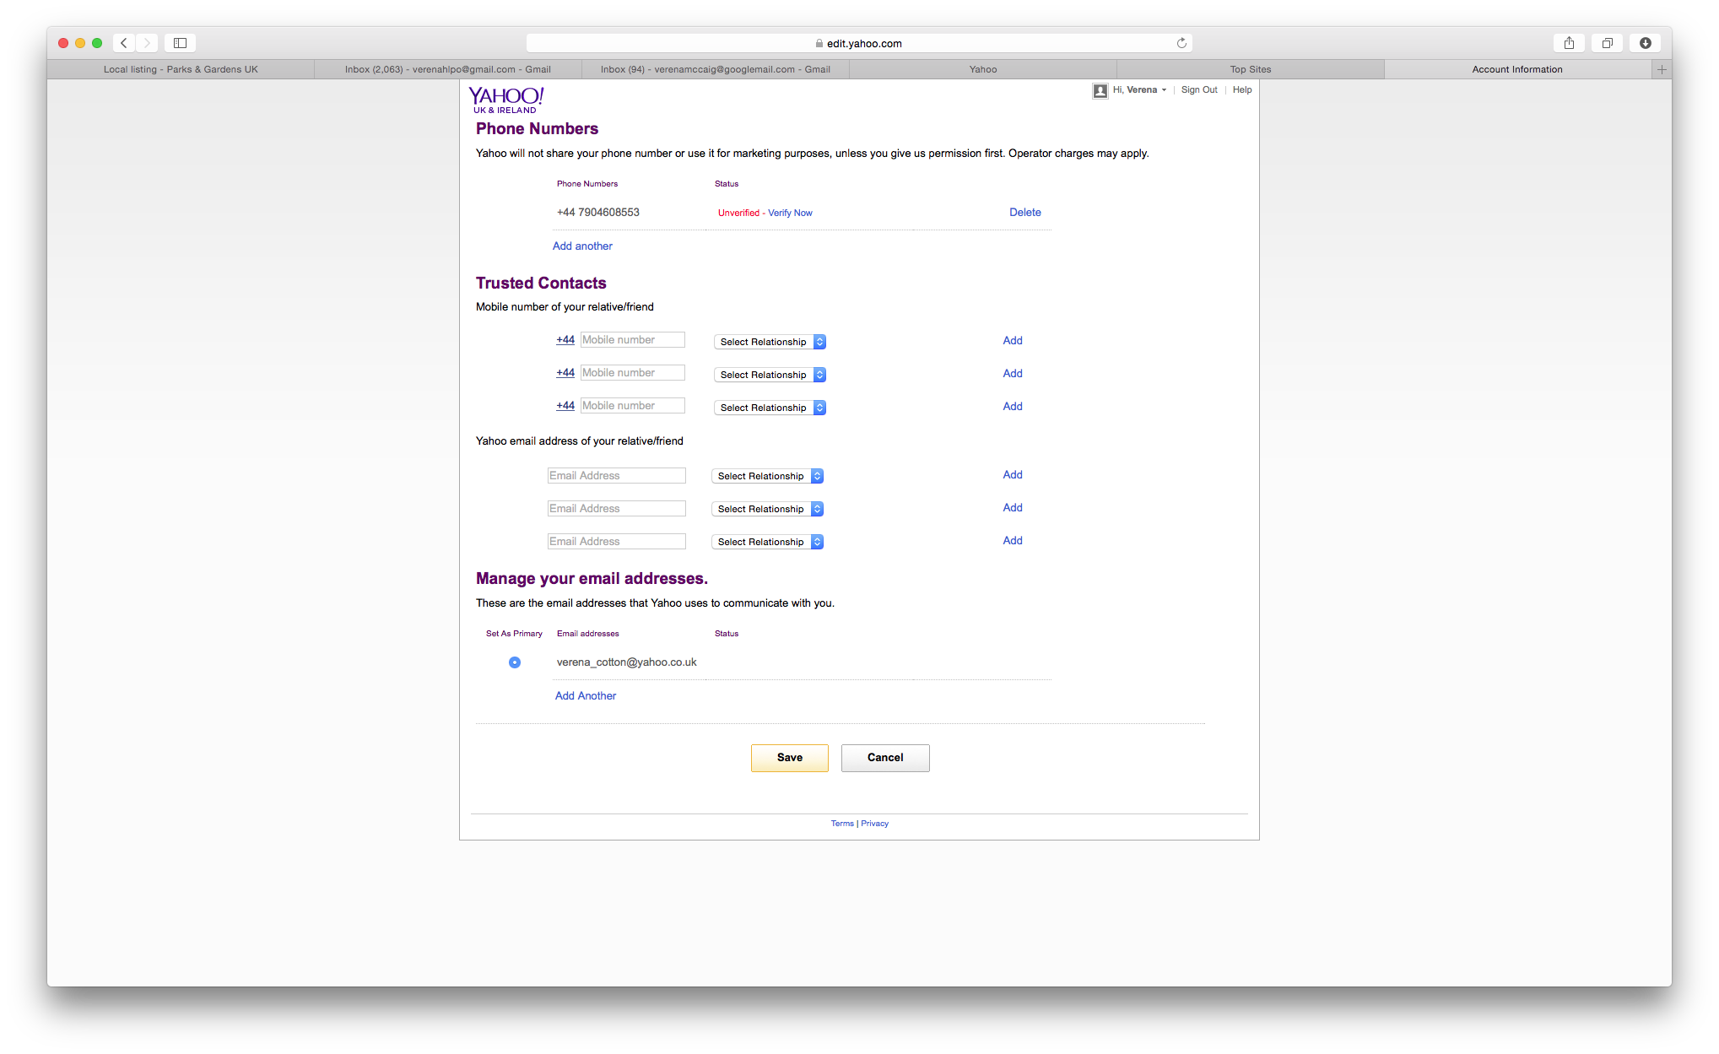

Down the bottom you’ll see it says ‘Add Another’ under your Yahoo email address. Add the email address to which you’d like to receive emails from the Leap The Ha Ha group.

(It may take a while for Yahoo to accept the change.)

It will automatically send an email to that email address in order that you verify it.

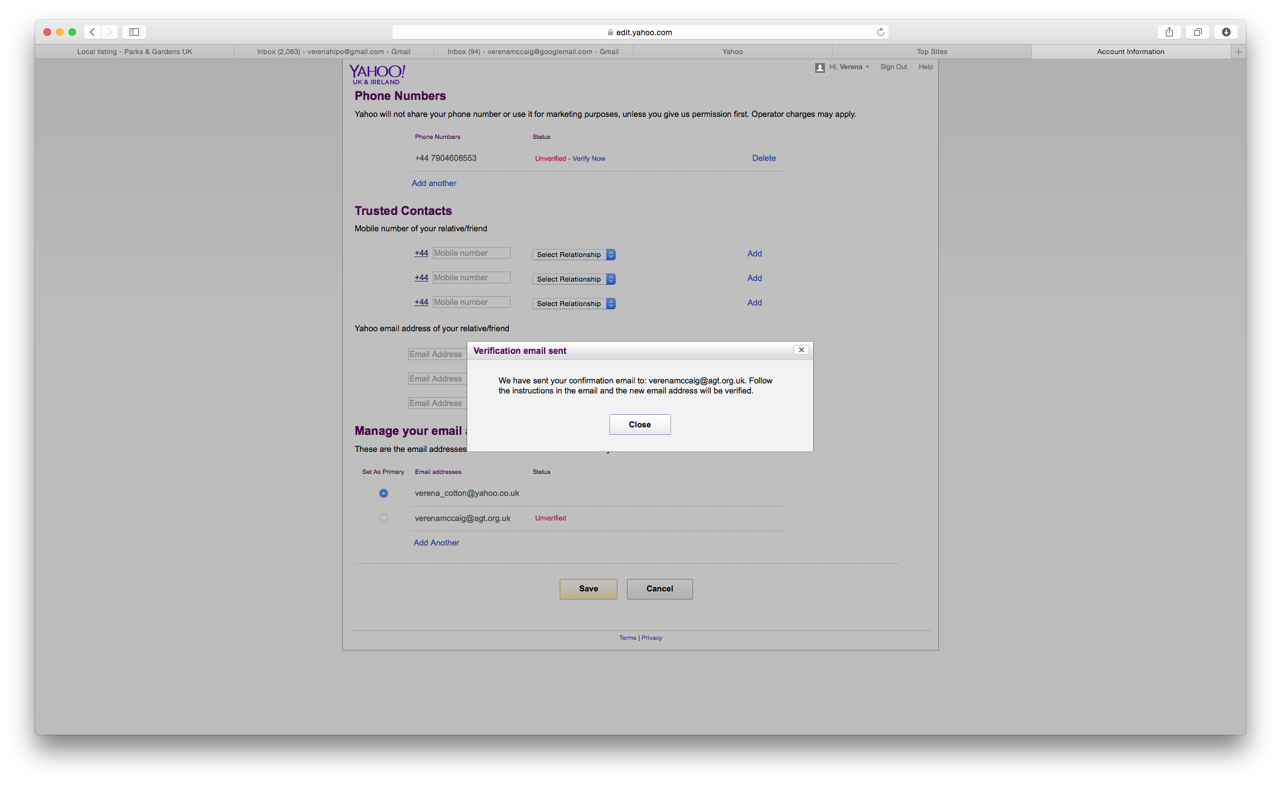

Close the box and go to that email account to verify it. You will merely be asked to click on a link.

You will then receive a message that tells you that your email account has been verified.
Click on ‘Continue’ and sign back in.
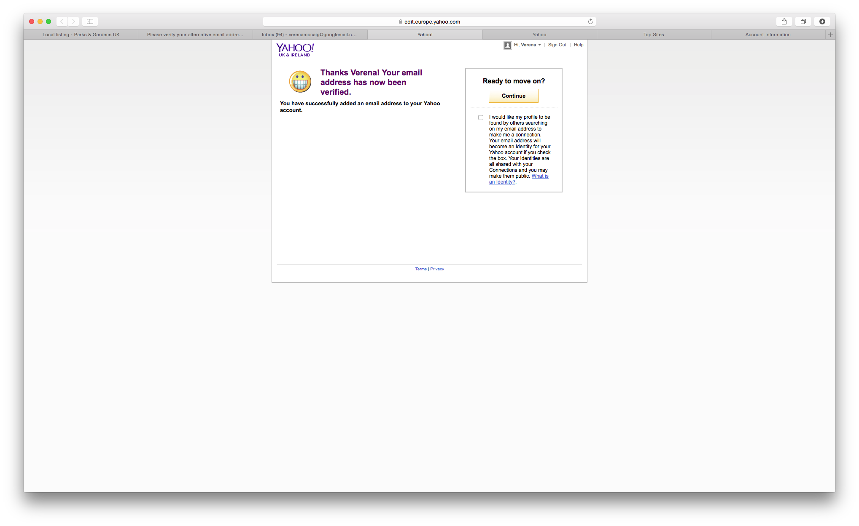

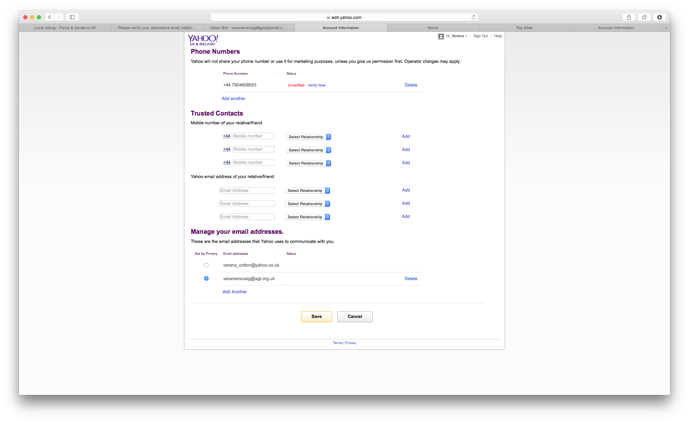

And it will take you back to where you were before – and you can now choose the email account you want!
Select the one you want and click on ‘Save’.

Adding an alias

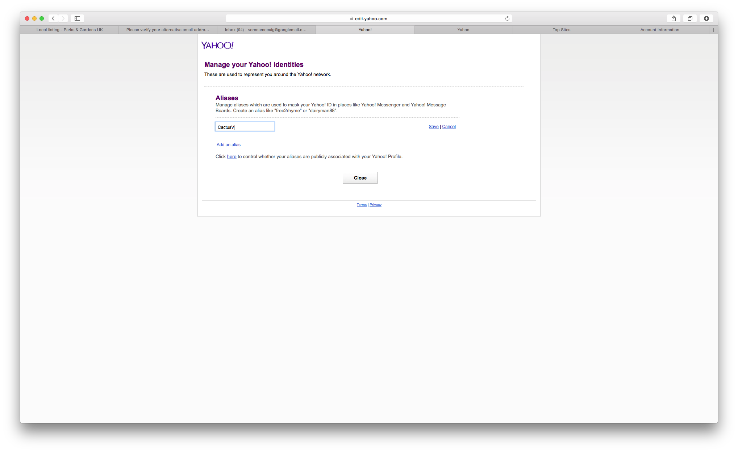

You may want to add an alias, particularly if you want to use the group wearing various ‘hats’.

Have a look around the options to see if there is anything else you would like to amend
You can amend this account information any time in future, too.
Now you’re ready to join the group!
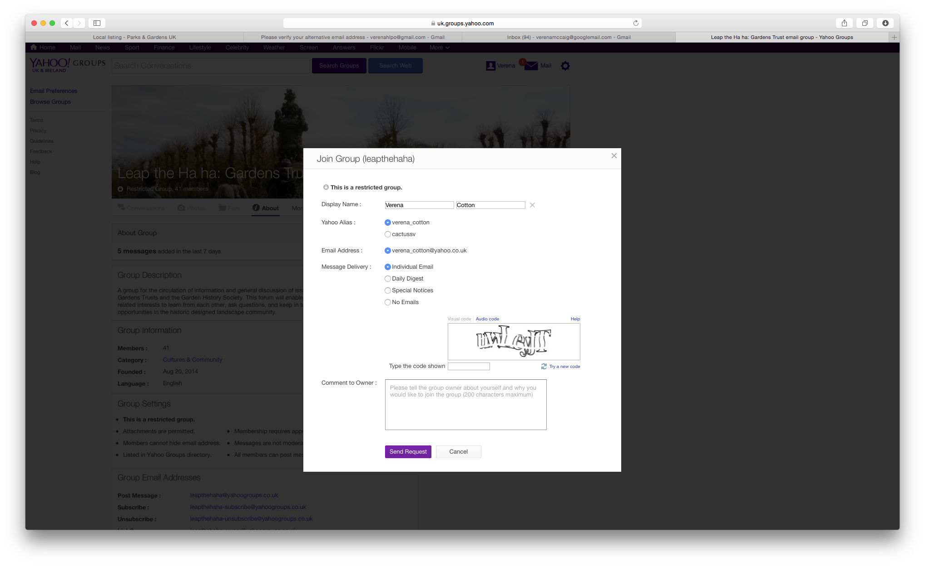
Your registration request is sent to the Historic Landscape Project Officers and we will accept it asap but bear in mind that we are part-time workers so if it is urgent, please email lindengroves@agt.org.uk to alert her again that you want to join.
Using the group: brief notes
Once you are on the group, do please have a good explore and experiment with using it, but here are a few pointers.
- AS when joining, you can access the group by going to http://uk.groups.yahoo.com/group/leapthehaha/join but filling in your Sign In details.
- To start a new discussion thread, simply click on the prominent purple ‘New Topic’ button. This will send your message to everyone in the group, via their email if that is how they have chosen to receive updates.
- When you post or reply to topics, your chosen identity will be shown but not your email address so replies will all come back via the group, If you particularly need replies to come just to you (and we hope not, as it rather defeats the object), then you can type your email address within your message.
- To reply to a message, simply hit ‘Reply’ if you are looking at the message via the website, or if you have received it as an email there will again be a ‘Reply’ button at the bottom.
- To see previous discussions, choose ‘Conversations’ on the Email Group home page.
- As you will see, some of the discussions have produced lots of helpful material for CGTs! It is intended that HLPOs will harvest the most useful of these into ‘CG Tips’ documents, which we will upload onto the Resource Hub for future reference.

